**LESSON PLAN FOR WEEK 1 ENDING 13/09/2024**

**Term 1st term**

**Week 1st  week**

**Date 11th September,2024**

**Class Nursery One**

**Subject Nature studies**

**Topic Our body.**

**Sub-topic Meaning of our body.**

**Period 4th period**

**Time 8:50 am**

**Duration 35 minutes**

**No in class 15**

**Average Age 3 years**

**Sex Mixed**

**Specific Objectives: By the end of the lesson, the pupils**

**should be able to:**

1. **Define our body.**
2. **Name the parts of the body.**
3. **Identify the parts of the body.**

**Rationale: To ensure the pupils have vital knowledge of our body.**

**Previous Knowledge: The pupils can identify the simple machines at school.**

**Instructional Resources: Parts of the body chart.**

**Reference Material: Elementary science by Showers kiddies nursery 1**

**LESSON PRESENTATION**

|  |  |  |  |
| --- | --- | --- | --- |
| **Steps** | **Teacher’s Activities** | **Pupils’ Activities** | **Learning Points** |
| **Introduction** | **The teacher introduces the lesson by showing the pupils “our body” chart.** | **The pupils listens attentively to identify parts of the body.** | **To arose the pupils’ interest.** |
| **Step 1** | **The teacher explains our body as the “physical structure that includes bones, flesh, and organs of a person or an animal”.** | **The pupils can define “our body”** | **For proper understanding.** |
| **Step 2** | **The teacher lists the parts of the body which include**  **EAR**  **EYES**  **HANDS**  **NECK**  **LEGS**  **NOSE**  **STOMACH**  **TEETH ETC** | **The pupils name the parts of the body with their teacher.** | **For better understanding.** |
| **Step 3** | **The teacher leads the pupils to identify the parts of their body with rhymes “My head, my shoulders, my knees, my toes, they all belong to me.** | **The pupils identify the parts of their body.** | **For further understanding.** |
| **Summary** | **The teacher summarizes the lesson by rhyming the parts of the body for the pupils.** | **The pupils can identify and rhyme the parts of their body.** | **For onward study.** |
| **Evaluation** | 1. **Define body?** 2. **Mention the parts of the body?** 3. **Show me your thighs?** | **The pupils answer the question correctly.** | **To ascertain the pupils’ understanding.** |
| **Conclusion** | **The teacher summarizes, reacts, and corrects the pupils.** | **The pupils gives answer to the teacher’s questions** | **To consolidate the lesson.** |
| **Assignment** | **Define body?**  **Mention the parts of the body?**  **Show me your thighs?**  **Draw your right hand fingers?** | **The pupils copy and do their homework at home.** | **To encourage learning while at home.** |

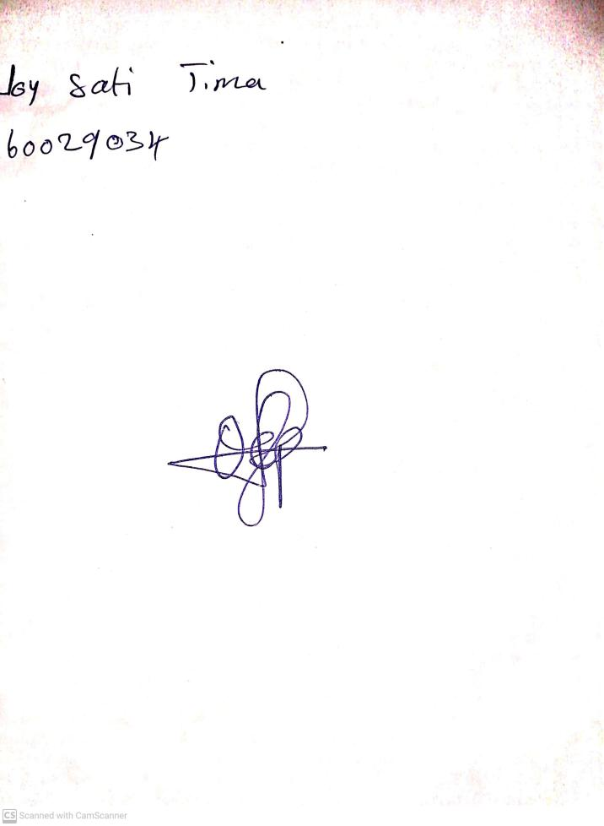

13th September, 2024

Perpetual Ojoma Ocheja

Stream Head Nursery