**EMERALD ROYAL INTERNATIONAL SCHOOL**

**MPAPE, ABUJA.**

**LESSON NOTE FOR WEEK 9 ENDING 8THMARCH, 2024.**

SUBJECT: Number Work

TOPIC: Counting numbers 1 - 23.

SUB-TOPIC: Counting objects 1 - 23.

DATE: 04/03/2024.

DURATION: 40 minutes.

TIME: 10 : 40 - 11 :20.

PERIOD: 4 th

CLASS: Pre-Nursery

NUMBER OF PUPILS: 19

AVERAGE AGE: 2 years

SEX: Mixed.

SPECIFIC OBJECTIVES: By the end of the lesson, the pupils should be able to:-

1. Count objects 1-23
2. Identify numbers 1 - 23

RATIONALE: For pupils to be able to count numbers.

PREVIOUS KNOWLEDGE: Pupils have been counting numbers.

INSTRUCTIONAL MATERIALS: Number chart, flash cards, building blocks etc

REFERENCE MATERIALS: Mastering mathematics for nursery schools book 1 by Henry Idogun.

**LESSON DEVELOPMENT**

|  |  |  |  |
| --- | --- | --- | --- |
| STAGES/STEPS | TEACHER’S ACTIVITIES | PUPILS’ ACTIVITIES | LEARNING POINTS |
| INTRODUCTION | Teacher counts numbers 1 - 23 for the pupils. | Pupils count numbers 1 - 23 along with the teacher. | To arouse pupils interest in the lesson. |
| PRESENTATION  STEP 1 | Teacher guides pupils to identify numbers 1 - 23. | Pupils point at the numbers. | For better understanding of the lesson . |
| STEP2 | Teacher guides each pupils to count objects 1 - 23. | Pupils count objects 1 - 23. I.e  BROOMBROOMBROOMBROOMBROOM  BROOMBROOMBROOMBROOMBROOM  BROOMBROOMBROOMBROOMBROOM  BROOMBROOMBROOMBROOMBROOM  BROOMBROOMBROOM | For proper understanding of the lesson. |
| SUMMARY | Teacher identifies each number 1 - 23 for the pupils. | Pupils point at the numbers. | For more understanding of the lesson. |
| EVALUATION | Teacher asks Pupils to 1. count numbers 1 - 23.  2. Identify numbers 1 to 23. | Pupils answer the questions and pay attention to the teacher. | To assess pupils understanding of the lesson. |
| CONCLUSION | Teacher sings a number rhyme for the pupils. | Pupils sing the rhyme along with the teacher. | To improve pupils speaking ability. |
| ASSIGNMENT (HOME WORK) | Count and circle these objects. | Pupils do their assignment at home. | To encourage pupils to learn at home. |

**EMERALD ROYAL INTERNATIONAL SCHOOL**

**MPAPE, ABUJA.**

**LESSON NOTE FOR WEEK 9 ENDING 8THMARCH, 2024.**

SUBJECT: Number Work

TOPIC: Counting numbers 1 - 23.

SUB-TOPIC: Copying numbers 1 & 2.

DATE: 06/03/2024.

DURATION: 40 minutes.

TIME: 08:50--09:30.

PERIOD: 2 nd

CLASS: Pre-nursery

NUMBER OF PUPILS: 19

AVERAGE AGE: 2 years

SEX: Mixed.

SPECIFIC OBJECTIVES: By the end of the lesson, the pupils should be able to:-

1. Count Numbers 1-23
2. Copy numbers 1 & 2

RATIONALE: For pupils to be able to count numbers.

PREVIOUS KNOWLEDGE: Pupils have been counting numbers.

INSTRUCTIONAL MATERIALS: Number chart, flash cards, building blocks etc

REFERENCE MATERIALS: Mastering mathematics for nursery schools book 1 by Henry Idogun.

**LESSON DEVELOPMENT**

|  |  |  |  |
| --- | --- | --- | --- |
| STAGES/STEPS | TEACHER’S ACTIVITIES | PUPILS’ ACTIVITIES | LEARNING POINTS |
| INTRODUCTION | Teacher introduces the lesson by asking the pupils to count numbers 1 - 20. | Pupils count numbers 1 - 20. | To draw pupils attention to the lesson. |
| PRESENTATION  STEP 1 | Teacher counts numbers 1 - 23 for the pupils to repeat after her. | Pupils count numbers 1 - 23 after the teacher. I.e 1 2 3 4 5 6 7 8 9 10 11 12 13 14 15 16 17 18 19 20 21 22 23. | For better understanding of the lesson . |
| STEP 2 | Teacher guides each pupils to copy numbers 1 & 2. | Pupils copy numbers 1 & 2.  1 1 1  2 2 2 | For proper understanding of the lesson. |
| SUMMARY | Teacher identifies each number 1 - 23 for the pupils. | Pupils point at the numbers. | For more understanding of the lesson. |
| EVALUATION | Teacher asks Pupils to 1. count numbers 1 - 23  2. copy number 1& 2 from the board. | Pupils count numbers 1 - 23 and copy the numbers. | To assess pupils understanding of the lesson. |
| CONCLUSION | Teacher sings a number rhyme for the pupils. | Pupils sing the rhyme along with the teacher. | To improve pupils speaking ability. |
| ASSIGNMENT (HOME WORK) | Count and circle numbers 1 & 2 among other numbers.  1 2 3 4 5 6 7 8 9 10 11 12 13 14 15 16 19 20 21 22 23. | Pupils do their assignment at home. | To encourage pupils to learn at home. |

**EMERALD ROYAL INTERNATIONAL SCHOOL**

**MPAPE, ABUJA.**

**LESSON NOTE FOR WEEK 9 ENDING 9THMARCH, 2024.**

SUBJECT: Number Work

TOPIC: Counting numbers 1 - 23.

SUB-TOPIC: Colouring correct number of objects 1 - 23.

DATE: 08/03/2024.

DURATION: 40 minutes.

TIME: 08 : 50 - 09 : 30.

PERIOD: 3rd

CLASS: Pre-nursery

NUMBER OF PUPILS: 19

AVERAGE AGE: 2 years

SEX: Mixed.

SPECIFIC OBJECTIVES: By the end of the lesson, the pupils should be able to:-

1. Colour objects 1-23
2. Identify numbers 1 - 23

RATIONALE: For pupils to be able to count numbers.

PREVIOUS KNOWLEDGE: Pupils have been counting numbers.

INSTRUCTIONAL MATERIALS: Number chart, flash cards, building blocks etc

REFERENCE MATERIALS: Mastering mathematics for nursery schools book 1 by Henry Idogun.

**LESSON DEVELOPMENT**

|  |  |  |  |
| --- | --- | --- | --- |
| STAGES/STEPS | TEACHER’S ACTIVITIES | PUPILS’ ACTIVITIES | LEARNING POINTS |
| INTRODUCTION | Teacher counts numbers 1 - 23 for the pupils. | Pupils count numbers 1 - 23 along with the teacher. | To arouse pupils interest in the lesson. |
| PRESENTATION  STEP 1 | Teacher guides pupils to identify numbers 1 - 23. | Pupils point at the numbers. | For better understanding of the lesson . |
| STEP2 | Teacher guides each pupils to colour objects 1 - 23. | Pupils colour objects 1 - 23. I .e | For proper understanding of the lesson. |
| SUMMARY | Teacher identifies each number 1 - 23 for the pupils. | Pupils point at the numbers. | For more understanding of the lesson. |
| EVALUATION | Teacher asks Pupils to 1.count numbers 1 - 23  2.colour these objects | Pupils count numbers 1 - 23 and colour the objects. | To assess pupils understanding of the lesson. |
| CONCLUSION | Teacher sings a number rhyme for the pupils. | Pupils sing the rhyme along with the teacher. | To improve pupils speaking ability. |
| ASSIGNMENT (HOME WORK) | Colour these objects  BROOM BROOMBROOM  BROOMBROOMBROOMBROOMBROOMBROOMBROOMBROOM | Pupils do their assignment at home. | To encourage pupils to learn at home. |

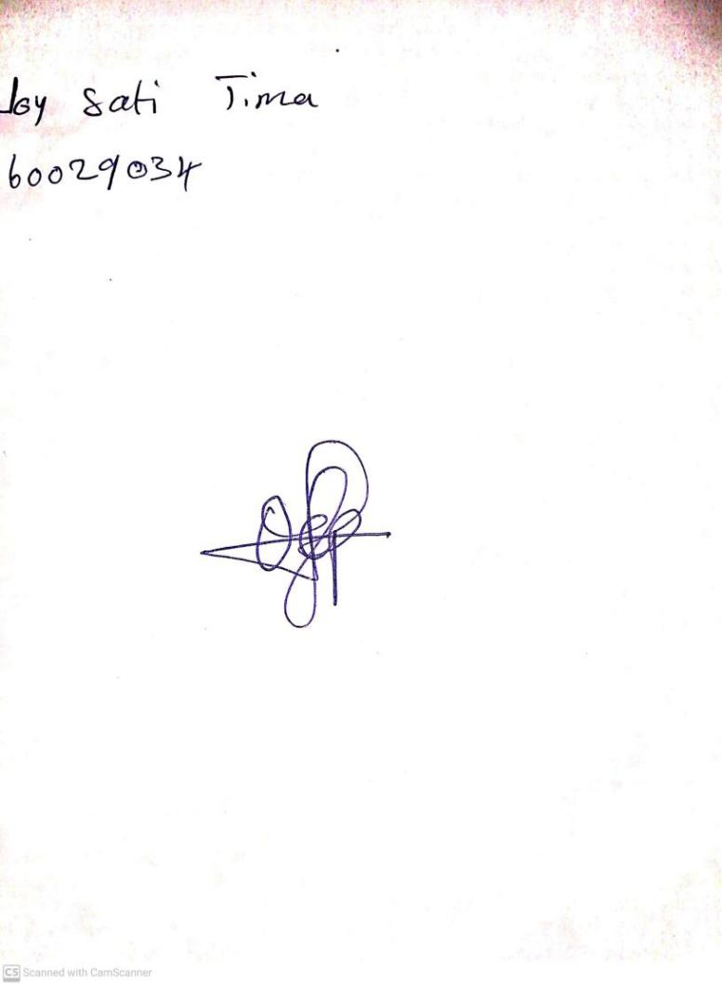

1ST MARCH, 2024

Perpetual Ojoma Ocheja

Stream Head Nursery