LESSON PLAN FOR WEEK 6

|  |  |
| --- | --- |
| TERM | 3rd |
| WEEK | 4 |
| DATE | 06/06/2023 |
| CLASS | SS 1 |
| SUBJECT | Data Processing |
| TOPIC | Chart and Graph |
| SUB-TOPIC | Definition, types of charts or graph, how to insert a chart or graph. |
| PERIOD | 8th Period |
| TIME | 1:20pm - 2:00pm |
| DURATION | 40 Minutes |
| NO IN CLASS | 8 |
| AVERAGE AGE | 13-14 Years |
| SEX | Mixed |
| SPECIFIC OBJECTIVES | By the end of the lesson, scholars should be able to:   1. Explain the meaning of Chart or graph. 2. List the different types of chart. |
| RATIONALE | To acquaint the scholars with the meaning of Chart and graph. |
| PREVIOUS KNOWLEDGE | The scholars have knowledge (of) some components of spreadsheet. |
| INSTRUCTIONAL RESOURCES | Microsoft Excel application on the computer in the computer lab. |
| REFERENCE MATERIAL | Data Processing for Senior Secondary Education (SS 1-3) HiiT Plc |

LESSON DEVELOPMENT

|  |  |  |  |
| --- | --- | --- | --- |
| STEPS | TEACHER’S ACTIVITIES | SCHOLARS’ ACTIVITIES | LEARNING POINTS |
| Introduction | The teacher introduces the topic by asking the scholars to list some components of Spreadsheet. | The scholars mentioned them as:  i.Cells  ii.Rows  iii.Columns  iv.Range etc | To arouse scholars’ interest towards the topic. |
| Step 1 | The teacher explains the meaning of Chart or graph. | The scholars pay attention. | To enhance proper understanding of the topic. |
| Step 2 | The teacher lists out the different types of charts, which includes;   1. Pie chart 2. Bar chart 3. Line chart 4. Statiscal chart etc. | The scholars listen and ask questions. | To encourage critical thinking on the topic. |
| Board summary | The teacher summarizes the lesson thus:  A chart also called a graph is a graphical representation of data, in which data is represented by symbols.  Types of chart or graph   1. Pie chart 2. Bar chart 3. Line chart 4. Statistical chart etc.   How to insert a chart or graph   1. Select the cells with data you want to include your chart 2. Click insert on the menu bar 3. Choose the chart type from the chart section. | The scholars copy notes into their notebooks. | For future references. |
| Evaluation | The teacher evaluates the scholars thus:  i.What is Graph?  ii.List four (4) types of chart. | The scholars attempt the questions. | To ascertain scholars understanding of the lesson. |
| Conclusion | The teacher check scholars notes and make corrections. | The scholars take corrections made by the teacher. | For consolidation of the lesson. |
| Assignment | The teacher gives the scholars assignment:   1. Write the steps of inserting a graph or chart in a worksheet. 2. List four (4) different types of charts that you know. | The scholars copy their assignment to do it at home. | The (To) encourage continuity of learning. |

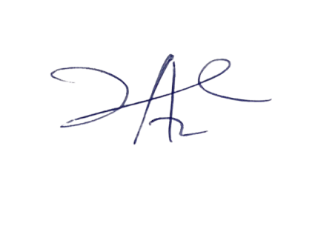

27/6/2023

Principal Head Instuctor

