**EMERALD ROYAL INTERNATIONAL SCHOOL**

**MPAPE, ABUJA.**

**LESSON PLAN AND NOTE FOR WEEK 6 PERIOD 1 ENDING 20/10/2023**

TERM: FIRST

WEEK: 6TH

DATE: 16/10/2023

CLASS: NURSERY 2

SUBJECT: LETTER WORK

TOPIC: SIMPLE SENTENCES WITH THREE LETTER

WORDS.

SUB-TOPIC: MEANING AND EXAMPLES OF SENTENCES

PERIOD: 1ST

TIME: O8:50-09:30.

DURATION: 40 MINUTES.

NUMBER IN CLASS: 15

AVERAGE AGE: 4 YEARS.

SEX: MIXED.

SPECIFIC OBJECTIVES: BY THE END OF THE LESSON,THE PUPILS SHOULD BE

ABLE TO:

1. EXPLAIN THE MEANING AND OF SENTENCE

2. STATES EXAMPLES OF SIMPLE SENTENCES.

RATIONALE: FOR PUPILS TO KNOW HOW TO MAKE SIMPLE

SENTENCES.

PREVIOU KNOWLEDGE: PUPILS HAVE LEARNT THREE LETTER WORDS WITH VOWEL "I" IN PREVIOUS LESSON.

INSTRUCTIONAL MATERIALS: CHAIRS, TABLES, AND BOOKS.

REFERENCE MATERIALS: MASTERING ENGLISH FOR NURSERY 2 BY J. M OMOGBAI

**LESSON DEVELOPMENT**

|  |  |  |  |
| --- | --- | --- | --- |
| STAGES/STEPS | TEACHER’S ACTIVITIES | PUPILS’ ACTIVITIES | LEARNING POINTS |
| INTRODUCTION | Teacher introduces the lesson by keeping a ball under the table and then asks, children where is the ball? | Pupil listen to the teacher attentively and answer the question asked by the teacher. | To arouse pupils interest for the lesson ahead. |
| PRESENTATION  STEP 1 | Teacher presents the lesson by explaining the meaning of sentence to pupils and then asks them to repeat after her. | Pupils pay attention and repeat after the teacher. | For proper understanding of the lesson . |
| STEP 2 | Teacher states the examples of simple sentences to pupils and also asks them to repeat after her. | Pupils listen to the teacher and repeat after her. | For better understanding of the lesson. |
| BOARD SUMMARY | Teacher summarizes the lesson by writing the whole note of lesson on the board for pupils to copy into their books. That is,  Sentence:  A sentence is a set of words that is complete in itself.  Examples of sentences:   1. The book is on the table. 2. The ball is under the table. 3. This is a table. 4. I have one pencil 5. That is our teacher. 6. The book is mine etc. | Pupils copy the note into their exercise books. | For onward study. |
| EVALUATION | Teacher asks pupils the following questions:   1. What is a sentence? 2. State the examples of simple sentences. | Pupils answer the questions asked by the teacher. | To assess pupils level of understanding of the lesson so far. |
| CONCLUSION | Teacher marks pupils books. | Pupils submit their books for marking. | For endorsement. |
| ASSIGNMENT | Read the following two letter words simple sentences.  I go up.  Up I go.  Go on. Go up.  Go in or on.  I am up. Up I go.  I am on. On I go.  I go on . I go in.  If I go on. I go up.  He is to go up.  I am to go in. | Pupils do their assignment at home. | To encourage reading at home. |

**LESSON PLAN AND NOTE FOR WEEK 6 PERIOD 2 ENDING 20/10/2023**

TERM: FIRST

WEEK: 6TH

DATE: 19/10/2023

CLASS: NURSERY 2

SUBJECT: LETTER WORK

TOPIC: SIMPLE SENTENCES WITH THREE LETTER

WORDS.

SUB-TOPIC: SENTENCES WITH BED,MAN,CAT,DOG,HEN AND

WIG.

PERIOD: 2ND

TIME: O8:50-09:30.

DURATION: 40 MINUTES.

NUMBER IN CLASS: 15

AVERAGE AGE: 4 YEARS.

SEX: MIXED.

SPECIFIC OBJECTIVES: BY THE END OF THE LESSON,THE PUPILS SHOULD BE

ABLE TO:

1. IDENTIFY THREE LETTER WORDS ON THE BOARD.

2. MAKE SIMPLE SENTENCES WITH THE THREE LETTER

WORDS.

RATIONALE: FOR PUPILS TO LEARN READING WITH THREE LETTER

WORDS SENTENCES.

PREVIOU KNOWLEDGE: PUPILS HAVE LEARNT THE MEANING AND EXAMPLES OF SENTENCES IN PREVIOUS LESS0N.

INSTRUCTIONAL MATERIALS: PICTURE F A BED, CAT,DOG, WIG AND HEN.

REFERENCE MATERIALS: MASTERING ENGLISH FOR NURSERY SCHOOLS BOOK 2 BY J.M OMOGBAI.

**LESSON DEVELOPMENT**

|  |  |  |  |
| --- | --- | --- | --- |
| STAGES/STEPS | TEACHER’S ACTIVITIES | PUPILS’ ACTIVITIES | LEARNING POINTS |
| INTRODUCTION | Teacher introduces the lesson by reviewing the previous lesson. | Pupil listen attentively to the teacher. | To arouse pupils interest for the lesson ahead. |
| PRESENTATION  STEP 1 | Teacher presents the lesson by writing three Letter words on the board, identify and then asks pupils to repeat after. | Pupils listen and repeat after the teacher. | For proper understanding of the lesson . |
| STEP 2 | Teacher makes simple sentences with the three letter words on the board and also asks pupils to repeat after her. | Pupils pay attention and repeat after the teacher. | For better understanding of the lesson. |
| BOARD SUMMARY | Teacher summarizes the lesson by writing the whole note of lesson on the board for pupils to copy into their books.That is;  THREE LETTER WORDS ARE:   1. Boy 2. Hen 3. Dog 4. Cat 5. Man 6. Bed   SIMPLE SENTENCES WITH THREE LETTER WORDS ARE:   1. The boy has a wig. 2. The hen is big. 3. The dog is sad. 4. The cat is up. 5. The man can run. 6. I can sit on the bed. | Pupils copy the note into their exercise books. | For onward study. |
| EVALUATION | Teacher asks Pupils to:   1. Identify the three letter words on the board. 2. Read the simple sentences on the board one after another. | Pupils read the note on the board one after another. | To assess pupils understanding of the lesson. |
| CONCLUSION | Teacher marks pupils books. | Pupils submit their books for marking. | For endorsement. |
| ASSIGNMENT | Read the following sentence:   1. He has a gun. 2. My bad zip. 3. It is a wet mop. 4. Sam has a yam. 5. It is a big van. 6. The bag has a tag. 7. Ted fed his red hen. | Pupils do their assignment at home. | To encourage learning at home. |

**LESSON PLAN AND NOTE FOR WEEK 6 PERIOD 3 ENDING 20/10/2023**

TERM: FIRST

WEEK: 6TH

DATE: 20/10/2023

CLASS: NURSERY 2

SUBJECT: LETTER WORK

TOPIC: SIMPLE SENTENCES WITH THREE LETTER

WORDS.

SUB-TOPIC: SIMPLE SENTENCES WITH THREE LETTER

WORDS

PERIOD: 3RD

TIME: 08:10- 08:50am

DURATION: 40 MINUTES.

NUMBER IN CLASS: 16

AVERAGE AGE: 4 YEARS.

SEX: MIXED.

SPECIFIC OBJECTIVES: BY THE END OF THE LESSON,THE PUPILS SHOULD

BE ABLE TO:

1. READ THREE LETTER WORDS SENTENCES ON

THE BOARD.

2. IDENTIFY MISSING WORDS IN SENTENCES.

RATIONALE: FOR PUPILS TO KNOW HOW TO LEARN HOW TO READ.

PREVIOU KNOWLEDGE: PUPILS HAVE BEEN MAKING SIMPLE SENTENCES IN

DAILY BASES.

INSTRUCTIONAL MATERIALS: A CHART OF THREE LETTER WORDS SIMPLE

SENTENCES.

REFERENCE MATERIALS: MY CHOICE OF ENGLISH LANGUAGE STAGE 3 BY J.F

J.F.OMOTAYO AND A.B.OMOTAYO

**LESSON DEVELOPMENT**

|  |  |  |  |
| --- | --- | --- | --- |
| STAGES/STEPS | TEACHER’S ACTIVITIES | PUPILS’ ACTIVITIES | LEARNING POINTS |
| INTRODUCTION | Teacher introduces the lesson by reviewing the previous lesson. | Pupils pay attention to the teacher. | To arouse pupils interest for the lesson ahead. |
| PRESENTATION  STEP 1 | Teacher presents the lesson by writing three letter words simple sentences on the board, read and then asks pupils to repeat after her. | Pupils listen to the teacher and repeat after her. | For proper understanding of the lesson . |
| STEP 2 | Teacher guides pupils to identify missing words in the sentences on the board. | Pupils identify missing words on the board. | For better understanding of the lesson. |
| BOARD SUMMARY | Teacher summarizes the lesson by preparing pupils books for them to copy the note on the board.ie,  SIMPLE SENTENCES ON THREE LETTER WORDS  Three Letter words simple sentences are:   1. Sam has a cap. 2. Dan has a pen. 3. Dad pat a cat. 4. He has a pad. 5. A fat cat ran. 6. The cap is on his lap. 7. The bed is wet. 8. The cat is wet. 9. He set the cat on the bed. 10. He put the pet on the bed.   FILLING OF THE MISSING WORDS   1. The ___ has a _____.  |  | | --- | | bag,zip |  1. The ___ ___ the ball.  |  | | --- | | hit,bat |  1. The ___ is ___  |  | | --- | | Sun,up |  1. The ___ is on the ____  |  | | --- | | bed,box |  1. The ____ is in the ____  |  | | --- | | cat,car | | Pupils copy the note into their exercise books and also fill the missing letters as:  Three letter words simple sentences are:   1. Sam has a cap. 2. Dan has a pen. 3. Dad pat a cat. 4. He has a pad. 5. A fat cat ran. 6. The cap is on his lap. 7. The bed is wet. 8. The cat is wet. 9. He set the cat on the bed. 10. He put the pet on the bed.   Filling of the missing words   1. The bag has a zip. 2. The bat hit the ball. 3. The sun is up. 4. The box is on the bed. 5. The cat is in the car. | For onward study. |
| EVALUATION | Teacher evaluates the lesson by asking pupils the following questions:   1. Read the three letter words simple sentences on the board all together 2. Identify and read the three letter words simple sentences on the board one after the other.. | Pupils all stand and read the note on the board all together and individually. | To create platform for slow learners. |
| CONCLUSION | Teacher concludes the lesson by marking pupils books. | Pupils submit their books for marking. | For endorsement. |
| ASSIGNMENT | Make simple sentences with the following words;   1. Hen 2. Cat 3. Cow 4. Dog 5. Bag 6. Fan 7. Mat 8. Sun 9. Pen 10. Mop   (Submit on Monday) | Pupils do their assignment at home. | To encourage learning at home. |

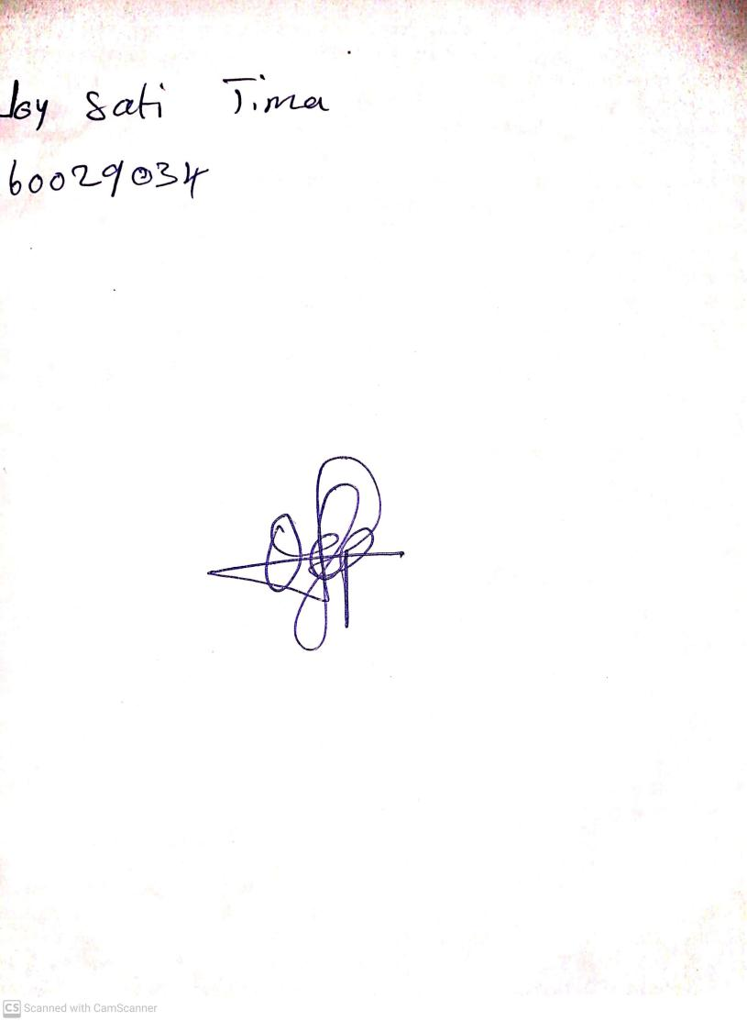

11TH OCTOBER, 2023

Perpetual Ojoma Ocheja

Stream Head Nursery