**EMERALD ROYAL INT’L SCHOOL**

**LESSON PLAN/NOTE FOR WEEK 2 ENDING: 21st JANUARY 2023**

|  |  |
| --- | --- |
| **Term** | 2nd |
| **Week** | 2 |
| **Class** | SS2 |
| **Date** | 21/01/2023 |
| **Subject** | Data Processing |
| **Topic** | Internet |
| **Sub-Topic** | Internet Security |
| **Period** | 5th |
| **Time** | 10:50 – 11:20 |
| **Duration** | 30minutes |
| **Number in class** | 5 |
| **Average age** | 15years |
| **Sex** | Mixed |
| **Specific Objectives** | By the end of the lesson, students should be able to:   1. Explain internet security 2. State the abuses of internet |
| **Rationale** | To enable students understand internet security |
| **Previous knowledge** | Students have been taught internet in their previous lesson |
| **Instructional material** | Computer set, internet and anti-virus CD’s |
| **Reference** | Data Processing for Senior Secondary Education (SS1 – 3) by Hiit Plc |

|  |  |  |  |
| --- | --- | --- | --- |
| **STEPS** | **TEACHER’S ACTIVITIES** | **STUDENTS ACTIVITIES** | **LEARNING POINTS** |
| Introduction | The teacher introduces the lesson by asking the students to explain what they understand by internet security | Students participate in the class discussion. | To arouse the students interest for the lesson. |
| Step I | *Teacher Explains Internet security thus:*  Internet security is the practice of protecting preserving private resources and information on the internet. It is the protection of your personal computer from any harmful and malicious spyware.  Examples of anti-virus are;   1. AVG 2. Avast 3. Nortons etc. | Students pay attention | To keep them focused |
| Step II | *Teacher states different ways internet can be abused.*  *Abuses of internet*  Internet abuse is the inappropriate usage of the internet. Below are some of the common internet abuse.   1. Computer crime   This is an unlawful activity that is done using a computer.   1. Cyber bullying   This is the use of technology to harass, threaten, embarrass or target another person.   1. Spam (electronic)   Unsolicited e-mail, often of a commercial nature sent indiscriminately to multiple mailing lists, individuals or newsgroups. An offence is committed when an individual sends unwanted advertising to multiple mailing list.   1. Malware   These are software designed to harm a user’s computer including computer viruses.  Malware is short for ‘malicious software’, as that is precisely what it is. Malware defines an entire clan of malicious software which includes; computer viruses, worms, Trojans, Adware, spyware, crime ware etc. | Students pay attention and ask questions for more clarification. | For proper understanding of the lesson |
| Summary | *Teacher summarizes the lesson thus:*  Anti- virus are used to protect personal computer from foreign program meant to destroy ones information and data. They include:   1. Nortons 2. Avast 3. Karpasky 4. AVG | Students pay attention and copy the note into their exercise books. | For reference purpose |
| Evaluation | The teacher asks the students to explain internet security | Students answer the question orally | To ascertain the students level of understanding of the lesson |
| Conclusion | The teacher corrects the students where necessary. | Students take note of the correction(s) made. | To ensure proper understanding of the lesson |
| Assignment | The teacher gives the students assignment below   1. State other abuses of the internet. | Students copy the assignment in their exercise books | To encourage studying at a home. |

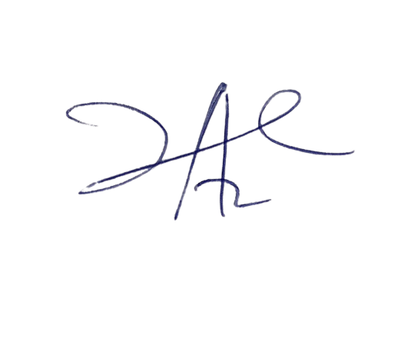

**22/2/2023**

**Head Instructor**