**LESSON PLAN AND NOTE 1 FOR WEEK 4 ENDING 17/5/2024**

**Term 3rd term**

**Week 4th week**

**Date 13/5/2024**

**Class Nursery One**

**Subject Letter Work**

**Topic Two letter words.**

**Sub-topic Define two letter words.**

**Period 4th period**

**Time 10:40 am**

**Duration 35 minutes**

**No in class 14**

**Average Age 3 years**

**Sex Mixed**

**Specific Objectives: By the end of the lesson, the pupils should be able to:**

1. **Define two letter words.**
2. **Name two letter words.**

**Rationale: To ensure the pupils define & name two letter words.**

**Previous Knowledge: The pupils can copy words with letter Rr-Zz.**

**Instructional Resources: Two letter words chart, Online research.**

**Reference Material: Online research, chart.**

**LESSON PRESENTATION**

|  |  |  |  |
| --- | --- | --- | --- |
| **Steps** | **Teacher’s Activities** | **Pupils’ Activities** | **Learning Points** |
| **Introduction** | **The teacher introduces the lesson by reading two letter words from two letter words chart.** | **The pupils listen to the teacher.** | **To arouse the interest of the pupils.** |
| **Step 1** | **The teacher starts the lesson by defining two letter words as “words that has two alphabet letters”.** | **The pupils repeat after the teacher the meaning of two letter words.** | **For proper understanding of the pupils.** |
| **Step 2** | **The teacher name two letter words for the pupils**  **on it**  **as at**  **an is**  **up am** | **The pupils repeat after and name the two letter words**  **it,**  **is,**  **up,**  **as,**  **at,**  **an, etc.** | **For better understanding.** |
| **Summary** | **The teacher summarizes the lesson by asking the pupils to define and name random two letter words.** | **The pupils respond to the teacher actively.** | **For onward study.** |
| **Evaluation** | **Question:**  **Define Two letter words?**  **Name (3) two letter words you know?** | **The pupils answer the question correctly.** | **To ascertain the pupils’ understanding.** |
| **Conclusion** | **The teacher reacts & summarizes the lesson to the pupils.** | **The pupils gives answer to the teacher’s question.** | **To consolidate the lesson.** |
| **Assignment** | **Question:**  **Define Two letter words?**  **Name (3) two letter words you know?** | **The pupils copy and do their homework at home.** | **To encourage learning while at home.** |

**LESSON PLAN AND NOTE 2 FOR WEEK 4 ENDING 26/5/2023**

**Term 3rd term**

**Week 4th week**

**Date 26/5/2023**

**Class Nursery One**

**Subject Letter Work**

**Topic Two letter words.**

**Sub-topic Identifying two letter words.**

**Period 4th period**

**Time 10:40 am**

**Duration 35 minutes**

**No in class 18**

**Average Age 3 years**

**Sex Mixed**

**Specific Objectives: By the end of the lesson, the pupils should be able to:**

1. **Identify two letter words.**
2. **Spell two letter words.**

**Rationale: To ensure the pupils identify & spell two letter words.**

**Previous Knowledge: The pupils can define & name two letter words.**

**Instructional Resources: Two letter words chart, Online research.**

**Reference Material: Online research, chart.**

**LESSON PRESENTATION**

|  |  |  |  |
| --- | --- | --- | --- |
| **Steps** | **Teacher’s Activities** | **Pupils’ Activities** | **Learning Points** |
| **Introduction** | **The teacher introduces the lesson by reading two letter words from two letter words chart.** | **The pupils listen to the teacher.** | **To arouse the interest of the pupils.** |
| **Step 1** | **The teacher leads the pupils to identify two letter words.**  **on it**  **as at**  **an is**  **up am** | **The pupils identify the two letter words.** | **For proper understanding of the pupils.** |
| **Step 2** | **The teacher leads the pupils to spell the two letter words it, is, up, as, at, an etc.** | **The pupils spell the two letter words it, is, up, as, at, an etc.** | **For better understanding.** |
| **Summary** | **The teacher summarizes the lesson by asking the pupils to identify random two letter words.** | **The pupils respond to**  **the teacher actively.** | **For onward study.** |
| **Evaluation** | **Question:**  **Identify (3) two letter words you know?**  **Spell this two letter word “us”?** | **The pupils answer the question correctly.** | **To ascertain the pupils’ understanding.** |
| **Conclusion** | **The teacher reacts & summarizes the lesson to the pupils.** | **The pupils gives answer to the teacher’s question.** | **To consolidate the lesson.** |
| **Assignment** | **Question:**  **Identify (3) two letter words you know?**  **Spell this two letter word “by”?** | **The pupils copy and do their home-work at home.** | **To encourage learning while at home.** |

**LESSON PLAN AND NOTE 3 FOR WEEK 4 ENDING 26/5/2023**

**Term 3rd term**

**Week 4th week**

**Date 26/5/2023**

**Class Nursery One**

**Subject Letter Work**

**Topic Two letter words.**

**Sub-topic Match two letter words.**

**Period 4th period**

**Time 10:40 am**

**Duration 35 minutes**

**No in class 18**

**Average Age 3 years**

**Sex Mixed**

**Specific Objectives: By the end of the lesson, the pupils should be able to:**

1. **Match two letter words.**
2. **Write two letter words.**

**Rationale: To ensure the pupils match & write two letter words.**

**Previous Knowledge: The pupils can identify & spell two letter words.**

**Instructional Resources: Two letter words chart, Online research.**

**Reference Material: Online research, chart.**

**LESSON PRESENTATION**

|  |  |  |  |
| --- | --- | --- | --- |
| **Steps** | **Teacher’s Activities** | **Pupils’ Activities** | **Learning Points** |
| **Introduction** | **The teacher introduces the lesson by reading two letter words from two letter words chart.** | **The pupils listen to the teacher.** | **To arouse the interest of the pupils.** |
| **Step 1** | **The teacher leads the pupils to match two letter words.**  **on up**  **up it**    **it on** | **The pupils match the two letter words.**  **on up**  **up it**    **it on** | **For proper understanding of the pupils.** |
| **Step 2** | **The teacher guides the pupils to write the two letter words it, is, up, as, at, an etc inside their notebook.**   |  |  | | --- | --- | | **it** | **as** | |  |  | | **up** | **on** | |  |  | | **The pupils write two letter words inside their notebook** | **For better understanding.** |
| **Summary** | **The teacher summarizes the lesson by naming random two letter words to the pupils.** | **The pupils understand the lesson actively.** | **For onward study.** |
| **Evaluation** | **Question:**  **Match the two letter words below?**  **on up**  **up it**    **it on**  **Write the two letter words below?**   |  |  | | --- | --- | | **it** | **as** | |  |  | | **up** | **on** | |  |  | | **The pupils answer the question correctly.** | **To ascertain the pupils’ understanding.** |
| **Conclusion** | **The teacher reacts & summarizes the lesson to the pupils.** | **The pupils gives answer to the teacher’s question.** | **To consolidate the lesson.** |
| **Assignment** | **Question:**  **Match the two letter words below?**  **on up**  **up it**    **it on**  **Write the two letter words below?**   |  |  | | --- | --- | | **it** | **as** | |  |  | | **up** | **on** | |  |  | | **The pupils copy and do their home-work at home.** | **To encourage learning while at home.** |

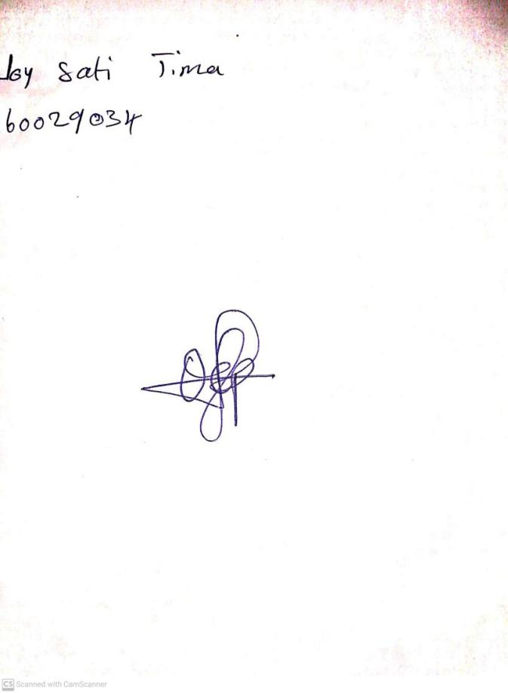

10th May, 2024

Perpetual Ojoma Ocheja

Stream Head Nursery