**EMERALD ROYAL INTERNATIONAL SCHOOL**

**MPAPE, ABUJA.**

**LESSON PLAN AND NOTE FOR WEEK 8 PERIOD 1 ENDING 14/06/2024**

**TERM: 3RD**

**WEEK: 8TH**

**DATE: 10/06/2024**

**CLASS: NURSERY 2**

**SUBJECT: NUMBERWORK**

**TOPIC: NUMBERS IN WORDS 11-20 .**

**SUB-TOPIC: RECITING AND WRITING OF NUMBERS 11-15**

**PERIOD: 1ST**

**TIME: O8:50-09:30.**

**DURATION: 40 MINUTES.**

**NUMBER IN CLASS: 13**

**AVERAGE AGE: 5 YEARS.**

**SEX: MIXED.**

**SPECIFIC OBJECTIVES: BY THE END OF THE LESSON,THE PUPILS SHOULD BE**

**ABLE TO:**

1. **RECITE NUMBERS IN WORDS 11-15**
2. **IDENTIFY AND READ NUMBERS IN WORDS 11-15**

**RATIONALE: FOR PUPILS TO KNOW NUMBERS IN WORDS 11-15**

**PREVIOU KNOWLEDGE: PUPILS HAVE LEARNT NUMBERS IN WORDS 1-10 PREVIOUS LESS0N.**

**INSTRUCTIONAL MATERIALS: A CHART OF NUMBERS IN WORDS 11-15 .**

**REFERENCE MATERIALS: THE NEW MASTERING MATHEMATICS FOR NURSERY SCHOOLSBOOK 3 BY HENRY.Z.IDOGUN.**

**LESSON DEVELOPMENT**

|  |  |  |  |
| --- | --- | --- | --- |
| **STAGES/STEPS** | **TEACHER’S ACTIVITIES** | **PUPILS’ ACTIVITIES** | **LEARNING POINTS** |
| **INTRODUCTION** | **Teacher introduces the lesson by reviewing the previous lesson.** | **Pupil listen to the teacher.** | **To arouse pupils interest for the lesson ahead.** |
| **PRESENTATION**  **STEP 1** | **Teacher recites numbers 11-15 and then asks pupils to repeat after her.** | **Pupils listen attentively to the teacher and repeat after her.** | **For proper understanding of the lesson .** |
| **STEP 2** | **Teacher writes numbers 11-15 in words on the board and then recite and also asks pupils to identify and repeat after her.** | **Pupils pay attention to the board and repeat after the teacher.** | **For better understanding of the lesson.** |
| **BOARD SUMMARY** | **Teacher summarizes the lesson by writing the whole note of lesson on the board for pupils to copy into their books. That is,**  **NUMBERS IN WORDS 11-15**  **Eleven 11**  **Twelve 12**  **Thirteen 13**  **Fourteen 14**  **Fifteen 15** | **Pupils copy the note into their exercise books.** | **For onward study.** |
| **EVALUATION** | **Teacher asks Pupils to identify and recite the number in words 11-15 on the board one after the other.** | **Pupils identify and recite the number in words 11-15 on the board one after another.** | **To assess pupils understanding of the lesson.** |
| **CONCLUSION** | **Teacher marks pupils books.** | **Pupils submit their books for marking.** | **For endorsement.** |
| **ASSIGNMENT** | **Identify, recite and write numbers 16-20 in words** | **Pupils do their assignment at home.** | **To encourage learning at home.** |

**LESSON PLAN AND NOTE FOR WEEK 8 PERIOD 2 ENDING 14/06/2024**

**TERM: 3RD**

**WEEK: 8TH**

**DATE: 11/06/2024**

**CLASS: NURSERY 2**

**SUBJECT: NUMBER WORK**

**TOPIC: NUMBERS IN WORDS 11-20 .**

**SUB-TOPIC: IDENTIFY, RECITE AND WRITE NUMBERS IN WORDS 16- 20**

**PERIOD: 2nd**

**TIME: O8:50-09:30.**

**DURATION: 40 MINUTES.**

**NUMBER IN CLASS: 13**

**AVERAGE AGE: 5 YEARS.**

**SEX: MIXED.**

**SPECIFIC OBJECTIVES: BY THE END OF THE LESSON,THE PUPILS SHOULD BE**

**ABLE TO:**

1. **RECITE NUMBERS IN WORDS 16-20**
2. **IDENTIFY AND READ NUMBERS IN WORDS 16-20**

**RATIONALE: FOR PUPILS TO KNOW NUMBERS IN WORDS 16-20 .**

**PREVIOU KNOWLEDGE: PUPILS HAVE LEARNT NUMBERS IN WORDS 11-15 IN PREVIOUS LESS0N.**

**INSTRUCTIONAL MATERIALS: A CHART OF NUMBERS IN WORDS 16- 20 .**

**REFERENCE MATERIALS: THE NEW MASTERING MATHEMATICS FOR NURSERY SCHOOLSBOOK 3 BY HENRY.Z.IDOGUN.**

**LESSON DEVELOPMENT**

|  |  |  |  |
| --- | --- | --- | --- |
| **STAGES/STEPS** | **TEACHER’S ACTIVITIES** | **PUPILS’ ACTIVITIES** | **LEARNING POINTS** |
| **INTRODUCTION** | **Teacher introduces the lesson by asking pupils to all stand and recite numbers in words 11- 15.** | **Pupil all stand and recite numbers in words 11-15** | **To prepare pupils minds for the lesson ahead.** |
| **PRESENTATION**  **STEP 1** | **Teacher presents the lesson by reciting numbers in words 16-20 and then asks pupils to repeat after.** | **Pupils pay attention to the teacher and the repeat after her.** | **For proper understanding of the lesson .** |
| **STEP 2** | **Teacher writes numbers in words 16-20 on the board and then read and also asks pupils to repeat after her.** | **Pupils pay attention to the teacher and repeat after her.** | **For better understanding of the lesson.** |
| **BOARD SUMMARY** | **Teacher summarizes the lesson by writing the whole note of lesson on the board for pupils to copy into their books .That is,**  **NUMERS IN WORDS 16-20**  **SIXTEEN 16**  **SEVENTEEN 17**  **EIGHTEEN 18**  **NINTEEN 19**  **TWENTY 20** | **Pupils copy the note into their exercise books.** | **For onwardstudy.** |
| **EVALUATION** | **Teacher asks Pupils to all stand and recite number in words 16-20 on the board all together.** | **Pupils all stand and recite the numbers 16-20 in words on the board all together.** | **To create platform for slow learners.** |
| **CONCLUSION** | **Teacher marks pupils books.** | **Pupils submit their books for marking.** | **For endorsement.** |
| **ASSIGNMENT** | **Identify, recite and write numbers in words 11-20.** | **Pupils do their assignment at home.** | **To encourage learning at home.** |

**LESSON PLAN AND NOTE FOR WEEK 8 PERIOD 3 ENDING 14/06/2024**

**TERM: 3RD**

**WEEK: 8TH**

**DATE: 14/06/2024**

**CLASS: NURSERY 2**

**SUBJECT: NUMBER WORK**

**TOPIC: NUMBERS IN WORDS 11-20 .**

**SUB-TOPIC: IDENTIFY,READ AND WRITE NUMBER IN WORDS 11-20**

**PERIOD: 3RD**

**TIME: 08:10- 08:50am**

**DURATION: 40 MINUTES.**

**NUMBER IN CLASS: 13**

**AVERAGE AGE: 5 YEARS.**

**SEX: MIXED.**

**SPECIFIC OBJECTIVES: BY THE END OF THE LESSON,THE PUPILS SHOULD BE**

**ABLE TO:**

**1. READ NUMBERS IN WORDS 11-20 ORALLY**

**2. WRITE NUMBERS IN WORDS 11-20**

**RATIONALE: FOR PUPILS TO BE COVERSANT WITH NUMBERS IN**

**WORDS 1-10.**

**PREVIOU KNOWLEDGE: PUPILS HAVE LEARNT NUMBERS IN WORDS 11- 20**

**INSTRUCTIONAL MATERIALS: NUMBER CHART IN WORDS 11-20 .**

**REFERENCE MATERIALS: THE NEW MASTERING MATHEMATICS FOR NURSERY**

**SCHOOLS BOOK 3 BY J.M OMOGBAI.**

**LESSON DEVELOPMENT**

|  |  |  |  |
| --- | --- | --- | --- |
| **STAGES/STEPS** | **TEACHER’S ACTIVITIES** | **PUPILS’ ACTIVITIES** | **LEARNING POINTS** |
| **INTRODUCTION** | **Teacher introduces the lesson by singing nursery numbers rhymes .That**  **1little, 2little, 3little fingers**  **4little, 5little,6little fingers………** | **Pupils sing the rhymes along with the teacher.** | **To arouse pupils interest for the lesson ahead.** |
| **PRESENTATION**  **STEP 1** | **Teacher presents the lesson by writing numbers in words 11-20 on the board and then recites and then asks pupils to repeat after her.** | **Pupils listen to the teacher and repeat after her.** | **For proper understanding of the lesson .** |
| **STEP 2** | **Teacher guides pupils to recite numbers in words 11-20 often and often.** | **Pupils recite numbers 11-20 in words often and often.** | **For better understanding of the lesson.** |
| **BOARD SUMMARY** | **Teacher summarizes the lesson by preparing pupils books for them to copy the note on the board.ie,**  **NUMBERS IN WORDS 11-20..**  **Eleven 11**  **Twelve 12**  **Thirteen 13**  **Fourteen 14**  **Fifteen 15**  **Sixteen 16**  **Seventeen 17**  **Eighteen 18**  **Nineteen 19**  **Twenty 20** | **Pupils copy the note into their exercise books.** | **For onwardstudy.** |
| **EVALUATION** | **Teacher evaluates the lesson by asking pupils to all stand and recite numbers in words 11-20 on the board all together.** | **Pupils all stand and recite numbers 11-20 in words on the board all together.** | **To create platform for slow learners.** |
| **CONCLUSION** | **Teacher concludes the lesson by marking pupils notes .** | **Pupils submit their books for marking.** | **For endorsement.** |
| **ASSIGNMENT** | **Practice and write numbers in words 1-20** | **Pupils do their assignment at home.** | **To encourage learning at home.** |

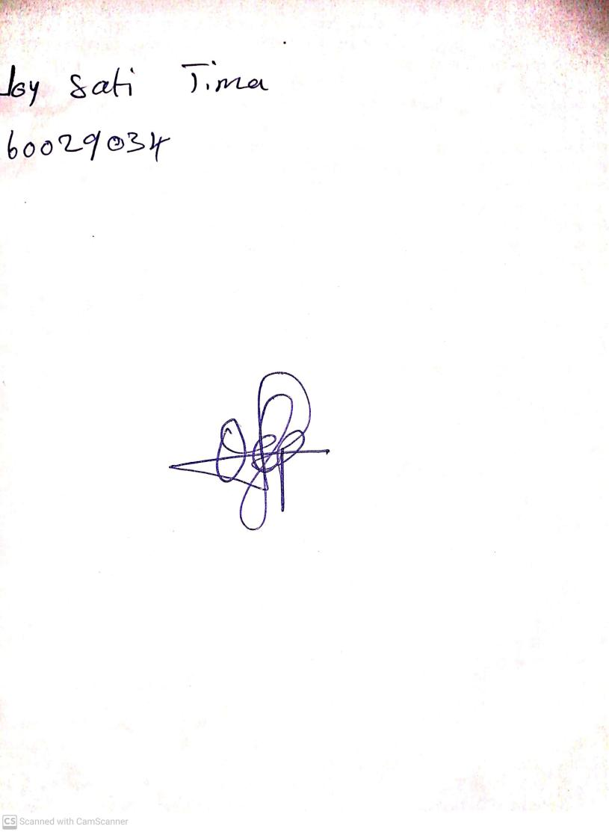

**7th June, 2024**

**Perpetual Ojoma Ocheja**

**Stream Head Nursery**