EMERALD ROYAL INTERNATIONAL SCHOOL

MPAPE, ABUJA.

LESSON PLAN AND NOTE 1 FOR WEEK 1 ENDING 15TH SEPTEMBER, 2023.

SUBJECT: Letter work

TOPIC: Alphabets.

SUB-TOPIC: Learning letters A-E

DATE: 12/9/2023.

DURATION: 40 minutes.

TIME: 08:50--09:30.

PERIOD: 2nd

CLASS: Pre-nursery

NUMBER OF PUPILS: 14

AVERAGE AGE: 2 YEARS

SEX: Mixed.

SPECIFIC OBJECTIVES: By the end of the lesson, the pupils should be able to:-

1. Identify letters A-E.
2. Trace letters A-E.

RATIONALE: For pupils to be able to identify letters.

PREVIOUS KNOWLEDGE: Pupils may have been singing ABC'S song unknown to them that they are singing the letters of the alphabet.

INSTRUCTIONAL MATERIALS: Flash cards, chart.

REFERENCE:Mastering English for nursery schools book 1 by J.M.Omogbai.

LESSON DEVELOPMENT

|  |  |  |  |
| --- | --- | --- | --- |
| STAGES/STEPS | TEACHER’S ACTIVITIES | PUPILS’ ACTIVITIES | LEARNING POINTS |
| INTRODUCTION | Teacher introduces the lesson by singing ABC'S song for the pupils. | Pupils listen attentively to the teacher and try to emulate the teacher to sing. | To arouse the interest of the pupils for the lesson. |
| PRESENTATION  STEP 1 | Teacher presents flash cards that has letters A-E to the pupils. Teacher displays the flash cards on the table and points at them and read as thus:-  A B C D E .  The teacher also asks the pupils to repeat after her. | Pupils watch the teacher as she display the flash cards on the table. Pupils point at them and repeat after the teacher. | For better understanding of the lesson . |
| STEP2 | Teacher prepares the pupils books for them to trace letters A - E. | Pupils trace letter A - E inside their books. | To improve pupils psychomotive skills. |
| SUMMARY | Teacher summarizes the lesson by reading the letters again for proper understanding.  A B C D E. | Pupils listen very attentively to the teacher | For more understanding of the lesson. |
| EVALUATION | Teacher asks the pupils to identify letters A - E amongst other letters. | Pupils answer the teacher’s question. | To assess the level of pupils understanding of the lesson. |
| CONCLUSION | Teacher marks the pupils books and make corrections where necessary. | Pupils submit their books for marking and corrections . | For onwards study. |
| ASSIGNMENT | Teacher asks the pupils to trace letters A - E at home. | Pupils do their Home work at home. | To ensure learning takes place at home. |

LESSON PLAN AND NOTE 2 FOR WEEK 1 ENDING 15TH SEPTEMBER, 2023.

SUBJECT: Letter work

TOPIC: Alphabet.

SUB-TOPIC: Learning letters A-E.

DATE: 12/9/2023.

DURATION: 40 minutes.

TIME: 08:50--09:30.

PERIOD: 2nd

CLASS: Pre-nursery

NUMBER OF PUPILS: 14

AVERAGE AGE: 2 YEARS

SEX: Mixed.

SPECIFIC OBJECTIVES: By the end of the lesson, the pupils should be able to:-

1. Identify letters A -E .
2. Re-write letter A-E.

RATIONALE: For pupils to be able to identify letters.

PREVIOUS KNOWLEDGE: Pupils have been taught letters A-E.

INSTRUCTIONAL MATERIALS: Flash cards, and chart.

REFERENCE:Mastering English for nursery schools book 1 by J.M.Omogbai.

LESSON DEVELOPMENT

|  |  |  |  |
| --- | --- | --- | --- |
| STAGES/STEPS | TEACHER’S ACTIVITIES | PUPILS’ ACTIVITIES | LEARNING POINTS |
| INTRODUCTION | Teacher introduces the lesson by singing a jolly phonics song for the pupils. | Pupils listen and sing along with the teacher. | To arouse the interest of the pupils for the lesson. |
| PRESENTATION  STEP 1 | Teacher models the pupils to point at the chart and say the letter name from letter A-E. | Pupils point at the letters on the chart and say the letter names.  A B C D E. | For better understanding of the lesson. |
| STEP2 | Teacher prepares the pupils books and guides them to re-write letter A-E.   |  |  |  |  |  | | --- | --- | --- | --- | --- | | A | B | C | D | E | |  |  |  |  |  | |  |  |  |  |  | |  |  |  |  |  | | Pupils re-write letter A-E as instructed by the teacher.   |  |  |  |  |  | | --- | --- | --- | --- | --- | | A | B | C | D | E | | A | B | C | D | E | | A | B | C | D | E | | A | B | C | D | E | | To improve pupils psychomotive skills. |
| SUMMARY | Teacher summarizes the lesson by touching the letters on the chart for the pupils to read and identify. | Pupils touch the letters on the chart one after another and say the letter name. | For more understanding of the lesson. |
| EVALUATION | Teacher randomly places flash cards of letters and asks the pupils to identify letters A-E . | Pupils identify the letters correctly. | To assess the level of pupils understanding of the lesson. |
| CONCLUSION | Teacher marks the pupils books and make corrections where necessary. | Pupils submit their books for marking and corrections . | For onwards study. |
| ASSIGNMENT | Teacher asks the pupils to identify and re-write letters A-E.   |  |  |  |  |  | | --- | --- | --- | --- | --- | | **A** | **B** | **C** | **D** | **E** | |  |  |  |  |  | |  |  |  |  |  | |  |  |  |  |  | | Pupils do their Home work at home. | To ensure learning takes place at home. |

LESSON PLAN AND NOTE 3 FOR WEEK 1 ENDING 15TH SEPTEMBER, 2023.

SUBJECT: Letter work

TOPIC: Alphabets

SUB-TOPIC: Identification and matching of letters A-E.

DATE: 15/9/2023.

DURATION: 40 minutes.

TIME: 08:50--09:30.

PERIOD: 2nd

CLASS: Pre-nursery

NUMBER OF PUPILS: 14

AVERAGE AGE: 2 YEARS

SEX: Mixed.

SPECIFIC OBJECTIVES: By the end of the lesson, the pupils should be able to:-

1. Identify letters A-E.
2. Match letters A - E correctly.

RATIONALE: For pupils to be able to identify letters.

PREVIOUS KNOWLEDGE: Pupils have been taught how to re-write letters A-E.

INSTRUCTIONAL MATERIALS: Flash cards and charts.

REFERENCE:Mastering English for nursery schools book 1 by J.M.Omogbai.

LESSON DEVELOPMENT

|  |  |  |  |
| --- | --- | --- | --- |
| STAGES/STEPS | TEACHER’S ACTIVITIES | PUPILS’ ACTIVITIES | LEARNING POINTS |
| INTRODUCTION | Teacher introduces the lesson by reviewing the last lesson on Alphabets. | Pupils listen as the teacher reviews the last lesson. | To arouse the interest of the pupils for the lesson. |
| PRESENTATION  STEP 1 | Teacher models the pupils to identify letter A-E randomly on the chart and circles them as it is on the first roll.  A C A D A  B B B O D  C A D C E  D D E F  E E F E B | Pupils identify the letters A-E randomly and circle them on the chart. | For proper recognition of letters. |
| STEP2 | Teacher prepares the pupils books for them to match letters A-E.  A E  B D    C B  D C    E A | Pupils match the letters correc tly.  A E  B D  C B  D C  E A | To improve pupils psychomotive skills. |
| SUMMARY | Teacher summarizes the lesson by showing the pupils the flash cards of letters A-E respectively for them to identify. | Pupils identify the letters shown by the teacher. | For more understanding of the lesson. |
| EVALUATION | Teacher calls out the pupils one after another to:-  1. identify letter E on a flash cards.  2. Match letters A-E on the board. | Pupils answer the teacher’s questions. | To assess the level of pupils understanding of the lesson. |
| CONCLUSION | Teacher marks the pupils books and make corrections where necessary. | Pupils submit their books for marking and corrections . | For onwards study. |
| ASSIGNMENT | Teacher asks the pupils to circle letters A-E randomly at home.    A C A D  B B O B  C D C E  D A E D  E B F E | Pupils do their Home work at home. | To ensure learning takes place at home. |

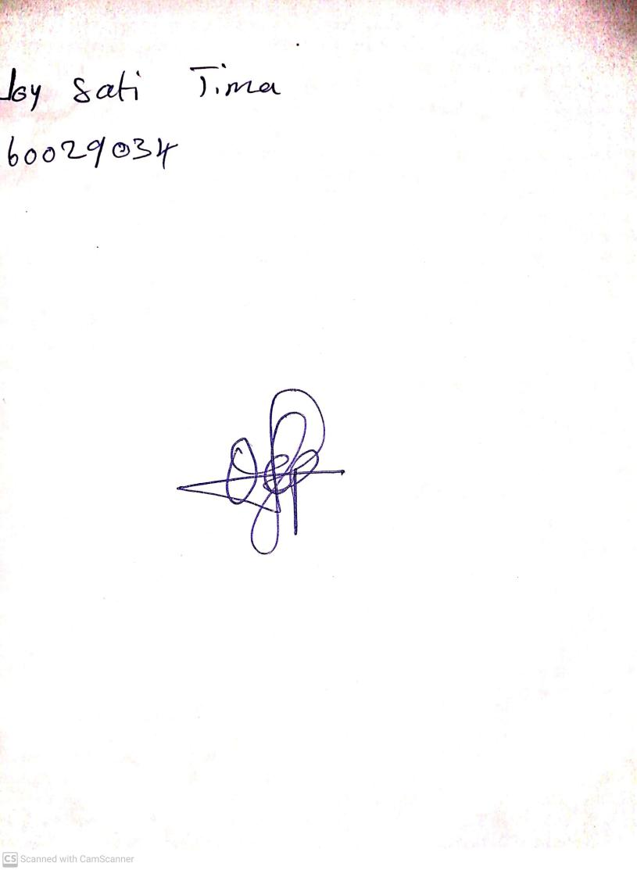

2ND OCTOBER, 2023

Perpetual Ojoma Ocheja

Stream Head Nursery

1. B: KINDLY CORRECT THE FOLLOWING

1.You should make your specific objectives three (3) in number, that is add

Why not spread the letters

Lesson plan and note 1

1. Identify letters A - B
2. Pronouce letters A - B
3. Colour letters A - B
4. Trace letters A - B
5. Match letters A - B

Lesson plan and note 2

1. Identify letters C - D
2. Pronouce letters C - D
3. Colour letters C - C
4. Trace letters C - D
5. Match letters C - D

Lesson plan and note 3

1. Identify letter E
2. Pronouce letter E
3. Colour letter E
4. Trace letter E
5. Match letter E