**EMERALD ROYAL INTERNATIONAL SCHOOL, MPAPE ABUJA**

**LESSON PLAN AND NOTE FOR WEEK 6 ENDING FRIDAY, 20TH OCTOBER, 2023**

**TERM:** FIRST TERM

**WEEK:** WEEK 6

**SUBJECT:** ENGLISH LANGUAGE (SPEECH)

**TOPIC:** RHYMES

**SUB-TOPIC:** A LITTLE BIRD

**DATE:** WEDNESDAY, 18TH OCTOBER, 2023

**TIME:** 02:00 – 02:20PM

**DURATION:** 30 MINUTES

**PERIOD:** 9TH

**CLASS:** NURSERY 3

**NUMBER IN CLASS:** ELEVEN

**AVERAGE AGE:** FIVE

**SEX:** MIXED

**LEARNING OBJECTIVES:** By the end of the lesson, the pupils should be able to

1. Recite the poem.
2. Identify the rhyming words in the poem.

**RATIONALE:** for pupils to learn how to recite the poem ‘A little bird’.

**PREVIOUS KNOWLEGDE:** pupils have learnt recite the poem ‘A boy and a girl’. **INSTRUCTIONAL MATERIALS:**

1. Textbook. Nigeria Primary English book 1

**REFERENCE MATERIALS:**

1. Nigeria Primary English book 1 by B. Someye, D Dallas etal 2000

**LESSON DEVELOPMENT**

|  |  |  |  |
| --- | --- | --- | --- |
| **STAGES/STEPS** | **TEACHER’S ACTIVITIES** | **PUPILS’ ACTIVITIES** | **LEARNING POINTS** |
| **INTRODUCTION** | Review previous knowledge. | Respond to the question. | Arouse the pupils interest. |
| **PRESENTATION**  **STEP 1** | Leads pupils to recite the poem ‘A little bird’  Once I saw a little bird  Come hop, hop, hop  So I cried, ‘little bird,  Will you stop. Stop, stop?’  As I was going to the window,  To say, ‘How do you do?’  But it shook its little tail,  And away it flew. | Listen and recite the poem along with the teacher. | For proper understanding. |
| **STEP 2** | Leads pupils to identify rhyming words from the poem.   1. Bird 2. Hop and stop 3. Window and do 4. Tail and flew | Identify the rhyming words. | For better understanding. |
| **SUMMARY** | Summarizes the lesson by emphasizing on the main concept and writes note on the board. | Listen and copy their notes | For onward study |
| **EVALUATION** | Ask pupils to:   1. Recite the poem ‘A little bird’. 2. Mention the rhyming words. | Respond to the teacher’s questions. | To test the understanding of the pupils of the lesson |
| **CONCLUSION** | Summarizes, correct and mark pupils’ notebooks. | Write the note on the board and submit their notebooks for marking | Clarifying the concept. |
| **HOME-WORK** | Write any poem of your choice. | Copy and return home with task | Extending lesson home. |

**LESSON PLAN AND NOTE FOR WEEK 6 ENDING FRIDAY, 20TH OCTOBER, 2023**

**TERM:** FIRST TERM

**WEEK:** WEEK 6

**SUBJECT:** ENGLISH LANGUAGE (GRAMMAR)

**TOPIC:** SINGULAR AND PLURAL

**SUB-TOPIC:** INDICATING SINGULAR AND PLURAL NOUNS

**DATE:** MONDAY, 16TH OCTOBER, 2023

**TIME:** 01:20PM – 02:00PM

**DURATION:** 30 MINUTES

**PERIOD:** 8TH

**CLASS:** NURSERY 3

**NUMBER IN CLASS:** ELEVEN

**AVERAGE AGE:** FIVE

**SEX:** MIXED

**LEARNING OBJECTIVES:** By the end of the lesson, the pupils should be able to

1. State the meaning of singular and plural.
2. Identify singular and plural nouns.

**RATIONALE:** for pupils to know how to write singular and plural nouns.

**PREVIOUS KNOWLEGDE:** pupils have learnt how to place a full stop appropriately in a sentence.

**INSTRUCTIONAL MATERIALS:**

1. Nigeria Primary English book 1

**REFERENCE MATERIALS:**

1. Nigeria Primary English book 1 by B. Someye, D Dallas etal 2000

**LESSON DEVELOPMENT**

|  |  |  |  |
| --- | --- | --- | --- |
| **STAGES/STEPS** | **TEACHER’S ACTIVITIES** | **PUPILS’ ACTIVITIES** | **LEARNING POINTS** |
| **INTRODUCTION** | Review previous knowledge. | Respond to the teacher. | Arouse the pupils interest. |
| **PRESENTATION**  **STEP 1** | Teaches pupils the meaning of singular and plural.  Singular means one while plural means more than one. To form the plural noun, ‘s’ is usually added to to singular nouns. | Listen attentively and learn. | For proper understanding. |
| **STEP 2** | Guides pupils to identify singular and plural nouns.  **Singular plural**   1. Cup Cups 2. Pencil pencils 3. Ruler rulers 4. Bag bags 5. Ball balls 6. Broom brooms 7. Bottle bottles 8. Plate plates 9. Book books 10. Shoe shoes | Listen attentively and learn. | For better understanding. |
| **SUMMARY** | Summarizes the lesson by emphasizing on the main concept and writes note on the board. | Listen and copy their notes | For onward study |
| **EVALUATION** | Ask pupils to:   1. Give the meaning of singular and plural. 2. Mention examples of singular nouns and their plural. | Respond to the teacher’s questions. | To test the understanding of the pupils of the lesson |
| **CONCLUSION** | Summarizes, correct and mark pupils’ notebooks. | Write the note on the board and submit their notebooks for marking | To consolidate the lesson. |
| **HOME-WORK** | Nigeria Primary English, book 1, page 40, exercise 2. | Return home with task | Extending lesson home. |

**LESSON PLAN AND NOTE FOR WEEK 6 ENDING FRIDAY, 20TH OCTOBER, 2023**

**TERM:** FIRST TERM

**WEEK:** WEEK 6

**SUBJECT:** ENGLISH LANGUAGE (COMPREHENSION)

**TOPIC:** READING

**SUB-TOPIC:** MY FAMILY

**DATE:** THURSDAY, 19TH OCTOBER, 2023

**TIME:** 09:25AM – 09:55AM

**DURATION:** 30 MINUTES

**PERIOD:** 3RD

**CLASS:** NURSERY 3

**NUMBER IN CLASS:** ELEVEN

**AVERAGE AGE:** FIVE

**SEX:** MIXED

**LEARNING OBJECTIVES:** By the end of the lesson, the pupils should be able to:

1. Read the passage carefully.
2. Pronounce difficult words.
3. Answer the questions bellow the passage.

**RATIONALE:** to improve the pupils reading skill and also learn about ‘my family’.

**PREVIOUS KNOWLEGDE:** pupils have learnt about reading passage ‘the game’.

**INSTRUCTIONAL MATERIALS:**

1. Nigeria Primary English book 1, fourth edition

**REFERENCE MATERIALS:**

1. Nigeria Primary English book 1 by B. Someye, D Dallas etal 2000

**LESSON DEVELOPMENT**

|  |  |  |  |
| --- | --- | --- | --- |
| **STAGES/STEPS** | **TEACHER’S ACTIVITIES** | **PUPILS’ ACTIVITIES** | **LEARNING POINTS** |
| **INTRODUCTION** | Review previous knowledge | Respond to the teacher instructions. | Arouse the pupils interest. |
| **PRESENTATION**  **STEP 1** | Lead pupils to read the passage ‘my family’.  I belong to a great Ojekunle family of Ilorin. We are five in my family: my father, my mother and three children. I am the last child of my family.my elder brother is in primary 5. my elder sister is in primary 3………….. | Read the passage together with the teacher. | For proper understanding. |
| **STEP 2** | Guides pupils to pronounce difficult words in the passage.  **Words from the passage**   1. Great 2. Children 3. Family 4. Elder 5. Primary 6. Sergeant 7. Pretty 8. Discipline 9. Complexion 10. Hardworking | Spell and pronounce difficult words in the passage. | For better understanding. |
| **STEP 3** | Ask pupils questions based on the passage.   1. I am from _____ family. 2. We are ________ in my family. 3. My mother is a ____ woman. | Answer the questions. | For further understanding. |
| **SUMMARY** | Summarizes the lesson by emphasizing on the main concept and writes note on the board. | Listen and copy their notes | For onward study |
| **EVALUATION** | Ask pupils to:   1. Read the passage carefully. 2. Pronounce difficult words. 3. Answer the question from the passage. | Respond to the teacher’s questions. | To test the understanding of the pupils of the lesson |
| **CONCLUSION** | Summarizes, correct and mark pupils’ notebooks. | Write the note on the board and submit their notebooks for marking | Clarifying the concept. |
| **HOME-WORK** | Nigeria Primary English. Book 1, page 38, exercise 1 and 2. | Return home with task | Extending lesson home. |

**LESSON PLAN AND NOTE FOR WEEK 6 ENDING FRIDAY, 20TH OCTOBER, 2023**

**TERM:** FIRST TERM

**WEEK:** WEEK 6

**SUBJECT:** ENGLISH LANGUAGE (COMPOSITION)

**TOPIC:** LETTERS OF THE ALPHABET

**SUB-TOPIC:** WRITING OF LETTERS OF THE ALPHABET

**DATE:** THURSDAY, 19TH OCTOBER, 2023

**TIME:** 11:10AM – 11:50AM

**DURATION:** 30 MINUTES

**PERIOD:** 5TH

**CLASS:** NURSERY 3

**NUMBER IN CLASS:** ELEVEN

**AVERAGE AGE:** FIVE

**SEX:** MIXED

**LEARNING OBJECTIVES:** By the end of the lesson, the pupils should be able to

1. Identify letters i - l.
2. Write letters i - l.

**RATIONALE:** for pupils to know how to identify and write letters i - l.

**PREVIOUS KNOWLEGDE:** pupils have learnt about my best food.

**INSTRUCTIONAL MATERIALS:**

1. Textbook- Nigeria Primary English book 1
2. Letter chart
3. Flash cards

**REFERENCE MATERIALS:**

1. Nigeria Primary English book 1 by B. Someye, D Dallas etal 2000

**LESSON DEVELOPMENT**

|  |  |  |  |
| --- | --- | --- | --- |
| **STAGES/STEPS** | **TEACHER’S ACTIVITIES** | **PUPILS’ ACTIVITIES** | **LEARNING POINTS** |
| **INTRODUCTION** | Review previous knowledge. | Respond to the teacher. | Arouse the pupils interest. |
| **PRESENTATION**  **STEP 1** | Leads pupils to identify letters i - l.  i j k l | Identify letters i - l. | For proper understanding. |
| **STEP 2** | Leads pupils to write letters i - l.  i j k l | Write letters i -l. | For better understanding. |
| **SUMMARY** | Summarizes the lesson by emphasizing on the main concept and writes note on the board. | Listen and copy their notes | For onward study |
| **EVALUATION** | Ask pupils to:   1. Identify letters i - l Form the flash cards. | Respond to the teacher’s questions. | To test the understanding of the pupils of the lesson |
| **CONCLUSION** | Summarizes, correct and mark pupils’ notebooks. | Write the note on the board and submit their notebooks for marking | Clarifying the concept. |
| **HOME-WORK** | 1. New general mathematics book 1, page 41. | Return home with task | Extending lesson home. |

**LESSON PLAN AND NOTE FOR WEEK 6 ENDING FRIDAY, 20TH OCTOBER, 2023**

**TERM:** FIRST TERM

**WEEK:** WEEK 6

**SUBJECT:** ENGLISH LANGUAGE (PHONICS)

**TOPIC:** SOUND BANK

**SUB-TOPIC:** WORDS WITH THE SOUNDS /^/ AND /e/

**DATE:** TUESDAY, 17TH OCTOBER, 2023

**TIME:** 10:30AM – 11:10AM

**DURATION:** 30 MINUTES

**PERIOD:** 4TH

**CLASS:** NURSERY 3

**NUMBER IN CLASS:** ELEVEN

**AVERAGE AGE:** FIVE

**SEX:** MIXED

**LEARNING OBJECTIVES:** By the end of the lesson, the pupils should be able to

1. Identify the sounds /^/ and /e/.
2. Pronounce the sounds /^/ and /e/..
3. Mention words with the sounds /^/ and /e/..

**RATIONALE:** for pupils to identify and pronounce the sounds /^/ and /e/.

1. **PREVIOUS KNOWLEGDE:** pupils have learnt about the sounds /Ə/ and /Ȝ:/

**INSTRUCTIONAL MATERIALS:**

1. Flash cards.
2. Pictorial charts.

**REFERENCE MATERIALS:**

1. Nigeria Primary English book 1 by B. Someye, D Dallas etal 2000

**LESSON DEVELOPMENT**

|  |  |  |  |
| --- | --- | --- | --- |
| **STAGES/STEPS** | **TEACHER’S ACTIVITIES** | **PUPILS’ ACTIVITIES** | **LEARNING POINTS** |
| **INTRODUCTION** | Display flash cards on a flat surface with words with the sounds /^/ and /e/. | Focus on the flash cards to identify words with the sounds /^/ and /e/. | Arouse the pupils interest. |
| **PRESENTATION**  **STEP 1** | Leads pupils to identify the sounds /^/ and /e/ on the flash cards and in the textbook.  **/^/ /e/** | Learn attentively. | For proper understanding. |
| **STEP 2** | Teaches pupils how to pronounce the sounds /^/ and /e/.  The sound /^/ is a short vowel sound. To say /^/, the sides of the the tongue lightly touch the bottom teeth.  The sound /e/ is a mild front vowel. When saying the sound, the tongue is position at the middle height in the mouth. | Learn carefully. | For better understanding. |
| **STEP 3** | Teaches pupils word with the sounds /^/ and /e/.  /^/ /e/   1. up yes 2. cup help 3. cutlass friend 4. does web 5. young bread 6. flood very 7. sun elephant 8. come ten 9. bus any 10. son said | Learn attentively. | For further understanding. |
| **SUMMARY** | Summarizes the lesson by emphasizing on the main concept and writes note on the board. | Listen and copy their notes | For onward study |
| **EVALUATION** | Ask pupils to:   1. Identify the sounds /^/ and /e/. 2. Pronounce the sounds /^/ and /e/ . 3. Mention words with the sounds /^/ and /e/. | Respond to the teacher’s questions. | To test the understanding of the pupils of the lesson |
| **CONCLUSION** | Summarizes, correct and mark pupils’ notebooks. | Write the note on the board and submit their notebooks for marking | Clarifying the concept. |
| **HOME-WORK** | Nigeria Primary English work book 1, page 11. | Return home with task | Extending lesson home. |

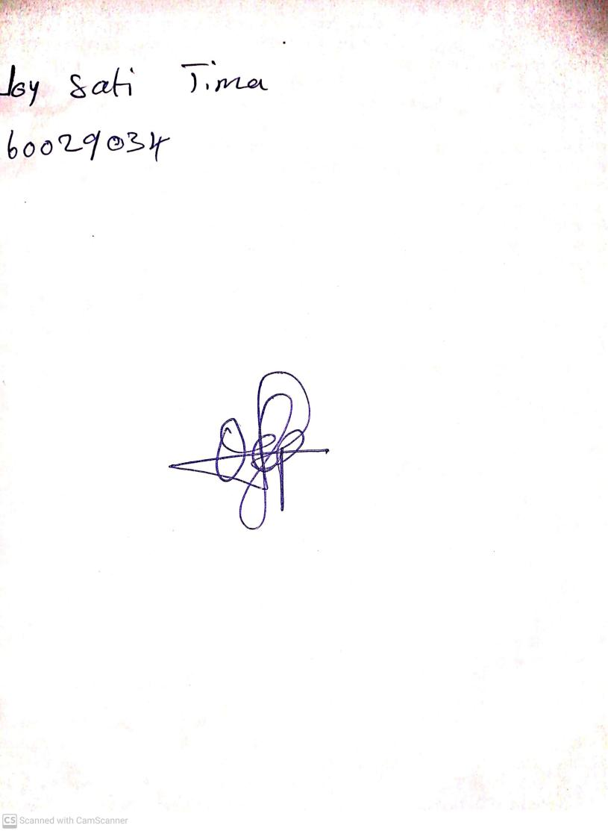

13TH October, 2023

Perpetual Ojoma Ocheja

Stream Head Nursery