EMERALD ROYAL INTERNATIONAL SCHOOL

MPAPE, ABUJA.

LESSON NOTE FOR WEEK 8 ENDING 1ST MARCH,2024.

SUBJECT: social norms.

TOPIC: Playing together.

SUB-TOPIC: Learning to be friendly and taking turns.

DATE 1/3/2024.

DURATION: 40 minutes.

TIME: 08:10--08:50.

PERIOD: 1st.

CLASS: Pre-nursery.

NUMBER OF PUPILS: 19

AVERAGE AGE: 2years

SEX: Mixed

SPECIFIC OBJECTIVES: By the end of the lesson, the pupils should be able to:-

1. Exhibit a friendly attitude towards one another.
2. Learn to take turns when playing with building blocks.

RATIONALE:- For Pupils to learn how to be social and friendly.

PREVIOUS KNOWLEDGE: Pupils have been playing with their friends on the playing ground.

INSTRUCTIONAL MATERIALS: Building blocks.

REFERENCE: Smart start Civic Education for Nursery schools book 1 by T Y.Alabi and A.M.Solu.

LESSON DEVELOPMENT

|  |  |  |  |
| --- | --- | --- | --- |
| Stages/steps | Teacher's activities | Pupils' activities | Learning points. |
| Introduction | Teacher introduces the lesson by singing a familiar rhyme for the Pupils . | Pupils sing the rhyme along with the teacher . | To arouse the interest for the lesson. |
| Presentation  Step 1 | Teacher takes the Pupils outdoor to play with building blocks in the play ground. During the cause of the play , teacher explains to the Pupils that it is very important to play together as friends and have fun. | Pupils play the outdoor activities together with their friends. | To improve Pupils psychomotive skills and for them to be happy. |
| Step 2 | During the outdoor activities, teacher encourages the pupils to take turns while playing on the slide and swing. | Pupils play and also take turns on the slide and swing. | To enhance Pupils groose motor skills. |
| Summary | Teacher summarizes the lesson by singing this rhyme:- "I love you, you love me, we are happy family with a great big hug and a kiss from me to you, won't you say you love me too." | Pupils sing the rhyme along with the teacher and hug each other. | To encourage Pupils to be social. |
| Evaluation | Teacher puts building blocks on the mat and watch from afar to see how Pupils will relates to each other. | Pupils play with the building blocks and relate with each other very well. | To ascertain Pupils understanding of the lesson. |
| Conclusion | Teacher concludes the lesson by encouraging the Pupils to always relates to each other. | Pupils listen to the teacher's advise. | To inculcate in the Pupils good social behavior. |
| Assignment | Teacher asks the Pupils to make new friends and mention the names of their friends verbally. | Pupils practice to play with their friends at home. | To encourage cordial relationship with others. |

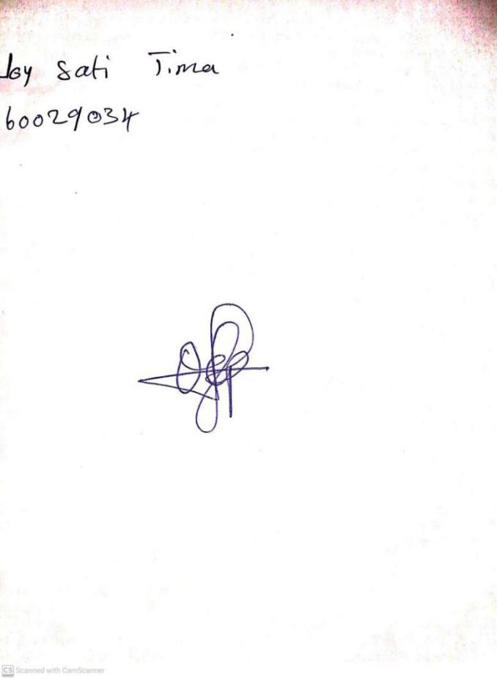

**23RD FEBRUARY, 2024**

**Perpetual Ojoma Ocheja**

**Stream Head Nursery**