**EMERALD ROYAL INTERNATIONAL SCHOOL**

**MPAPE, ABUJA.**

**LESSON PLAN AND NOTE FOR WEEK 3 ENDING 29TH SEPTEMBER,2023**

TERM : First term.

WEEK : 3

SUBJECT: Social Norms

TOPIC: The family.

SUB-TOPIC: Meaning and members of the family.

DATE: 27/8/2023

DURATION: 40 minutes

TIME: 10:40-11:20

PERIOD: 5th

CLASS: pre-nursery

NUMBER OF PUPILS:

AVERAGE AGE: 2

SEX: Mixed

SPECIFIC OBJECTIVES: By the end of the lesson, the pupils should be able to:-

1. Define a family.

2. Mention the members of the family.

RATIONALE: For pupils to know the meaning of family and the people that made up the family. about themselves.

PREVIOUS KNOWLEDGE: Pupils came from a family that comprises father, and mother .

INSTRUCTIONAL MATERIALS: chart.

REFERENCE: Smart start Civic education for nursery Schools book 1 by T.Y. Alabi and A. M. Solu.

LESSON DEVELOPMENT

|  |  |  |  |
| --- | --- | --- | --- |
| Stages/steps | Teacher's activities | Pupils' activities | Learning points |
| Introduction | Teacher introduces the lesson by singing nursery rhymes for the pupils as:-  Daddy daddy daddy  Mummy mummy mummy  Mummy is good and  Daddy is great  If not for them I will not be in school  When I grow up  I will take care of them. | Pupils attempt to sing the rhymes along with the teacher. | To get pupils attention for the lesson. |
| Presentation  Step 1 | Teacher defines family as:-  " Family is a group of people who are related by blood." | Pupils pay attention to the teacher's definition and repeat after her. | To improve better understanding. |
| Step 2 | Teacher leads the pupils to mention the people they see in their homes as members of the family. | Pupils mention the members of their family as:-   1. Daddy. 2. Mummy 3. Children. | For better understanding of the lesson. |
| Summary | Teacher summarizes the lesson by emphasizing on the topic again for more clarification and better understanding of the lesson. | Pupils pay attention to the teacher's explanation. | To ensure better understanding of the lesson. |
| Evaluation | Teacher asks the pupils to:-   1. Define family. 2. Mention two members of the family. | Pupils answer the teacher's question correctly. | To assess pupils level of understanding of the lesson. |
| Conclusion | Teacher ends the lesson by singing a nursery rhyme that was sang at the introduction of the lesson. | Pupils sing the rhyme along with the teacher. | To consolidate the lesson. |

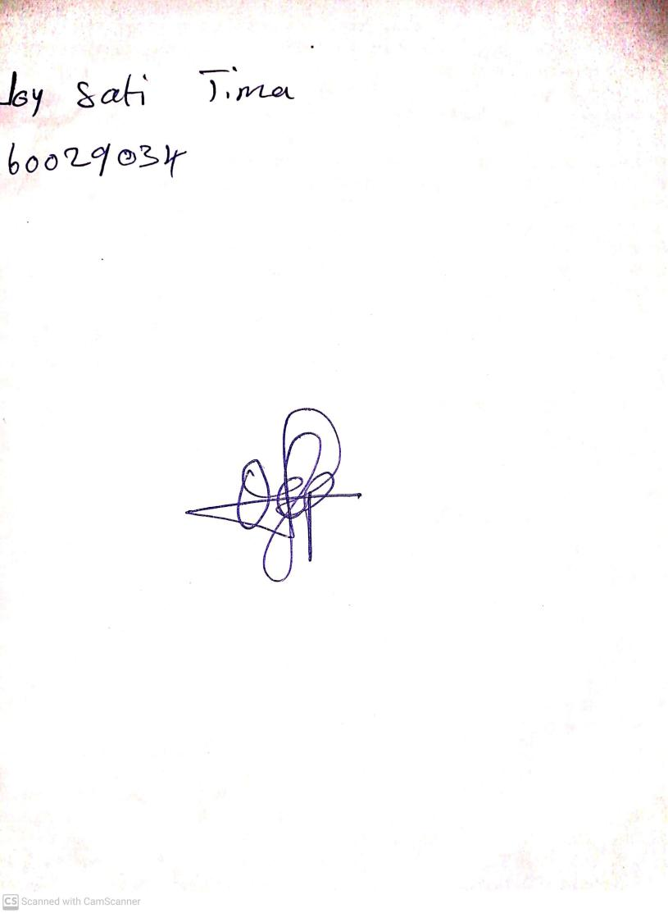

25th August, 2023

Perpetual Ojoma Ocheja

Stream Head Nursery