**LESSONS PLAN AND NOTE FOR WEEK 2 ENDING 12TH MAY 2023**

**TERM : 3rd**

**WEEK: 2nd**

**DATE: 08/05/2023**

**CLASS: Nursery 2**

**SUBJECT: Nature studies**

**TOPIC : Sources of clean water**

**SUB- TOPIC : Meaning of clean water and their sources.**

**PERIOD : 4th**

**TIME: 10:40–11:20 am**

**DURATION: 40 minutes**

**NUMBER IN CLASS: 14**

**AVERAGE AGE: 4 years**

**SEX : Mixed**

**SPECIFIC OBJECTIVES: By the end of the lesson,the Pupils should be able to:**

1. Explain the meaning of clean water

**2. Mention the sources of clean water**

**RATIONALE : For Pupils to know where clean water is gotten from.**

**PREVIOUS KNOWLEDGE: Pupils have learnt the water transportation.**

**INSTRUCTIONAL MATERIALS: Pictures of sources of water in Pupils textbooks**

**REFERENCE MATERIALS: Basic science and technology Nursery schools book 3 by OPEMIPO DADA**

**LESSON DEVELOPMENT**

|  |  |  |  |
| --- | --- | --- | --- |
| **Steps** | **Teacher's activities** | **Pupils' activities** | **Learning point** |
| **Introduction** | **Teacher introduces the lesson by asking pupils the first aid treatment for drowning.** | **Pupils answer the question asked by the teacher.** | **To prepare pupils minds for the lesson ahead** |
| **Step 1** | **Teacher presents the lesson by explaining the meaning of clean water and then asks them to repeat after her.** | **Pupils listen to the teacher and repeat after her.** | For proper understanding. |
| **Step 2** | **Teacher mention the sources of clean water to pupils and also asks them to repeat after her.** | **Pupils pay attention to the teacher and repeat after her.** | **For better understanding.** |
| **Board summary** | **Teacher summarizes the lesson by writing the whole note of lesson on the board for pupils to copy into their books. As;**  **SOURCES OF CLEAN WATER**  **CLEAN WATER: Clean water is water that is safe for drinking, bathing and cooking. We need water to stay alive.**  **We can get clean water from,**  **1. Wells**  **2. Springs**  **3. Boreholes**  **4. lakes**  **5. Taps**  **6 Rain fall**  **7. River**  **8. Stream etc.** | **Pupils copy the note into their exercise books.** | **For onward study.** |
| **Evaluation** | **Teacher evaluates the lesson by asking pupils the following questions**  1. What is clean water?  2. Mention the sources of clean water. | **Pupils answer the questions ask by the teacher.** | **To assess pupils level of understanding.** |
| **Conclusion** | **Teacher concludes the lesson by marking pupils books.** | **Pupils submit their books for marking.** | **For endorsement** |
| **Assignment** | Answer all the questions in unit 16 page 57. | **Pupils do their assignment at home.** | **To encourage learning at home.** |

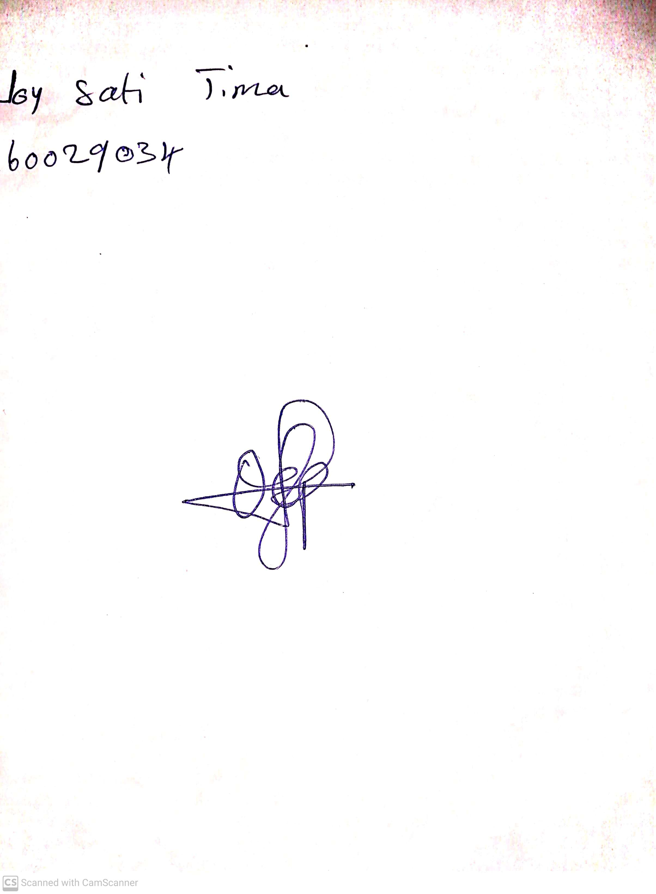

28th April, 2023

Perpetual Ojoma

Stream Head Nursery