LESSON PLAN AND NOTE FOR WEEK 5 ENDING 02/06/2023

TERM: 3rd

WEEK: 5th

DATE: 29/05/2023

CLASS: Nursery 2

SUBJECT: Social norms

TOPIC: Care of children with special needs.

SUB—TOPIC: Meaning of children with special needs.

PERIOD: 2nd period after long break

TIME: 11:20—12: 00pm

DURATION: 40 minutes

NUMBER IN CLASS: 14

AVERAGE AGE: 5 years

SEX: Mixed

LEARNING OBJECTIVES: By the end of the lesson, the Pupils should be able to:

1. Explain the meaning of children with special needs.

3. Mention the various ways of caring for children with special

needs.

RATIONALE: For pupils to learn how to care for children with special needs.

PREVIOUS KNOWLEDGE: Pupils have learnt mental violence in previous lesson.

INSTRUCTIONAL MATERIALS: Vedio clip of children with disabilities

REFERENCE MATERIALS: Google. com

LESSON DEVELOPMENT

|  |  |  |  |
| --- | --- | --- | --- |
| Steps | Teacher's activities | Pupils' activities | Learning point |
| Introduction | Teacher introduces the lesson by asking pupils if they have seen people with one hand or one leg before? | Pupils answer the question ask by the teacher. | To prepare pupils minds for the lesson ahead. |
| Presentation step 1 | Teacher explains the meaning of children with special needs to pupils and then asks them to repeat after her. | Pupils pay attention to the teacher and repeat after her. | For proper understanding. |
| Step 2 | Teacher mentions the ways to care for people with special needs to pupils and also asks them to repeat after her. | Pupils listen to the teacher and repeat after her. | For better understanding. |
| Board summary | Teacher summarizes the lesson by writing the whole note of lesson on the board for pupils to copy into their books. That is;  CARE OF CHILDREN WITH SPECIAL NEEDS  Children with special needs means children with developmental disabilities, mental retardation, emotional disturbance, sensory impairment, etc.  CARE FOR CHILDREN WITH SPECIAL NEEDS  1. Show them understanding and patience when they struggle.  2. Treat their disability as natural.  3. Encourage the friendships with both non–disabled and disabled kids.  4. Encourage decision making  5. Don't try to force them  6. Give proper support etc. | Pupils copy the note into their books. | For onward study. |
| Evaluation | Teacher evaluates the lesson by asking pupils the following questions:  1. What are children with special needs?  2. How do we care for children with special needs? | Pupils answer the questions asked by the teacher. | To assess pupils level of understanding. |
| Conclusion | Teacher concludes the lesson by marking pupils books. | Pupils submit their books for marking.. | For endorsement. |
| Assignment | Answer the following questions:  1. What is the meaning of orphan's?  2. Who are the vulnerable children?  3 mention 3 ways we can care for orphaned and vulnerable children. | Pupils do their assignment at home. | To encourage learning at home. |

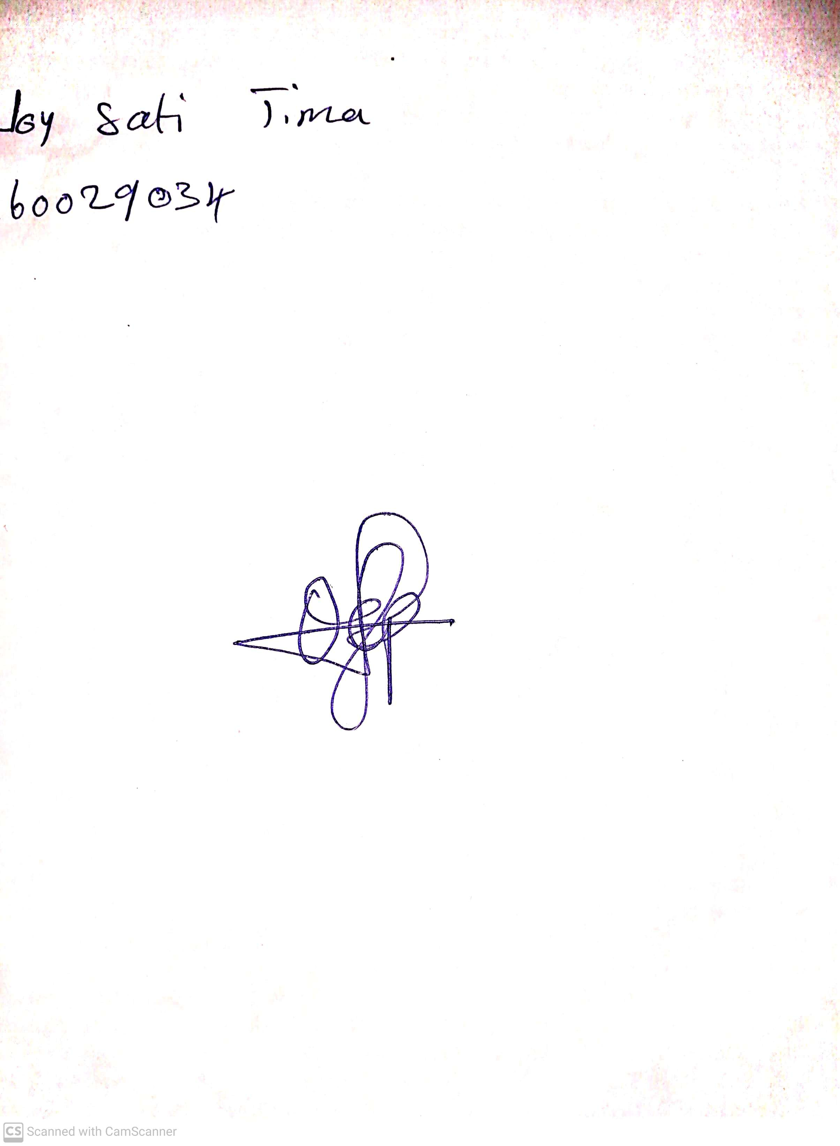

10th May, 2023

Perpetual Ojoma

Stream Head Nursery