**Lesson Plan/Notes for week 3 Ending 27/1/2023.**

**Term:** 2nd

**Week:** 3

**Date:** 25/1/2023

**Class:** SS 2

**Subject:** Civic Education

**Topic:** Drug and Drug Abuse.

**Sub-Topic:** Meaning and symptoms of drug abuse.

**Period:** 6th

**Time:** 11:50-12:30.

**Duration:** 40 minutes

**Number in class**: 5 Students.

**Average Age:**14 Years

**Sex:** mixed

**Learning objectives:** By the end of the lesson the students should be able to:

(1) Define Drug and Drug Abuse.

(11) state the symptoms of Drug Abuse.

(111) Explain the symptoms of Drug Abuse.

**Rationale:** For the students to be able to identify the symptoms or signs of drug abuse.

**Previous knowledge:** The students have been using drugs and have seen people that abuse drugs.

**Instructional Material:** A chart showing Drug and Drug Abuse or drug addict displaying their characters.

**Reference material:** Gbenga Babalola (2017) Essential civic Education for senior Secondary schools.

**LESSON DEVELOPMENT.**

|  |  |  |  |
| --- | --- | --- | --- |
| **Stages/Steps** | **Teacher's Activities** | **Students' Activities** | **Learning points** |
| **Introduction** | Reviews the previous lesson. | Participate actively in the class discussion | To arouse the students interest to focus in the lesson. |
| **Step 1** | Defines Drug and Drug Abuse as: Drug is any substance that we take to cure or prevent illness. Drug Abuse is the miss use of drugs. | Listen carefully to the teacher. | For better understanding of the lesson. |
| **Step 11** | Guides the students to state the symptoms of drug abuse | State the symptoms of drug abuse as: (1) family signs (2) school signs (3) emotional signs etc. | To keep the students focus. |
| **Step 111** | Leads the students to explain the symptoms of drug abuse | Respond to the class activity | To encourage critical thinking |
| **Board Summary** | Summarizes the lesson as:  **Meaning of Drug and Drug Abuse**  Drug according to WHO is any substance other than those required for the maintenance of normal health, which when taken into living organism, may modify one or more of its functions.  **Drug Abuse**  Drug Abuse is the illegal, wrong or excessive use of drugs and other substances.  **Symptoms of Drug Abuse**  (1) Family signs and symptoms: Exhibiting lackadaisical attitude towards laws and parents, sneaking to unusual and secret places, isolation from family members, locking bedroom door, avoiding family affairs, hiding in the room etc.  (2) physical signs and symptoms: Frequent minor illnesses such as sluggishness, frequent naps etc, small of substance like cocaine, marijuana, alcohol, menthols etc.  (3) Social signs and symptoms: over popularity and excessive greetings in a noisy Way with friends, breaking of rules and regulations, promiscuity.  (4) school signs and symptoms: fighting always with teachers and students, sleeping in class, hating school, frequent trauncy.  (5) Emotional signs and symptoms: Talking to oneself repeatedly, smiles and laughter, traces of madness, violent acts such as shooting, killing, stabbing, breaking bottles etc. | Copy and submit the note book for marking | For future reference. |
| **Evaluation** | Evaluates the lesson as:  (1) What is Drug and Drug Abus?  (2) State 4 symptoms of Drug Abuse.  (3) Explain any 3 of the symptoms of Drug Abuse. | Respond to the questions | Ascertaining the attainment of the stated objectives. |
| **Conclusion** | Rounds up the lesson by marking and correcting students work | Check and do their correction | Consolidation of the lesson. |
| **Assignment** | Gives home work as:  (1) Mention and explain 5 cause of drug abuse. | Respond by doing the home work at home. | To ensure continuity of learning. |

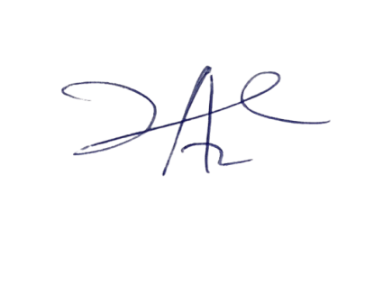

14/3/2023

Principal Head Instructor