**EMERALD ROYAL INTERNATIONAL SCHOOL,**

**MPAPE ABUJA**

**NURSERY 2 SCHEME OF WORK ON NATURE STUDY THIRD TERM**

|  |  |
| --- | --- |
| **WEEKS** | **TOPICS** |
| 1 | Sources of water |
| 2 | Water: uses |
| 3 | Water: characteristics |
| 4 | Water: methods of water purification |
| 5 | Water storage |
| 6 | Water–borne diseases |
| 7 | Growing plants |
| 8 | Colours |
| 9 | Things that have natural colours |
| 10 | Elements of weather |
| 11 | The existence of Air |
| 12 | Importance of air |
| 13 | Revision |
| 14 | Examination |

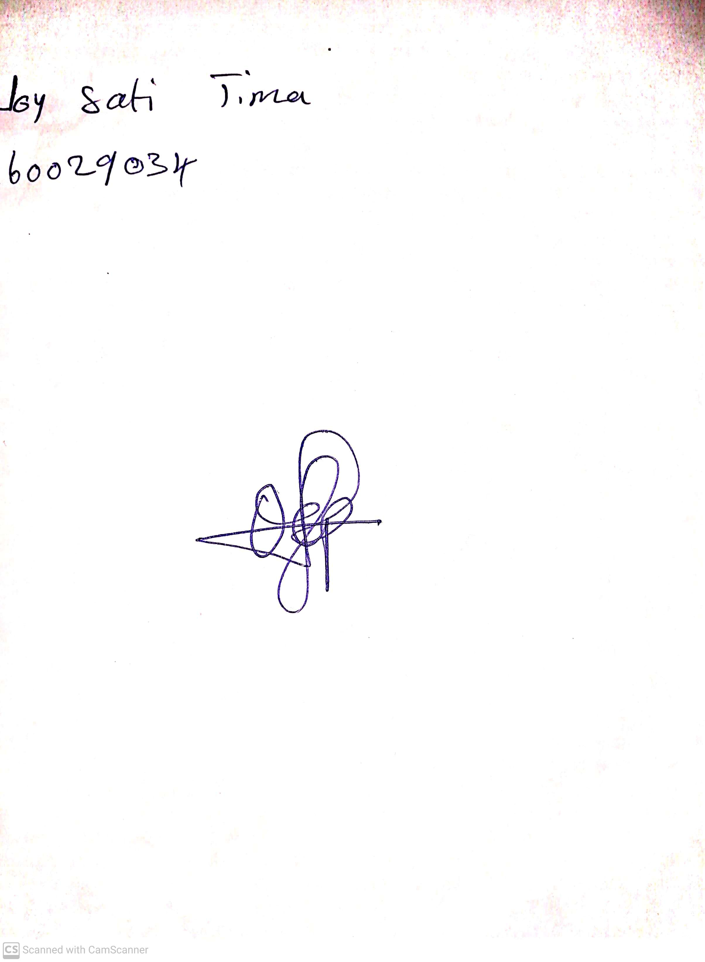

4th May, 2023

Perpetual Ojoma

Stream Head Nursery