EMERALD ROYAL INTERNATIONAL SCHOOL

MPAPE, ABUJA.

LESSON NOTE FOR WEEK 3 AND 4 ENDING 26TH JANUARY ,2024.

SUBJECT: Number Work

TOPIC: Counting Numbers 1 - 17

SUB-TOPIC: Counting Numbers 1 - 17

DATE: 23/01/2024.

DURATION: 40 minutes.

TIME: 08:50--09:30.

PERIOD: 2nd

CLASS: Pre-nursery

NUMBER OF PUPILS: 17

AVERAGE AGE: 2 YEARS

SEX: Mixed.

SPECIFIC OBJECTIVES: By the end of the lesson, the pupils should be able to:-

1. Count Numbers 1-17
2. Identify numbers 1 - 17

RATIONALE: For pupils to be able to count numbers.

PREVIOUS KNOWLEDGE: Pupils have been counting numbers.

INSTRUCTIONAL MATERIALS: Number chart, flash cards, cups,balls,building blocks etc

REFERENCE:Mastering mathematics for nursery schools book 1 by Henry Idogun.

LESSON DEVELOPMENT

|  |  |  |  |
| --- | --- | --- | --- |
| STAGES/STEPS | TEACHER’S ACTIVITIES | PUPILS’ ACTIVITIES | LEARNING POINTS |
| INTRODUCTION | Teacher introduces the lesson by singing a number rhyme for the pupils. | Pupils sing the rhyme along with the teacher. | To arouse pupils interest in the lesson. |
| PRESENTATION  STEP 1 | Teacher counts numbers 1 - 17 for the pupils to repeat after her. | Pupils count numbers 1 - 17 after the teacher. | For better understanding of the lesson . |
| STEP2 | Teacher guides each pupils to count numbers 1 -17. | Pupils count numbers 1 - 17 .  1 2 3 4 5 6 7 8 9 10 11 12 13 14 15 16 17. | For proper understanding of the lesson. |
| SUMMARY | Teacher identifies each number 1 - 17 for the pupils. | Pupils point at the numbers. | For more understanding of the lesson. |
| EVALUATION | Teacher asks Pupils to   1. count numbers 1 - 17. 2. Identify numbers 1-17. | Pupils count numbers 1 - 17. | To assess pupils understanding of the lesson. |
| CONCLUSION | Teacher plays a number video clip for the pupils to watch. | Pupils sit and watch the video. | To improve pupils listening ability. |
| ASSIGNMENT (HOME WORK) | Touch these numbers and Count them.  1 2 3 4 5 6 7 8 9 10 11 12 13 14 15 16 17. | Pupils do their assignment at home. | To encourage pupils to study at home. |

EMERALD ROYAL INTERNATIONAL SCHOOL

MPAPE, ABUJA.

LESSON NOTE FOR WEEK 3 AND 4 ENDING 26TTH  JANUARY, 2024.

SUBJECT: Number Work

TOPIC: Counting Numbers 1 - 17

SUB-TOPIC: Counting objects 1 - 17

DATE: 26/01/2024.

DURATION: 40 minutes.

TIME: 08:50 - 09: 30

PERIOD: 2nd

CLASS: Pre-nursery

NUMBER OF PUPILS: 17

AVERAGE AGE: 2 YEARS

SEX: Mixed.

SPECIFIC OBJECTIVES: By the end of the lesson, the pupils should be able to:-

1. Count Numbers 1-17

4. Count the objects 1 -17.

RATIONALE: For pupils to be able to count numbers.

PREVIOUS KNOWLEDGE: Pupils have been counting numbers.

INSTRUCTIONAL MATERIALS: Number chart, flash cards etc

REFERENCE:Mastering mathematics for nursery schools book 1 by Henry Idogun.

LESSON DEVELOPMENT

|  |  |  |  |
| --- | --- | --- | --- |
| STAGES/STEPS | TEACHER’S ACTIVITIES | PUPILS’ ACTIVITIES | LEARNING POINTS |
| INTRODUCTION | Teacher displays objects on the table for the pupils to see. | Pupils touch the objects on the table and say the names of the objects after the teacher. | To draw pupils interest to the lesson. |
| PRESENTATION  STEP 1 | Teacher counts numbers 1 - 17 for the pupils to repeat after her. | Pupils count numbers 1 - 17 after the teacher. | For better understanding of the lesson . |
| STEP2 | Teacher guides each pupils to count objects 1 -17. | Pupils point at the objects and count after the teacher.  1    1  17 faces. | For proper understanding of the lesson. |
| SUMMARY | Teacher count 17 objects for the pupils. | Pupils count the objects after the teacher. I.e  17 cups. | For more understanding of the lesson. |
| EVALUATION | Teacher asks Pupils to 1. count numbers 1 - 17.  2. identify number 1 - 17. | Pupils count numbers 1 - 17. | To assess pupils understanding of the lesson. |
| CONCLUSION | Teacher plays a number video clip for the pupils to watch. | Pupils sit and watch the video. | To improve pupils listening ability.  1 |
| ASSIGNMENT (HOME WORK) | Count and touch the objects.  . | Pupils do their assignment at home. | To encourage pupils to study at home. |

EMERALD ROYAL INTERNATIONAL SCHOOL

MPAPE, ABUJA.

LESSON NOTE FOR WEEK 3 AND 4 ENDING 26TH JANUARY, 2024.

SUBJECT: Number Work

TOPIC: Counting Numbers 1 - 17

SUB-TOPIC: Matching numbers 1 - 17

DATE: 30/01/2024.

DURATION: 40 minutes.

TIME: 08:50 - 09:30

PERIOD: 2nd

CLASS: Pre-nursery

NUMBER OF PUPILS: 17

AVERAGE AGE: 2 YEARS

SEX: Mixed.

SPECIFIC OBJECTIVES: By the end of the lesson, the pupils should be able to:-

1. Count Numbers 1-17
2. Match numbers 1 - 17

RATIONALE: For pupils to be able to identify numbers.

PREVIOUS KNOWLEDGE: Pupils have been counting numbers.

INSTRUCTIONAL MATERIALS: N umber chart, flash cards etc

REFERENCE:Mastering mathematics for nursery schools book 1 by Henry Idogun.

LESSON DEVELOPMENT

|  |  |  |  |
| --- | --- | --- | --- |
| STAGES/STEPS | TEACHER’S ACTIVITIES | PUPILS’ ACTIVITIES | LEARNING POINTS |
| INTRODUCTION | Teacher introduces the lesson by singing a number rhyme for the pupils. | Pupils sing the rhyme along with the teacher. | To arouse pupils interest in the lesson. |
| PRESENTATION  STEP 1 | Teacher counts numbers 1 - 17 for the pupils to repeat after her. | Pupils count numbers 1 - 17 after the teacher. I.e  1 2 3 4 5  6 7 8 9 10  11 12 13 14 15 16 17 | For better understanding of the lesson . |
| STEP2 | Teacher guides each pupils to match the numbers correctly. | Pupils match numbers with objects. I.e  1  2  c  3  4  5  6  7  8  9  10  11   |  | | --- | | 3  4  5  6  7  8  9  10 | | Pupils match numbers with objects. I.e  1  2  3  4  5  6  7  8  9  10 | |   12          13      14    15  16  17 |  |
| SUMMARY | Teacher identifies each number 1 - 17 for the pupils on the flash cards. | Pupils point at the numbers and identify them. | For more understanding of the lesson. |
| EVALUATION | Teacher asks Pupils to  1. count numbers 1 - 17.  2. match the numbers with the objects. | Pupils answer the teacher’s questions. | To assess pupils understanding of the lesson. |
| CONCLUSION | Teacher plays a number video clip for the pupils to watch. | Pupils sit and watch the video. | To improve pupils listening ability.  1 |
| ASSIGNMENT (HOME WORK) | Count and identify numbers 1 - 17  1 2 3 4 5  6 7 8 9 10  11 12 13 14 15 16 17 | Pupils do their assignment at home. | To encourage pupils to study at home. |

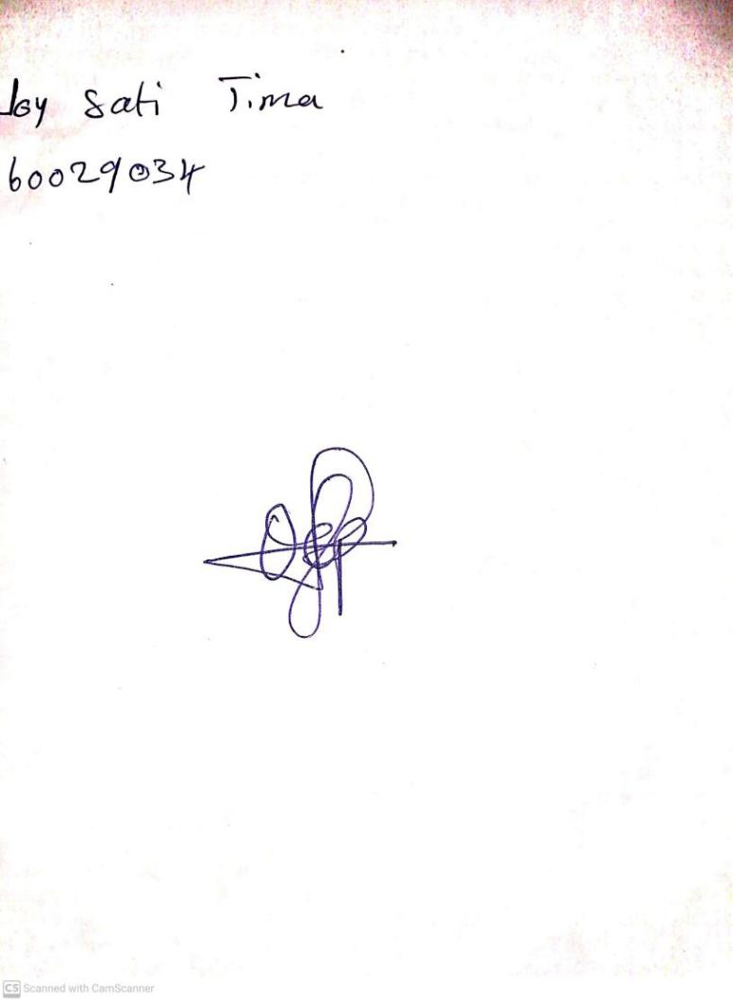

19TH January, 2024

Perpetual Ojoma Ocheja

Stream Head Nursery