**EMERALD ROYAL INTERNATIONAL SCHOOL MPAPE, ABUJA**

**LESSON PLAN AND NOTE FOR WEEK 4 ENDING 02/02/2024**

**TREM: 2nd**

**WEEK: 4**

**DATE: 29/01/2024**

**CLASS: Nursery 2**

**SUBJECT: Letter work**

**TOPIC: Initial consonant blend 3**

**SUB—TOPIC: Initial consonant blend “gl” and “gr”**

**PERIOD: 3rd**

**TIME: 09:30—10:10am**

**DURATION: 40 minutes**

**NUMBER IN CLASS: 13**

**AVERAGE AGE: 5 years**

**SEX: Mixed**

**LEARNING OBJECTIVES: By the end of the lesson, the Pupils should be able to:**

**1. Mention words with initial consonant “gl”**

**2. List words with initial consonant “gr”**

**RATIONALE: For Pupils to know pronunciation**

**PREVIOUS KNOWLEDGE: Pupils have learnt initial consonant “sm”and “sn”.**

**INSTRUCTIONAL MATERIALS: A chart of initials and Words.**

**REFERENCE MATERIALS: My choice of English Language stage 3 by J.F. OMOTAYO**

**LESSON DEVELOPMENT**

|  |  |  |  |
| --- | --- | --- | --- |
| **Steps** | **Teacher's activities** | **Pupils' activities** | **Learning point** |
| **Introduction** | **Teacher reviews the previous lesson.** | **Pupils listen to the teacher.** | **To arouse pupils interest for the lesson ahead.** |
| **Presentation step 1** | **Teacher mentions the examples of words with initial consonant blend “gl” and then asks pupils to repeat after her.** | **Pupils pay attention to the teacher and repeat after her.** | **For proper understanding.** |
| **Step 2** | **Teacher list out the examples of words with initial consonant blend “gr” and also asks Pupils to repeat after her.** | **Pupils listen attentively to the teacher and also repeat after her.** | **For better understanding.** |
| **Board summary** | **Teacher summarizes the lesson by writing the whole note of lesson on the board for pupils to copy into their books.**  **INITIAL CONSONANT BLEND “GL”ARE**  **gl as in gland**  **gl as in blade**  **gl as in glamour**  **gl as in glance**  **gl as in glory**  **gl as in glove**  **Glz as in glass etc.**  **INITIAL CONSONANT BLEND “GR” ARE**  **gr as in grab**  **gr as in grace**  **gr as in graft**  **gr as in grammar**  **gr as in grand**  **gr as in grant**  **gr as in gray**  **gr as in great**  **gr as in green etc.** | **Pupils copy the note into their exercise books.** | **For onward study.** |
| **Evaluation** | **Teacher evaluates the lesson by asking pupils to read the note on the board one after the other.** | **Pupils read the note on the board one after another.** | **To assess Pupils reading skills.** |
| **Conclusion** | **Teacher concludes the lesson by marking pupils books.** | **Pupils submit their books for marking.** | **For endorsement.** |
| **Assignment** | **Make words with initial consonant blend pl and pr.** | **Pupils do their assignment at home.** | **To encourage learning at home.** |

**LESSON PLAN AND NOTE FOR WEEK 4 ENDING 02/02/2024**

**TERM : 2nd**

**WEEK: 4**

**DATE: 01/02/2024**

**CLASS: Nursery 2**

**SUBJECT: Letter work**

**TOPIC : Initial consonant blend 3**

**SUB—TOPIC: Initial consonant blend “pl”and “pr”.**

**PERIOD: 2nd**

**TIME: 08:50—09:30am**

**DURATION: 40 minutes**

**NUMBER IN CLASS: 13**

**AVERAGE AGE: 5 years**

**SEX: Mixed**

**LEARNING OBJECTIVES: By the end of the lesson, the Pupils should be able to:**

**1. Mention words with initial consonant pl.**

**2. List words with initial consonant pr.**

**RATIONALE: For Pupils to be able to pronounce words with initial consonant pl and pr.**

**PREVIOUS KNOWLEDGE: Pupils have learnt initial gl and gr in previous lesson.**

**INSTRUCTIONAL MATERIALS: Chart of initials**

**REFERENCE MATERIALS: My choice of English Language stage 3 by J. F.OMOTAYO**

**LESSON DEVELOPMENT**

|  |  |  |  |
| --- | --- | --- | --- |
| **Steps** | **Teacher's activities** | **Pupils' activities** | **Learning point** |
| **Introduction** | **Teacher introduces the lesson by singing if you are happy and you know it clap your hands.....** | **Pupils sing the rhyme along with the teacher.** | **To arouse pupils interest for the lesson.** |
| **Presentation step 1** | **Teacher presents the lesson by mentioning the examples of words with initial consonant blend "pl" and then asks Pupils to repeat after her.** | **Pupils pay attention to the teacher and repeat after her.** | **For proper understanding.** |
| **Step 2** | **Teacher guides pupils to list the examples of initial consonant blend "pr "** | **Pupils list out the words with initial consonant blend "pr"** | **For better understanding.** |
| **Board summary** | **Teacher writes the whole note of lesson on the board as;**  **INITIAL CONSONANT BLEND PL AND PR ARE**  **pl as in plant**  **pl as in plenty**  **pl as in play**  **pl as in plaster**  **pl as in place**  **pl as in plasma**  **pl as in plan**  **pl as in plastic**  **pl as in plantain**  **pl as in planet**  **pl as in plate**  **pl as in plaza**  **pl as in please**  **pl as in plug**  **pl as in plus etc.**  **Initial consonant blend pr are;**  **pr as in pray**  **pr as in precious**  **pr as in prince**  **pr as in princess**  **pr as in press**  **pr as in prey**  **pr as in price**  **pr as in principal**  **pr as in primary**  **pr as in price**  **pr as in print**  **pr as in present etc.** | **Pupils copy the note into their exercise books.** | **For onward study.** |
| **Evaluation** | **Teacher asks pupils to all stand and pronounce the words on the board.** | **Pupils stand and pronounce the words on the board.** | **To enhance Pupils participation in class** |
| **Conclusion** | **Teacher concludes the lesson by marking pupils books.** | **Pupils submit their books for teacher to mark.** | **For endorsement.** |
| **Assignment** | **Spell and pronounce the following words;**  **1. Prey**  **2. pride**  **3. Print**  **4. Pray**  **5. Press**  **6. Play**  **7. Plant**  **8. Plug**  **9. Please**  **10. Plan** | **Pupils do their assignment at home.** | **To encourage learning at home.** |

**LESSON PLAN AND NOTE FOR WEEK 4 ENDING 02/02/2024**

**TERM: 2nd**

**WEEK: 4th**

**DATE: 02/02/2024**

**CLASS: Nursery 2**

**SUBJECT: Letter work**

**TOPIC: Initial consonant blend 3**

**SUB—TOPIC: Initial consonant "sp" and "sc"**

**PERIOD: 3rd**

**TIME: 09:30—10:10am**

**DURATION: Minutes**

**NUMBER IN CLASS: 13**

**AVERAGE AGE: 5 years**

**SEX: Mixed**

**LEARNING OBJECTIVES: By the end of the lesson, the Pupils should be able to:**

**1. Explain the meaning of initial consonant blend "sp"**

**2. Define initial consonant "sc "**

**3. Mention the examples of initial consonant " sp " and "sc "**

**RATIONALE: For Pupils to know how to pronounce words that begins with "sp " and " sc ".**

**PREVIOUS KNOWLEDGE: Pupils have learnt different initials in previous lesson.**

**INSTRUCTIONAL MATERIALS: A chart of words according to their initials.**

**REFERENCE MATERIALS: My choice of English Language stage 3 by J. F. OMOTAYO**

**LESSON DEVELOPMENT**

|  |  |  |  |
| --- | --- | --- | --- |
| **Steps** | **Teacher's activities** | **Pupils' activities** | **Learning point** |
| **Introduction** | **Teacher introduces the lesson by singing nursery rhymes.** | **Pupils sing the rhymes along with the teacher.** | **To arouse pupils interest for the lesson.** |
| **Presentation step 1** | **Teacher explains the meaning of initial consonant blend “sp” to pupils and asks them to repeat after her.** | **Pupils listen to the teacher and repeat after her.** | **For proper understanding.** |
| **Presentation step 2** | **Teacher defines initial consonant blend “sc” and also asks Pupils to repeat after her.** | **Pupils pay attention to the teacher and repeat after her.** | **For better understanding.** |
| **Presentation step 3** | **Teacher guides pupils to now mention the examples of initial “sp” and “sc”.** | **Pupils mention the examples of words with initial “sp” and “sc”** | **To enhance Pupils participation in class.** |
| **Board summary** | **Teacher writes the whole note of lesson on the board for pupils to copy into their books. That is;**  **Initial consonant blend “sp” means words who's first two letters begins with sp.**  **Examples are:**  **1. SP as in spoon**  **2. SP as in space**  **3. SP as in spam**  **4. SP as in speak**  **5. SP as in spaghetti**  **6. SP as in spade**  **7. SP as in spark etc**  **Initial consonant blend “sc” means words who's first two letters begins with “sc”.**  **Examples are:**  **1. SC as in school**  **2. Sc as in scalp**  **3. Sc as in scam**  **4. Sc as in scoop**  **5. Sc as in Scott**  **6. Sc as in scanner**  **7. Sc as in scot etc.** | **Pupils copy the note into their exercise books.** | **For onward study.** |
| **Evaluation** | **Teacher asks pupils to spell and pronounce the words on the board one after the other.** | **Pupils spell and pronounce the words on the board one after another.** | **To improve Pupils reading ability.** |
| **Conclusion** | **Teacher concludes the lesson by marking pupils books.** | **Pupils submit their books for marking.** | **For endorsement.** |
| **Assignment** | **Write 5 words each of the following initials**  **1. SP**  **2. Gl**  **3. Sc**  **4. Gr**  **5. Pl**  **6. Pr** | **Pupils do their assignment at home.** | **To encourage learning at home.** |

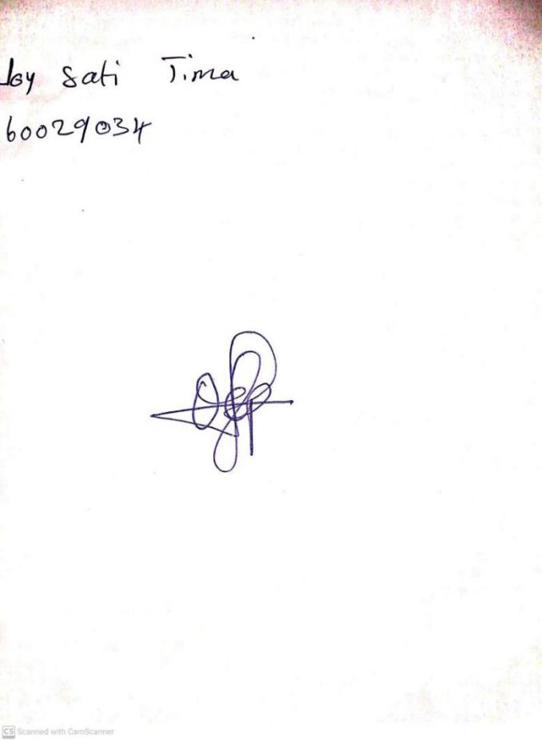

**26TH JANUARY, 2024**

**Perpetual Ojoma Ocheja**

**Stream Head Nursery**