**LESSON PLAN AND NOTE 1 FOR WEEK 9 ENDING 8/3/2024**

**Term 2nd term**

**Week 9th week**

**Date 4 March,2024**

**Class Nursery one**

**Subject Number work**

**Topic Learning & writing figures 1-5 in words.**

**Sub-topic Learning figure 1-3 in words**

**Period 2nd period**

**Time 9:05 am**

**Duration 35 minutes**

**No in class 15**

**Average Age 3 years**

**Sex Mixed**

**Specific Objectives: By the end of the lesson the pupils should be able to;**

1. **Spell figure 1-3 in words**
2. **Identify figures 1-3 in words**

**Rationale: To make sure the pupils spell & identify figures 1-3 in words**

**Previous knowledge: The pupils can colour & match numbers 100-110**

**Instructional Resources: Numbers in words chart.**

**Reference Materials: Online Research,chart,board.**

**LESSON PRESENTATION**

|  |  |  |  |
| --- | --- | --- | --- |
| **Steps** | **Teacher’s Activities** | **Pupils’ Activities** | **Learning Points** |
| **Introduction** | **The teacher introduces the topic [Learning & writing figures 1-5 in words] to the pupils.** | **The pupils listen attentively to the teacher.** | **To arouse the interest of the pupils.** |
| **Step 1** | **The teacher writes on the board the figures 1-3 in words and guides the pupils to spell**  **O-N-E T-W-O**  **T-H-R-E-E** | **The pupils spell the figures 1-3 in words as the teacher guides them.** | **For proper understanding.** |
| **Step 2** | **The teacher leads the pupils to identify the figures 1-3 in words**  **ONE THREE**  **TWO** | **The pupils identify the figures 1-3 in words.** | **For better understanding.** |
| **Summary** | **The teacher summarizes the lesson by spelling figures 1-3 in words.** | **The pupils can spell figures 1-3 in words.** | **For onward study.** |
| **Evaluation** | **Question: spell figure ‘3’ in words.** | **The pupils answer the question correctly.** | **To ascertain the pupils understanding.** |
| **Conclusion** | **The teacher summarizes, reacts, and corrects the pupils.** | **The pupils gives answers to the teacher.** | **To consolidate the lesson.** |
| **Assignment** | **Write the following figures in words**  **1 _____________**  **2 _____________**  **3 _____________** | **The pupils copy and do their homework at home.** | **To encourage learning while at home.** |

**LESSON PLAN AND NOTE 2 FOR WEEK 9 ENDING 8/3/2024**

**Term 2nd term**

**Week 9th week**

**Date 6th March,2024**

**Class Nursery one**

**Subject Number work**

**Topic Learning & writing figures 1-5 in words.**

**Sub-topic Learning figure 4-5 in words**

**Period 2nd period**

**Time 9:35 am**

**Duration 35 minutes**

**No in class 15**

**Average Age 3 years**

**Sex Mixed**

**Specific Objectives: By the end of the lesson the pupils should be able to;**

1. **Spell figure 4-5 in words**
2. **Identify figures 4-5 in words**

**Rationale: To make sure the pupils spell & identify figures 4-5 in words**

**Previous knowledge: The pupils can spell and identify figures 1-3 in words.**

**Instructional Resources: Numbers in words chart.**

**Reference Materials: Online Research,chart,board.**

**LESSON PRESENTATION**

|  |  |  |  |
| --- | --- | --- | --- |
| **Steps** | **Teacher’s Activities** | **Pupils’ Activities** | **Learning Points** |
| **Introduction** | **The teacher introduces the topic [Learning & writing figures 1-5 in words] to the pupils.** | **The pupils listen attentively to the teacher.** | **To arouse the interest of the pupils.** |
| **Step 1** | **The teacher writes on the board the figures 4-5 in words and guides the pupils to spell**  **F-O-U-R F-I-V-E** | **The pupils spell the figures 4-5 in words as the teacher guides them.** | **For proper understanding.** |
| **Step 2** | **The teacher leads the pupils to identify the figures 4-5 in words**  **FOUR FIVE** | **The pupils identify the figures 4-5 in words.** | **For better understanding.** |
| **Summary** | **The teacher summarizes the lesson by spelling figures 4-5 in words.** | **The pupils can spell figures 4-5 in words.** | **For onward study.** |
| **Evaluation** | **Question: spell figure ‘5’ in words.** | **The pupils answer the question correctly.** | **To ascertain the pupils understanding.** |
| **Conclusion** | **The teacher summarizes, reacts, and corrects the pupils.** | **The pupils gives answers to the teacher.** | **To consolidate the lesson.** |
| **Assignment** | **Write the following figures in words**  **4 _____________**  **5 _____________** | **The pupils copy and do their homework at home.** | **To encourage learning while at home.** |

**LESSON PLAN AND NOTE 3 FOR WEEK 9 ENDING 8/3/2024**

**Term 2nd term**

**Week 9th week**

**Date 8th March,2024**

**Class Nursery one**

**Subject Number work**

**Topic Learning & writing figures 1-5 in words.**

**Sub-topic Writing and Matching figures 1-5 in words**

**Period 2nd period**

**Time 9:50 am**

**Duration 35 minutes**

**No in class 15**

**Average Age 3 years**

**Sex Mixed**

**Specific Objectives: By the end of the lesson the pupils should be able to;**

1. **Write figure 1-5 in words**
2. **Match figures 1-5 in words**

**Rationale: To make sure the pupils write and match figures 1-5 in words**

**Previous knowledge: The pupils can spell and identify figures 4-5 in words.**

**Instructional Resources: Numbers in words chart.**

**Reference Materials: Online Research,chart,board.**

**LESSON PRESENTATION**

|  |  |  |  |
| --- | --- | --- | --- |
| **Steps** | **Teacher’s Activities** | **Pupils’ Activities** | **Learning Points** |
| **Introduction** | **The teacher introduces the topic [Learning & writing figures 1-5 in words] to the pupils.** | **The pupils listen attentively to the teacher.** | **To arouse the interest of the pupils.** |
| **Step 1** | **The teacher writes inside their notebooks the figures 1-5 for the pupils to write in words**  **1 ___________**  **2 ___________**  **3 ___________**  **4 ___________**  **5 ___________** | **The pupils write the figures 1-5 in words inside their notebooks.** | **For proper understanding.** |
| **Step 2** | **The teacher leads the pupils to match the figures 1-5 to their words**  **FOUR THREE**  **ONE FIVE**  **THREE TWO**  **FIVE FOUR**  **TWO ONE** | **The pupils match the figures 1-5 to their words.**  **FOUR THREE**  **ONE FIVE**  **THREE TWO**  **FIVE FOUR**  **TWO ONE** | **For better understanding.** |
| **Summary** | **The teacher summarizes the lesson by spelling figures 1-5 in words.** | **The pupils can spell figures 1-5 in words.** | **For onward study.** |
| **Evaluation** | **Question: spell figure ‘5’,’2’, ‘1’ in words.** | **The pupils answer the question correctly.** | **To ascertain the pupils understanding.** |
| **Conclusion** | **The teacher summarizes, reacts, and corrects the pupils.** | **The pupils gives answers to the teacher.** | **To consolidate the lesson.** |
| **Assignment** | **Match the following figures 1-5 to their words**  **FOUR THREE**  **ONE FIVE**  **THREE TWO**  **FIVE FOUR**  **TWO ONE**  **Write the following figure 1-5 in words**  **1 ___________**  **2 ___________**  **3 ___________**  **4 ___________**  **5 ___________** | **The pupils copy and do their homework at home.** | **To encourage learning while at home.** |

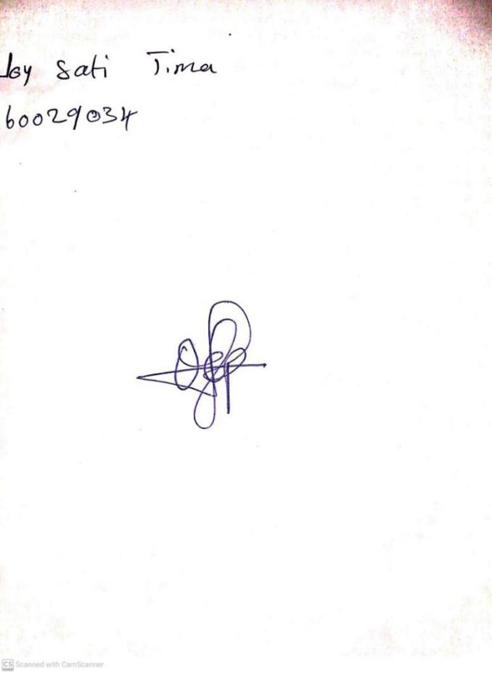

1ST March, 2024

Perpetual Ojoma Ocheja

Stream Head Nursery

**N.B THE EVALUATION SHOULD TALLY WITH THE LEARNING OBJECTIVES**

|  |  |
| --- | --- |
| **Evaluation** | **Question: spell figure ‘5’,’2’, ‘1’ in words.** |

**Specific Objectives: By the end of the lesson the pupils should be able to;**

1. **Write figure 1-5 in words**
2. **Match figures 1-5 in words**

KINDLY DO SAME FOR THE NOTES