**EMERALD ROYAL INTERNATIONAL SCHOOL**

**MPAPE, ABUJA.**

**LESSON PLAN AND NOTE FOR WEEK 7 ENDING 16TH JUNE,2023.**

TERM : Third term.

WEEK : 7th

SUBJECT: Social Norms

TOPIC: People and their profession.

SUB-TOPIC: Identifying people and their profession.

DATE: 13/6/2023

DURATION: 40 minutes

TIME: 10:40-11:20

PERIOD: 4th

CLASS: pre-nursery

NUMBER OF PUPILS: 11

AVERAGE AGE: 2

SEX: Mixed

SPECIFIC OBJECTIVES: By the end of the lesson, the pupils should be able to:-

1. Identify a doctor and a lawyer

2. Say what they do.

RATIONALE: For pupils to know people and what they do.

PREVIOUS KNOWLEDGE: Pupils have been seeing teachers and are familiar with them.

INSTRUCTIONAL MATERIALS: pictures of a doctor and a lawyer.

REFERENCE: Smart start Civic education for nursery Schools book 1 by T.Y. Alabi and A. M. Solu.

LESSON DEVELOPMENT

|  |  |  |  |
| --- | --- | --- | --- |
| Stages/steps | Teacher's activities | Pupils' activities | Learning points |
| Introduction | Teacher introduces the lesson by reviewing the previous lesson on identifying a teacher, banker and an engineer. | Pupils pay attention as teacher reviews the previous lesson. | To get pupils attention for the lesson. |
| Presentation  Step 1 | Teacher shows the pupils the picture of a doctor and a lawyer and tells them that :-  A doctor is person who prescribe drugs in the hospital for the the patient and attend to their medical challenges.  A lawyer is a person in the court that judges people's case. | Pupils look around and point at a doctor and lawyer in the picture and also pay attention to the teacher as she tells them more about a doctor and a lawyer. | For better understanding of who the doctor and a lawyer is. |
| Step 2 | Teacher explains to the pupils what a doctor and a lawyer does.  ---- A doctor gives treatment to the sick.  ---- A lawyer settles disputes between two people. | Pupils pay attention to the teacher and repeat after the teacher. | To enhance pupils knowledge. |
| Summary | Teacher summarizes the lesson by emphasizing on the topic over again for more understanding.. | Pupils listen to the teacher. | To ensure better understanding of the lesson. |
| Evaluation | Teacher asks the pupils:-   1. Who always prescribe drugs for them when they are sick.? 2. Where do lawyers stays.? | Pupils answer the questions correctly. | To assess pupils level of understanding of the lesson. |
| Conclusion | Teacher ends the lesson by singing a nursery rhymes for the pupils. | Pupils sing the rhyme along with the teacher. | To consolidate the lesson. |

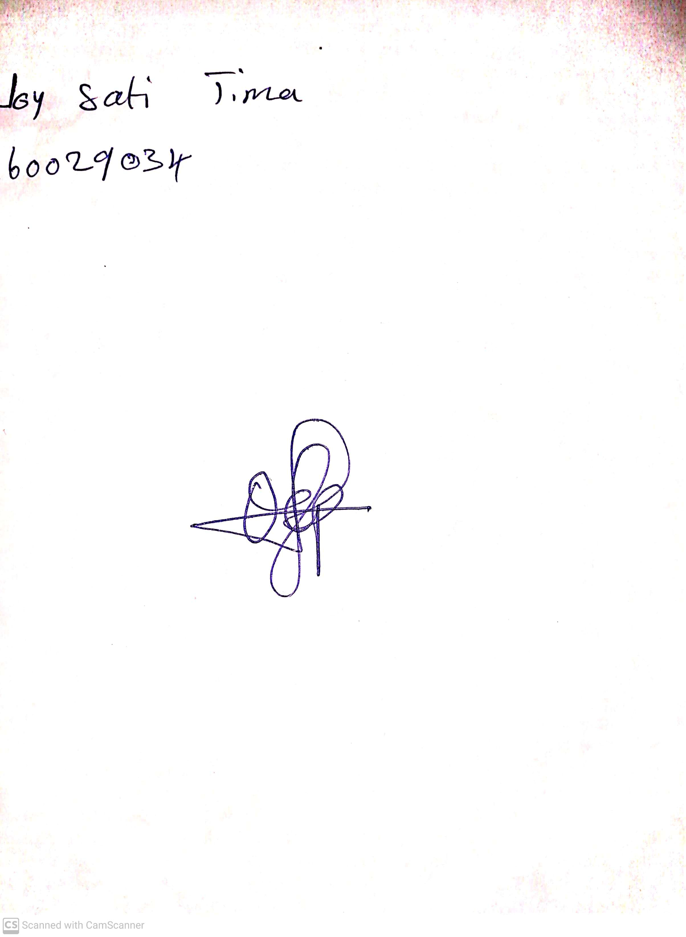

29th April, 2023

Perpetual Ojoma

Stream Head Nursery