EMERALD ROYAL INTERNATIONAL SCHOOL MPAPE, ABUJA

LESSON PLAN AND NOTE FOR WEEK 10 PERIOD 1 ENDING 17/11/2023

TERM: FIRST

WEEK: 10TH

DATE: 13/11/2023

CLASS: NURSERY 2

SUBJECT: LETTER WORK

TOPIC: READING EXERCISES ON THREE LETTER WORDS (RHYMING WORDS).

SUB-TOPIC: MEANING AND EXAMPLES OF RHYMING WORDS.

PERIOD: 3RD

TIME: 09: 30-10: 10 am

DURATION: 40 MINUTES

NUMBER IN CLASS: 16

AVERAGE AGE: 4

SEX: MIXED

SPECIFIC OBJECTIVES: BY THE END OF THE LESSON, THE PUPILS SHOULD BE ABLE

TO:

1. EXPLAIN THE MEANING OF RHYMING WORDS.
2. MENTION SOME EXAMPLES OF RHYMING WORDS.

RATIONALE: FOR PUPILS TO BE ABLE TO KNOW THE MEANING AND EXAMPLES OF RHYMING WORDS.

PREVIOUS KNOWLEDGE: PUPILS HAVE LEARNT THREE LETTER WORDS ACROSS THE FIVE VOWELS IN PREVIOUS LESSON.

INSTRUCTIONAL MATERIALS: A CHART OF RHYMING WORDS.

REFERENCE MATERIALS: THE NEW MASTERING ENGLISH FOR NURSERY SCHOOLS BOOK 2 BY J.M OMOGBAI

TOP STAR MY CHOICE OF ENGLISH LANGUAGE STAGE 3 BY

J.F OMOTAYO.

LESSON DEVELOPMENT

|  |  |  |  |
| --- | --- | --- | --- |
| STAGES/STEPS | TEACHER’S ACTIVITIES | PUPILS’ ACTIVITIES | LEARNING POINT |
| INTODUCTION | Teacher introduces the lesson by reviewing the previous lesson. | Pupils listen attentively to the teacher. | To arouse pupils interest for the lesson ahead. |
| PRESENTATION  STEP 1 | Teacher explains the meaning of rhyming words to pupils and then asks them to repeat after her. | Pupils pay attention to the teacher and repeat after her. | For proper understanding. |
| STEP 2 | Teacher mention the examples of rhyming words to pupils and also asks them to repeat after her. | Pupils listen very attentively to the teacher and repeat after her. | For better understanding of the lesson. |
| BOARD SUMMARY | Teacher summarizes the lesson by writing the whole note of lesson on the board for pupils to copy into their books. That is;  Three letter words (rhyming words)  Rhyming words are words that sound the same and often have the same letter endings.  Examples of rhyming words are;   1. Cat ---- rat 2. Pin ----- fin 3. Got ----- pot 4. Men ---- pen 5. Man ----- pan 6. Pun ----- sun 7. Not ------ cot etc. | Pupils copy the note on the board into their exercise books. | For onward study. |
| EVALUATION | Teacher evaluates the lesson by asking the following questions:   1. Explain the meaning of rhyming words. 2. Mention the examples of rhyming words. | Pupils answer the questions asked by the teacher. | To asses pupils level of understanding of the lesson. |
| CONCLUSION | Teacher concludes the lesson by marking pupils books. | Pupils submit their books for marking. | For endorsement. |
| ASSIGNMENT | Answer the following questions;   1. What are rhyming words? 2. Mention 10 examples of rhyming words. | Pupils do their assignment at home. | To encourage learning at home.s |

LESSON PLAN AND NOTE FOR WEEK 10 PERIOD 2 ENDING 17/11/2023

TERM: FIRST

WEEK: 10TH

DATE: 16/11/2023

CLASS: NURSERY 2

SUBJECT: LETTER WORK

TOPIC: READING EXERCISES ON THREE LETTER WORDS(RHYMING

WORDS).

SUB-TOPIC: MATCHING AND CIRCLING OF THREE LETTERS RHYMING WORDS

PERIOD: 2ND

TIME: 08: 50-09: 30 am

DURATION: 40 MINUTES

NUMBER IN CLASS: 16

AVERAGE AGE: 4

SEX: MIXED

SPECIFIC OBJECTIVES: BY THE END OF THE LESSON, THE PUPILS SHOULD BE ABLE

TO:

1. MATCH THREE LETTERS RHYMING WORDS.
2. CIRCLE THREE LETTERS RHYMING WORDS.

RATIONALE: FOR PUPILS TO KNOW WORDS THAT RHYMES.

PREVIOUS KNOWLEDGE: PUPILS HAVE LEARNT THE MEANING AND EXAMPLES OF RHYMING WORDS IN PREVIOUS LESSON.

INSTRUCTIONAL MATERIALS: A CHART OF THREE LETTER RHYMING WORDS.

REFERENCE MATERIALS: THE NEW MASTERING ENGLISH FOR NURSERY SCHOOLS BOOK 2 BY J. M OMOGBAI

TOP STAR MY CHOICE OF ENGLISH LANGUAGE STAGE 3 BY

1. F OMOTAYO.

LESSON DEVELOPMENT

|  |  |  |  |
| --- | --- | --- | --- |
| STAGES/STEPS | TEACHER’S ACTIVITIES | PUPILS’ ACTIVITIES | LEARNING POINT |
| INTODUCTION | Teacher introduces the lesson by reviewing the previous lesson. | Pupils listen attentively to the teacher. | To arouse pupils interest for the lesson ahead. |
| PRESENTATION  STEP 1 | Teacher writes some rhyming words on the board,match for pupils to understand and then asks pupils to repeat after her. | Pupils pay attention to the teacher and repeat after her. | For proper understanding. |
| STEP 2 | Teacher also writes some three letters words on the board and then circle the rhyming words for pupils to see and also asks them to repeat after her. | Pupils listen very attentively to the teacher and repeat after her. | For better understanding of the lesson. |
| BOARD SUMMARY | Teacher summarizes the lesson by writing the whole note of lesson on the board for pupils to copy into their books. That is:  Three letter rhyming words   1. Match the following words that rhymes with the first word. 2. boy rat dig 3. Cat toy bat 4. Pig tag fag 5. Bag big joy 6. Circle two words that rhyme with the first word. 7. SEX mud fix cat mix 8. COW now get how hat. 9. LEG gas bus beg peg. 10. TOP tow hop pop win. 11. PET set let fin box. | Pupils copy the note into their exercise books and then match and circle the rhyming words. | For onward study. |
| EVALUATION | Teacher evaluates the lesson by asking the following questions one after the other;   1. Mention the words that rhyme with the other:   Examples ,  boy, cat , pig and bag.   1. List the words that rhyme with another: examples,   six, cow, leg, top, and pet. | Pupils answer the questions asked by the teacher. | To asses pupils level of understanding of the lesson. |
| CONCLUSION | Teacher concludes the lesson by marking pupils books. | Pupils submit their books for marking. | For endorsement. |
| ASSIGNMENT | Write 2 three letters words that rhyme with the following words;   1. Cat 2. Bus 3. Gas 4. Pig 5. Boy 6. Mud 7. Cow 8. Hop 9. Pet | Pupils do their assignment at home. | To encourage learning at home.s |

LESSON PLAN AND NOTE FOR WEEK 10 PERIOD 3 ENDING 17/11/2023

TERM: FIRST

WEEK: 10TH

DATE: 17/11/2023

CLASS: NURSERY 2

SUBJECT: LETTER WORK

TOPIC: READING EXERCISE ON THREE LETTER WORDS (RHYMING WORDS) .

SUB-TOPIC: SIMPLE SENTENCES ON RHYMING WORDS

PERIOD: 3RD

TIME: 09: 30-10: 10 am

DURATION: 40 MINUTES

NUMBER IN CLASS: 16

AVERAGE AGE: 4

SEX: MIXED

SPECIFIC OBJECTIVES: BY THE END OF THE LESSON, THE PUPILS SHOULD BE ABLE

TO:

1. STATE THREE LETTER RHYMING WORDS
2. READ SIMPLE SENTENCES ON THREE LETTER

RHYMING WORDS.

RATIONALE: FOR PUPILS TO BE ABLE TO READ SIMPLE SENTENCES.

PREVIOUS KNOWLEDGE: PUPILS HAVE LEARNT THREE LETTER RHYMING WORDS IN PREVIOUS LESSON.

INSTRUCTIONAL MATERIALS: A CHART OF THREE LETTERS SIMPLE SENTENCES ON RHYMING WORDS .

REFERENCE MATERIALS: TOP STAR MY CHOICE OF ENGLISH LANGUAGE STAGE 3 BY J.F OMOTAYO.

LESSON DEVELOPMENT

|  |  |  |  |
| --- | --- | --- | --- |
| STAGES/STEPS | TEACHER’S ACTIVITIES | PUPILS’ ACTIVITIES | LEARNING POINT |
| INTODUCTION | Teacher introduces the lesson by reviewing the previous lesson. | Pupils listen attentively to the teacher. | To arouse pupils interest for the lesson ahead. |
| PRESENTATION  STEP 1 | Teacher states the three letters rhyming words to pupils and then asks them to repeat after her. | Pupils pay attention to the teacher and repeat after her. | For proper understanding. |
| STEP 2 | Teacher writes simple sentences on rhyming words on the board, read and also asks pupils to repeat after her. | Pupils listen very attentively to the teacher and repeat after her. | For better understanding of the lesson. |
| BOARD SUMMARY | Teacher summarizes the lesson by writing the whole note of lesson on the board for pupils to copy into their books. That is;  Simple sentences on three letters rhyming words are;   1. Dan and pan 2. Pat and cat 3. Cap and lap 4. Ben and hen 5. Meg and peg 6. Kit and pit 7. Pig and dig 8. Pet and wet 9. Fat and cat 10. Ted and bed   Simple sentences   1. Dan has a pan 2. Dad pat a cat 3. The cap is on his lap 4. Ben fed his hen 5. Meg has a red peg 6. His kit is in a pit 7. The pig can dig 8. My pet is wet 9. A fat cat ran 10. Ted is on the bed. | Pupils copy the note on the board into their exercise books. | For onward study. |
| EVALUATION | Teacher evaluates the lesson by asking the following questions:   1. State the three letters rhyming words on the board. 2. Read the simple sentences on three letter rhyming words on the board one after another. | Pupils answer the questions asked by the teacher. | To asses pupils level of understanding of the lesson. |
| CONCLUSION | Teacher concludes the lesson by marking pupils books. | Pupils submit their books for marking. | For endorsement. |
| ASSIGNMENT | Spell and pronounce the following four (4) letter words:   1. Tank 2. Lamp 3. Flag 4. Hand 5. Crab 6. Mask 7. Pant 8. Band 9. Lamb 10. Clap 11. Sand 12. Pram. | Pupils do their assignment at home. | To encourage learning at home.s |

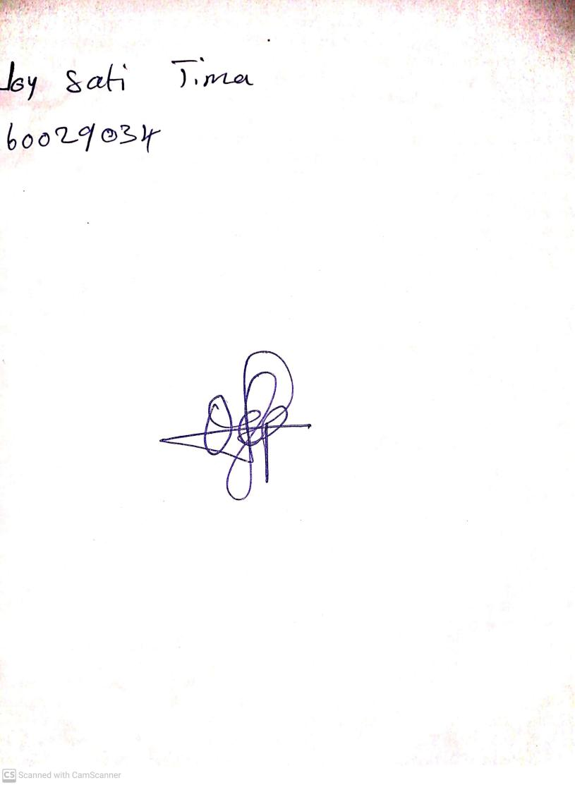

10TH November, 2023

Perpetual Ojoma Ocheja

Stream Head Nursery