**LESSON PLAN AND NOTE 1 FOR WEEK 4 ENDING 06/10/2023**

**Term 1st  term**

**Week 4th  week**

**Date 3rd October,2023**

**Class Nursery one**

**Subject Letter work**

**Topic Matching letter Kk - Oo with picture words.**

**Sub-topic Matching letter Kk - Ll with picture words.**

**Period 2nd period**

**Time 8:50 am**

**Duration 35 minutes**

**No in class 15**

**Average Age 3 years**

**Sex Mixed**

**Specific Objectives: By the end of the lesson the pupils should be able to;**

1. **Match letter Kk - Ll with picture words.**
2. **Write letter Kk - Ll.**

**Rationale: To make sure the pupils match and write Kk - Ll.**

**Previous knowledge: The pupils can match letters Aa - Jj with picture words.**

**Instructional Resources: Chart, board, marker, exercise books, pencils.**

**Reference Materials: Online Research,chart,board.**

**LESSON PRESENTATION**

|  |  |  |  |
| --- | --- | --- | --- |
| **Steps** | **Teacher’s Activities** | **Pupils’ Activities** | **Learning points** |
| **Introduction** | **The teacher introduces the topic (Matching letter Kk - Oo with picture words) to the pupils.** | **The pupils listen attentively to the teacher.** | **To arouse the interest of the pupils.** |
| **Step 1** | **The teacher leads the pupils to to associate letter Kk - Ll with picture words.**  **Ll image of a kettle**  **Kk image of legs** | **The pupils associate pictures with words along with the teacher.**  **Ll image of a kettle**  **Kk image of legs** | **For proper understanding.** |
| **Step 2** | **The teacher guides the pupils to write capital and small letter Kk - Ll inside their notebooks.**   |  |  | | --- | --- | | **Kk** | **Kk** | |  |  | | **Ll** | **Ll** | |  |  | | **The pupils writes capital and smallletter Kk - Ll inside their notebooks.** | **For better understanding.** |
| **Summary** | **The teacher summarizes the lesson by sounding the capital and small letter Kk - Ll for the pupils.** | **The pupils sounds along with their teacher capital and small letter Kk - Ll.** | **For onward study.** |
| **Evaluation** | 1. **Associate letter Kk - Ll with picture words.**   **Ll image of a kettle**  **Kk image of legs**   1. **Write the capital and small letters below:**  |  |  | | --- | --- | | **Kk** | **Ll** | |  |  | | **The pupils answer the question correctly.** | **To ascertain the pupils’ understanding.** |
| **Conclusion** | **The teacher summarizes, reacts & corrects the pupils.** | **The pupils answer to the teacher’s questions.** | **To consolidate the lesson.** |
| **Assignment** | 1. **Write the capital and small letters below:**  |  |  | | --- | --- | | **Kk** | **Ll** | |  |  |  1. **Associate picture words to their letters below:**   **Ll image of a kettle**  **Kk image of legs** | **The pupils copy and do their homework at home.** | **To encourage learning while at home.** |

**LESSON PLAN AND NOTE 2 FOR WEEK 4 ENDING 06/10/2023**

**Term 1st  term**

**Week 4th  week**

**Date 4th October,2023**

**Class Nursery one**

**Subject Letter work**

**Topic Matching letter Kk - Oo with picture words.**

**Sub-topic Matching letter Mm - Nn with picture words.**

**Period 4th period**

**Time 10:40 am**

**Duration 35 minutes**

**No in class 15**

**Average Age 3 years**

**Sex Mixed**

**Specific Objectives: By the end of the lesson the pupils should be able to;**

1. **Match letter Mm - Nn with picture words.**
2. **Write letter Mm - Nn.**

**Rationale: To make sure the pupils match and write Mm - Nn.**

**Previous knowledge: The pupils can match letters Kk - Ll with picture words.**

**Instructional Resources: Chart, board, marker, exercise books, pencils.**

**Reference Materials: Online Research,chart,board.**

**LESSON PRESENTATION**

|  |  |  |  |
| --- | --- | --- | --- |
| **Steps** | **Teacher’s Activities** | **Pupils’ Activities** | **Learning points** |
| **Introduction** | **The teacher introduces the topic (Matching letter Kk - Oo with picture words) to the pupils.** | **The pupils listen attentively to the teacher.** | **To arouse the interest of the pupils.** |
| **Step 1** | **The teacher leads the pupils to to associate letter Mm - Nn with picture words.**  **Nn image of a mouse**  **Mm image of a nose** | **The pupils associate pictures with words letter Mm - Nn along with the teacher.**  **Nn image of a mouse**  **Mm image of a nose** | **For proper understanding.** |
| **Step 2** | **The teacher guides the pupils to write capital and small letter Mm - Nn inside their notebooks.**   |  |  | | --- | --- | | **Mm** | **Mm** | |  |  | | **Nn** | **Nn** | |  |  | | **The pupils writes capital and smallletter Mm - Nn inside their notebooks.** | **For better understanding.** |
| **Summary** | **The teacher summarizes the lesson by sounding the capital and small letter Mm - Nn for the pupils.** | **The pupils sounds along with their teacher capital and small letter Mm - Nn.** | **For onward study.** |
| **Evaluation** | 1. **Associate letter Mm - Nn with picture words.**   **Nn image of a mouse**  **Mm image of a nose**   1. **Write the capital and small letters below:**  |  |  | | --- | --- | | **Mm** | **Mm** | |  |  | | **The pupils answer the question correctly.** | **To ascertain the pupils’ understanding.** |
| **Conclusion** | **The teacher summarizes, reacts & corrects the pupils.** | **The pupils answer to the teacher’s questions.** | **To consolidate the lesson.** |
| **Assignment** | 1. **Write the capital and small letters below:**  |  |  | | --- | --- | | **Mm** | **Mm** | |  |  |  1. **Associate picture words to their letters below:**   **Nn image of a mouse**  **Mm image of a nose** | **The pupils copy and do their homework at home.** | **To encourage learning while at home.** |

**LESSON PLAN AND NOTE 3 FOR WEEK 4 ENDING 06/10/2023**

**Term 1st  term**

**Week 4th  week**

**Date 6th October,2023**

**Class Nursery one**

**Subject Letter work**

**Topic Matching letter Kk - Oo with picture words.**

**Sub-topic Matching letter Kk - Oo with picture words.**

**Period 2nd period**

**Time 8:50 am**

**Duration 35 minutes**

**No in class 15**

**Average Age 3 years**

**Sex Mixed**

**Specific Objectives: By the end of the lesson the pupils should be able to;**

1. **Match letter Kk - Oo with picture words.**
2. **Write letter Kk - Oo .**

**Rationale: To make sure the pupils match and write Kk - Oo .**

**Previous knowledge: The pupils can match with picture words letters Mm - Nn.**

**Instructional Resources: Chart, board, marker, exercise books, pencils.**

**Reference Materials: Online Research,chart,board.**

**LESSON PRESENTATION**

|  |  |  |  |
| --- | --- | --- | --- |
| **Steps** | **Teacher’s Activities** | **Pupils’ Activities** | **Learning points** |
| **Introduction** | **The teacher introduces the topic (Matching letter Kk - Oo with picture words) to the pupils.** | **The pupils listen attentively to the teacher.** | **To arouse the interest of the pupils.** |
| **Step 1** | **The teacher leads the pupils to to associate letter Kk - Oo with picture words.**  **Oo image of a kettle**  **Kk image of an orange**  **Nn image of a mouse**  **Mm image of legs**  **Ll image of a nose** | **The pupils associate pictures with words letters Kk - Oo along with the teacher.**  **Oo image of a kettle**  **Kk image of an orange**  **Nn image of a mouse**  **Mm image of legs**  **Ll image of a nose** | **For proper understanding.** |
| **Step 2** | **The teacher guides the pupils to write capital and small letter Kk - Oo inside their notebooks.**   |  |  | | --- | --- | | **Kk** | **Kk** | |  |  | | **Ll** | **Ll** | |  |  | | **Mm** | **Mm** | |  |  | | **Nn** | **Nn** | |  |  | | **Oo** | **Oo** | |  |  | | **The pupils writes capital and small letter Kk - Oo inside their notebooks.** | **For better understanding.** |
| **Summary** | **The teacher summarizes the lesson by sounding the capital and small letter Kk - Oo for the pupils.** | **The pupils sounds along with their teacher capital and small letter Kk - Oo .** | **For onward study.** |
| **Evaluation** | 1. **Associate letter Kk - Oo with picture words.**   **Oo image of a kettle**  **Kk image of an orange**  **Nn image of a mouse**  **Mm image of legs**  **Ll image of a nose**   1. **Write the capital and small letters below:**  |  |  | | --- | --- | | **Kk** | **Kk** | |  |  | | **Mm** | **Mm** | |  |  | | **Oo** | **Oo** | |  |  | | **The pupils answer the question correctly.** | **To ascertain the pupils’ understanding.** |
| **Conclusion** | **The teacher summarizes, reacts & corrects the pupils.** | **The pupils answer to the teacher’s questions.** | **To consolidate the lesson.** |
| **Assignment** | 1. **Write the capital and small letters below:**  |  |  | | --- | --- | | **Kk** | **Kk** | |  |  | | **Mm** | **Mm** | |  |  | | **Oo** | **Oo** | |  |  |  1. **Associate picture words to their letters below:**   **Oo image of a kettle**  **Kk image of an orange**  **Nn image of a mouse**  **Mm image of legs**  **Ll image of a nose** | **The pupils copy and do their homework at home.** | **To encourage learning while at home.** |

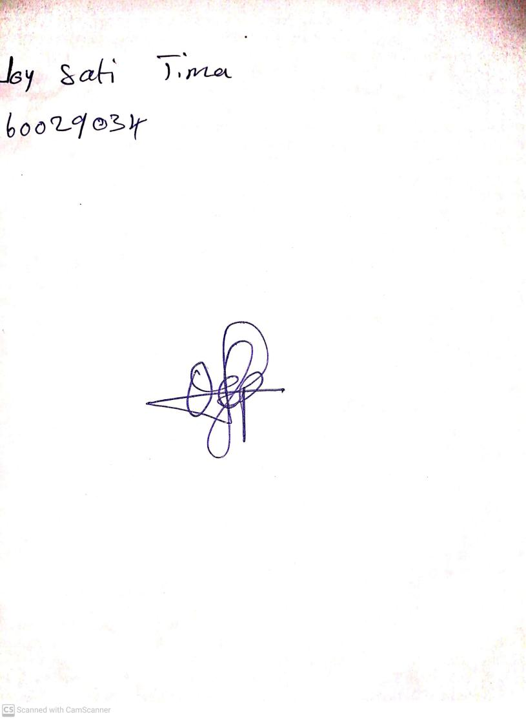

15th August, 2023

Perpetual Ojoma Ocheja

Stream Head Nursery