**EMERALD ROYAL INTERNATIONAL SCHOOL**

**MPAPE, ABUJA.**

**LESSON PLAN AND NOTE FOR WEEK 3 PERIOD 1 ENDING 27/09/2024**

**TERM: FIRST**

**WEEK: 3RD**

**DATE: 23/09/2024**

**CLASS: NURSERY 2**

**SUBJECT: LITERACY**

**TOPIC: THREE LETTER WORDS ENDING “ED” “EN” “ET”**

**"EG"**

**SUB-TOPIC: THREE LETTER WORDS ENDING IN “ED” AND “EN”**

**PERIOD: 1ST PERIOD**

**TIME: 08: 50 - 09:30am**

**DURATION: 40 MINUTES.**

**NUMBER IN CLASS: 14**

**AVERAGE AGE: 5 YEARS.**

**SEX: MIXED.**

**SPECIFIC OBJECTIVES: BY THE END OF THE LESSON,THE PUPILS SHOULD BE**

**ABLE TO:**

**1. IDENTIFY THREE LETTER WORDS ENDING IN "ED" AND**

**"EN"**

**2. SPELL AND PRONOUNCE WORDS WITH “ED”AND "EN"**

**RATIONALE: FOR PUPILS TO BE ABLE TO SPELL AND PRONOUNCE**

**WORDS ENDING “ED" AND "EN”**

**PREVIOU KNOWLEDGE: PUPILS HAVE LEARNT ABOUT THREE LETTER WORDS**

**ENDING IN “AT”“AD”IN PREVIOUS LESSON.**

**INSTRUCTIONAL MATERIALS: A CHART OF THREE LETTER WORDS THAT ENDS IN**

**" ED" AND "EN"**

**REFERENCE MATERIALS: MASTERING ENGLISH FOR NURSERY SCHOOLS BOOK 2**

**BY J.M OMOGBAI .**

**LESSON DEVELOPMENT**

|  |  |  |  |
| --- | --- | --- | --- |
| **STAGES/STEPS** | **TEACHER’S ACTIVITIES** | **PUPILS’ ACTIVITIES** | **LEARNING POINTS** |
| **INTRODUCTION** | **Teacher introduces the lesson by reviewing the previous lesson.** | **Pupils listen attentively to the teacher.** | **To arouse pupils interest for the lesson ahead.** |
| **PRESENTATION**  **STEP 1** | **Teacher writes three letter words ending in “ed”, “en” on the board identify and asks pupils to repeat after her.** | **Pupils listen attentively to the teacher and repeat after her.** | **For proper understanding .** |
| **STEP 2** | **Teacher spells and pronounce the words on the board to pupils and also asks them to repeat after her.** | **Pupils pay attention to the teacher and repeat after her.** | **For better understanding of the lesson.** |
| **BOARD SUMMARY** | **Teacher writes the whole not of lesson on the board for pupils to copy. That is:**  **Three letter words ending in “ed”, “en”:**  **“ed” as in;**   1. **Bed** 2. **Fed** 3. **Red** 4. **Ted** 5. **Led etc**   **“ en” as in;**   1. **Ben** 2. **Hen** 3. **Men** 4. **Ten** 5. **Pen** 6. **Den etc.** | **Pupils copy the note into their exercise books.** | **For onward study.** |
| **EVALUATION** | **Teacher evaluates the lesson by asking pupils to spell and pronounce words ending in “ed” and “en” on the board one after another.** | **Pupils listen to the teacher and read the note on the board one after another.** | **To assess pupils reading skills.** |
| **CONCLUTION** | **Teacher concludes the lesson by marking pupils books.** | **Pupils submit their books for marking.** | **For endorsement.** |
| **ASSIGNMENT** | **Fill in the missing letters:**   1. **B ---- d** 2. **R ---- d** 3. **F ----- d** 4. **T ----- d** 5. **L ----- d** 6. **B ---- n** 7. **H ---- n** 8. **M ---- n** 9. **T ---- n** 10. **P ---- n** | **Pupils do their assignment at home.** | **To encourage learning at home.** |

**LESSON PLAN AND NOTE FOR WEEK 3 PERIOD 2 ENDING 27/09/2024**

**TERM: FIRST**

**WEEK: 3RD**

**DATE: 24/09/2024**

**CLASS: NURSERY 2**

**SUBJECT: LITERACY**

**TOPIC: THREE LETTER WORDS ENDING IN “ed" “en"“et" "eg"**

**SUB-TOPIC: THREE LETTER WORDS ENDING IN “et”**

**PERIOD : 2ND PERIOD**

**TIME: 08: 50 - 09:30am**

**DURATION: 40 MINUTES.**

**NUMBER IN CLASS: 14**

**AVERAGE AGE: 5 YEARS.**

**SEX: MIXED.**

**SPECIFIC OBJECTIVES: BY THE END OF THE LESSON,THE PUPILS SHOULD BE**

**ABLE TO:**

1. **IDENTIFY THREE LETTER WORDS ENDING IN “et”.**
2. **SPELL AND PRONOUNCE THREE LETTER WORDS**

**ENDING “et"**

**RATIONALE: FOR PUPILS TO BE ABLE TO SPELL AND PRONOUNCE WORDS ENDING WITH “et”**

**PREVIOU KNOWLEDGE: PUPILS HAVE LEARNT ABOUT THREE LETTER WORDS ENDING IN “ed” AND “en” PREVIOUS LESSON.**

**INSTRUCTIONAL MATERIALS: CHART OF THREE LETTER WORDS ENDING IN “et”.**

**REFERENCE MATERIALS: MASTERING ENGLISH FOR NURSERY SCHOOLS BOOK 3**

**BY J.M OMOGBAI.**

**LESSON DEVELOPMENT**

|  |  |  |  |
| --- | --- | --- | --- |
| **STAGES/STEPS** | **TEACHER’S ACTIVITIES** | **PUPILS’ ACTIVITIES** | **LEARNING POINTS** |
| **INTRODUCTION** | **Teacher introduces the lesson by asking pupils to spell and pronounce words ending in “ed” and “en” .** | **Pupils spell and pronounce words with “at” and “ad”.** | **To arouse pupils interest for the lesson ahead.** |
| **PRESENTATION**  **STEP 1** | **Teacher writes three letter words ending in “et” on the board, identify to pupils and then asks them to repeat after her.** | **Pupils listen attentively to the teacher and repeat after her.** | **For proper understanding .** |
| **STEP 2** | **Teacher guides pupils on how to spell and pronounce the three letter words ending in “et” on the board and also asks them to repeat after her.** | **Pupils pay attention to the teacher and repeat after her.** | **For better understanding of the lesson.** |
| **BOARD SUMMARY** | **Teacher writes the whole not of lesson on the board for pupils to copy. That is;**  **Three letter words ending in “et” :**  **Three letter words ending in “et” are:**   1. **Vet** 2. **Set** 3. **Met** 4. **Bet** 5. **Pet** 6. **Net** 7. **Ret** 8. **Tet** 9. **Wet** 10. **Cet etc.** | **Pupils copy the note into their exercise books.** | **For onward study.** |
| **EVALUATION** | **Teacher evaluates the lesson by asking pupils to all stand and,**   1. **Identify the three letter words ending in "et" on the board.** 2. **Spell and pronounce words ending in “et" on the board.** | **Pupils listen to the teacher and read the note on the board one after another.** | **To assess pupils reading skills.** |
| **CONCLUTION** | **Teacher concludes the lesson by marking pupils books.** | **Pupils submit their books for marking.** | **For endorsement.** |
| **ASSIGNMENT** | **Spell and pronounce 10 words ending in “et”** | **Pupils do their assignment at home.** | **To encourage learning at home.** |

**LESSON PLAN AND NOTE FOR WEEK 3 PERIOD 3 ENDING 27/09/2024**

**TERM: FIRST**

**WEEK: 3RD**

**DATE: 25/09/2024**

**CLASS: NURSERY 2**

**SUBJECT: LITERACY**

**TOPIC: THREE LETTER WORDS ENDING IN “ED,EN,ET,EG.**

**SUB-TOPIC: THREE LETTER WORDS ENDING IN “EG”.**

**PERIOD: 3RD PERIOD**

**TIME: 08: 50 - 09:30am**

**DURATION: 40 MINUTES.**

**NUMBER IN CLASS: 14**

**AVERAGE AGE: 5 YEARS.**

**SEX: MIXED.**

**SPECIFIC OBJECTIVES: BY THE END OF THE LESSON,THE PUPILS SHOULD BE**

**ABLE TO:**

1. **IDENTIFY THREE LETTER WORDS ENDING IN “EG”.**
2. **SPELL AND PRONOUNCE THREE LETTER WORDS ENDING IN “EG”.**

**RATIONALE: FOR PUPILS TO KNOW HOW TO PRONOUNCE WORDS**

**ENDING IN“EG”.**

**PREVIOU KNOWLEDGE: PUPILS HAVE LEARNT ABOUT THREE LETTER WORDS**

**ENDING IN“ET”**

**REFERENCE MATERIALS: MASTERING ENGLISH FOR NURSERY SCHOOLS BOOK 3**

**BY J.M OMOGBAI .**

**LESSON DEVELOPMENT**

|  |  |  |  |
| --- | --- | --- | --- |
| **STAGES/STEPS** | **TEACHER’S ACTIVITIES** | **PUPILS’ ACTIVITIES** | **LEARNING POINTS** |
| **INTRODUCTION** | **Teacher reviews the previous lesson to pupils.** | **Pupils listen attentively to the teacher.** | **To arouse pupils interest for the lesson ahead.** |
| **PRESENTATION**  **STEP 1** | **Teacher writes three letter words ending in “eg” on the board for pupils to identify.** | **Pupils listen attentively to the board and identify .** | **For proper understanding .** |
| **STEP 2** | **Teacher spells and pronounce three letter words ending in “eg” on the board and then asks pupils to repeat after her.** | **Pupils pay attention to the teacher and repeat after her.** | **For better understanding of the lesson.** |
| **BOARD SUMMARY** | **Teacher writes the whole not of lesson on the board for pupils to copy.ie,**  **Three letter words ending in “eg”**  **Three letter words ending “eg” are:**   1. **Leg** 2. **Peg** 3. **Beg** 4. **Keg** 5. **Meg** 6. **Seg** 7. **Neg** 8. **Reg** 9. **Teg** 10. **Veg** 11. **Zeg etc.** | **Pupils copy the note into their exercise books.** | **For onward study.** |
| **EVALUATION** | **Teacher evaluates the lesson by asking pupils to all stand and,**   1. **Identify the three letter words ending in "eg" on the board.** 2. **Spell and pronounce the words that ends in “eg” on the board one after another.** | **Pupils listen to the teacher and read the note on the board one after another.** | **To assess pupils reading skills.** |
| **CONCLUTION** | **Teacher concludes the lesson by marking pupils books.** | **Pupils submit their books for marking.** | **For endorsement.** |
| **ASSIGNMENT** | **Spell and pronounce ten (10) three letter words that ends in” eg”.** | **Pupils do their assignment at home.** | **To encourage learning at home.** |

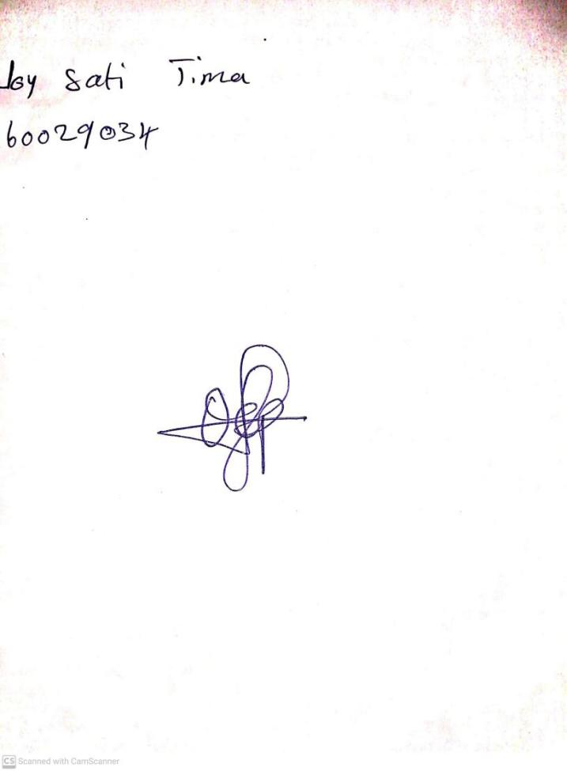

**20th September, 2024**

**Perpetual Ojoma Ocheja**

**Stream Head Nursery**