**EMERALD ROYAL INTERNATIONAL SCHOOL MPAPE, ABUJA.**

**LESSON PLAN AND NOTE FOR WEEK 4 PERIOD 1 ENDING 17/05/2024**

**TERM: 3rd**

**WEEK: 4th**

**DATE: 13/05/2024**

**CLASS: Nursery 2**

**SUBJECT: Number work**

**TOPIC: Place value of numbers**

**SUB—TOPIC: Meaning of place value**

**PERIOD: 1st**

**TIME: 08:50—09:30 am**

**DURATION: 40 minutes**

**NUMBER IN CLASS: 13**

**AVERAGE AGE: 5 years**

**SEX: Mixed**

**LEARNING OBJECTIVES: By the end of the lesson, the Pupils should be able to:**

**1. Explain the meaning of digit.**

**2. State the meaning of place value.**

**RATIONALE: For Pupils to know the meaning of the topic, place value of numbers.**

**PREVIOUS KNOWLEDGE: Pupils have learnt counting of numbers.**

**INSTRUCTIONAL MATERIALS: chart of place value of numbers.**

**REFERENCE MATERIALS: Google. com**

**LESSON DEVELOPMENT**

|  |  |  |  |
| --- | --- | --- | --- |
| **STAGES/ STEPS** | **TEACHER'S ACTIVITIES** | **PUPILS' ACTIVITIES** | **LEARNING POINT** |
| **Introduction** | **Teacher reviews the previous lesson.** | **Pupils listen attentively to the teacher.** | **To arouse pupils interest for the lesson.** |
| **Presentation step 1** | **Teacher explains the meaning of digit to pupils and then asks them to repeat after her.** | **Pupils listen to the teacher and repeat after her.** | **For proper understanding.** |
| **Step 2** | **Teacher States the meaning of place value to pupils and also asks them to repeat after her.** | **Pupils pay attention to the teacher and repeat after her.** | **To enhance Pupils participation in class.** |
| **Board summary** | **Teacher writes the whole note of lesson on the board for pupils to copy into their books. That is,**  **PLACE VALUE OF NUMBERS**  **Place value: describes the position of each digit in a number.**  **Digit: means any number from zero to 9.**  **The 10 digits we used to represent the numbers are:**  **0 1 2 3 4 5 6 7 8 9** | **Pupils copy the note into their exercise books.** | **For onward study.** |
| **Evaluation** | **Teacher evaluates the lesson by asking pupils the following questions;**  **1. What is the meaning of place value?**  **2. Digit means ____.** | **Pupils answer the questions ask by the teacher.** | **To assess Pupils level of understanding.** |
| **Conclusion** | **Teacher concludes the lesson by marking pupils books.** | **Pupils submit their books for marking.** | **For endorsement.** |
| **Assignment** | **1. Explain the meaning of place value.**  **2. 786 which digit is in the tens place?**  **3. 786 which digit is in the ones place?**  **4. 786 which digit is in the hundreds place?** | **Pupils do their assignment at home.** | **To encourage learning at home.** |

**LESSON PLAN AND NOTE 2 FOR WEEK 4 ENDING 17/05/2024**

**TERM: 3rd**

**WEEK: 4th**

**DATE: 14/05/2024**

**CLASS: Nursery 2**

**SUBJECT: Number work**

**TOPIC: Place value of numbers**

**SUB—TOPIC: Meaning of place value.**

**PERIOD: 2nd**

**TIME: 08:50—09:30 am**

**DURATION: 40 minutes**

**NUMBER IN CLASS: 13**

**AVERAGE AGE: 5 years**

**SEX: Mixed**

**LEARNING OBJECTIVES: By the end of the lesson, the Pupils should be able to:**

**1. Explain numbers according to their place value.**

**2. Solve simple problem on place value.**

**RATIONALE: For Pupils to know the meaning of the topic, place value of numbers.**

**PREVIOUS KNOWLEDGE: Pupils have learnt the meaning of place value and digit in previous lesson.**

**INSTRUCTIONAL MATERIALS: chart of place value of numbers.**

**REFERENCE MATERIALS: Google. com**

**LESSON DEVELOPMENT**

|  |  |  |  |
| --- | --- | --- | --- |
| **STAGES/ STEPS** | **TEACHER'S ACTIVITIES** | **PUPILS' ACTIVITIES** | **LEARNING POINT** |
| **Introduction** | **Teacher reviews the previous lesson.** | **Pupils listen attentively to the teacher.** | **To arouse pupils interest for the lesson.** |
| **Presentation step 1** | **Teacher writes numbers on the board and then explains them according to the position each digit represents and then asks pupils to repeat after her.**  **As;**  **Examples: find the place value of each of the digits.**  **Method 1:**  **(i) 145**  **Solution**  **The use of counting in hundreds tens and ones**  **145 = 100 + 40 + 5**  **100 = 10 bundles of ten = 10 tens = 1 hundred.**  **40 = 4 bundles of ten = 4 tens.**  **5 = 5 ones**  **=145= 1 hundreds, 4 tens, 5 ones.**  **Method 2: place value into hundreds, tens and ones**  **H T O= Place.**  **1 4 5= value.**  **= 145 = 1 hundred, 4 tens, 5 ones** | **Pupils listen to the teacher and repeat after her.** | **For proper understanding.** |
| **Step 2** | **Teacher guides pupils to solve some simple questions on the board. As;**  **Find the place value of each of the digits.**  **(i) 276**  **(ii) 158**  **(iii) 209 etc.** | **Pupils pay attention to the teacher solve the questions on the board. As;**  **Solution:**  **(i) 276= 2 hundreds, 7 tens and 6 ones.**  **(ii) 158= 1 hundreds, 5 tens and 8 ones.**  **(iii) 209= 2 hundreds, 0 tens and 9 ones etc.** | **To enhance Pupils participation in class.** |
| **Board summary** | **Teacher writes the whole note of lesson on the board for pupils to copy into their books. That is;**  **Find the place value of the following digits.**  **1. 145**  **2. 273**  **3. 213**  **4. 184**  **5. 159**  **Solution:**   |  |  |  | | --- | --- | --- | | **H**  **(Hundreds)** | **T**  **(Tens)** | **O**  **(Ones)** | | **1** | **4** | **5** | | **2** | **7** | **3** | | **2** | **1** | **3** | | **1** | **8** | **4** | | **1** | **5** | **9** | | **Pupils copy the note into their exercise books.** | **For onward study.** |
| **Evaluation** | **Teacher evaluates the lesson by asking pupils the following questions;**  **Write the place value of each of the digits.**  **1.248**  **2. 105**  **3. 271**  **4. 300**  **5. 129** | **Pupils answer the questions ask by the teacher.** | **To assess Pupils level of understanding.** |
| **Conclusion** | **Teacher concludes the lesson by marking pupils books.** | **Pupils submit their books for marking.** | **For endorsement.** |
| **Assignment** | **What is the place value of each underline digit?**  **(a) 651**  **(b)128**  **(c)203**  **(d)408**  **(e)643**  **(f)344**  **(g)600**  **(h)733**  **(i)888**  **(j)611** | **Pupils do their assignment at home.** | **To encourage learning at home.** |

**LESSON PLAN AND NOTE 3 FOR WEEK 4 ENDING 17/05/2024**

**TERM: 3rd**

**WEEK: 4th**

**DATE: 17/05/2024**

**CLASS: Nursery 2**

**SUBJECT: Number work**

**TOPIC: Place value of numbers**

**SUB—TOPIC: solving simple problems on place value of numbers.**

**PERIOD: 3rd**

**TIME: 08: 10–80 :50am**

**DURATION: 40 minutes**

**NUMBER IN CLASS: 17**

**AVERAGE AGE: 5 years**

**SEX: Mixed**

**LEARNING OBJECTIVES: By the end of the lesson, the Pupils should be able to:**

**1. Explain numbers according to their place value.**

**2. Solve simple problem on place value.**

**RATIONALE: For Pupils to know the meaning of the topic, place value of numbers.**

**PREVIOUS KNOWLEDGE: Pupils have learnt the meaning of place value and digit in previous lesson.**

**INSTRUCTIONAL MATERIALS: chart of place value of numbers.**

**REFERENCE MATERIALS: Google. com**

**LESSON DEVELOPMENT**

|  |  |  |  |
| --- | --- | --- | --- |
| **STAGES/ STEPS** | **TEACHER'S ACTIVITIES** | **PUPILS' ACTIVITIES** | **LEARNING POINT** |
| **Introduction** | **Teacher reviews the previous lesson.** | **Pupils listen attentively to the teacher.** | **To arouse pupils interest for the lesson.** |
| **Presentation step 1** | **Teacher writes numbers on the board and then explains them according to the position each digit represents and then asks pupils to repeat after her.**  **As;**  **Examples: In the number 705, study the place value of each number.**  **Solution:**  **A. The place value of 7 is Hundreds.**  **B. The place value of 0 is Tens.**  **C. The place value of 5 is Ones.** | **Pupils listen to the teacher and repeat after her.** | **For proper understanding.** |
| **Step 2** | **Teacher guides pupils to solve some simple questions on the board. As;**  **Find the place value of each of the digits.**  **(i) 532**  **(ii) 649**  **(iii) 920**  **(iv) 984** | **Pupils pay attention to the teacher solve the questions on the board. As;**  **Solution:**  **(i) 532= 5 hundreds, 3 tens and 2 ones.**  **(ii) 649 = 6 hundreds, 4 tens and 9 ones.**  **(iii) 920 = 9 hundreds, 2 tens and 0 ones**  **(iv) 984 = 9 hundreds, 8 Tens and 4 ones.** | **To enhance Pupils participation in class.** |
| **Board summary** | **Teacher writes the whole note of lesson on the board for pupils to copy into their books. That is;**  **Write the place value of the following digits.**  **1. 92**  **2. 84**  **3. 48**  **4. 16**  **5. 125**  **6. 231**  **7. 249**  **8.174**  **Solution:**   |  |  |  | | --- | --- | --- | | **H**  **(Hundreds)** | **T**  **(Tens)** | **O**  **(Ones)** | |  | **9** | **2** | |  | **8** | **4** | |  | **4** | **8** | |  | **1** | **6** | | **1** | **2** | **5** | | **2** | **3** | **1** | | **2** | **4** | **9** | | **1** | **7** | **4** | | **Pupils copy the note into their exercise books.** | **For onward study.** |
| **Evaluation** | **Teacher evaluates the lesson by asking pupils the following questions;**  **What the place value of each of the digits.**  **1.48**  **2. 05**  **3. 27**  **4. 30**  **5. 129** | **Pupils answer the questions ask by the teacher.** | **To assess Pupils level of understanding.** |
| **Conclusion** | **Teacher concludes the lesson by marking pupils books.** | **Pupils submit their books for marking.** | **For endorsement.** |
| **Assignment** | **Copy and complete these sentences.**  **(a) 5 Tens and 8 ones makes 58.**  **(b) 3 Tens and 5 ones makes_____?**  **(c) 7 Tens and 4 ones makes_____?**  **(d) 8 Tens and 3 ones makes_____?**  **(e) 6 Tens and 1 ones makes______?** | **Pupils do their assignment at home.** | **To encourage learning at home.** |

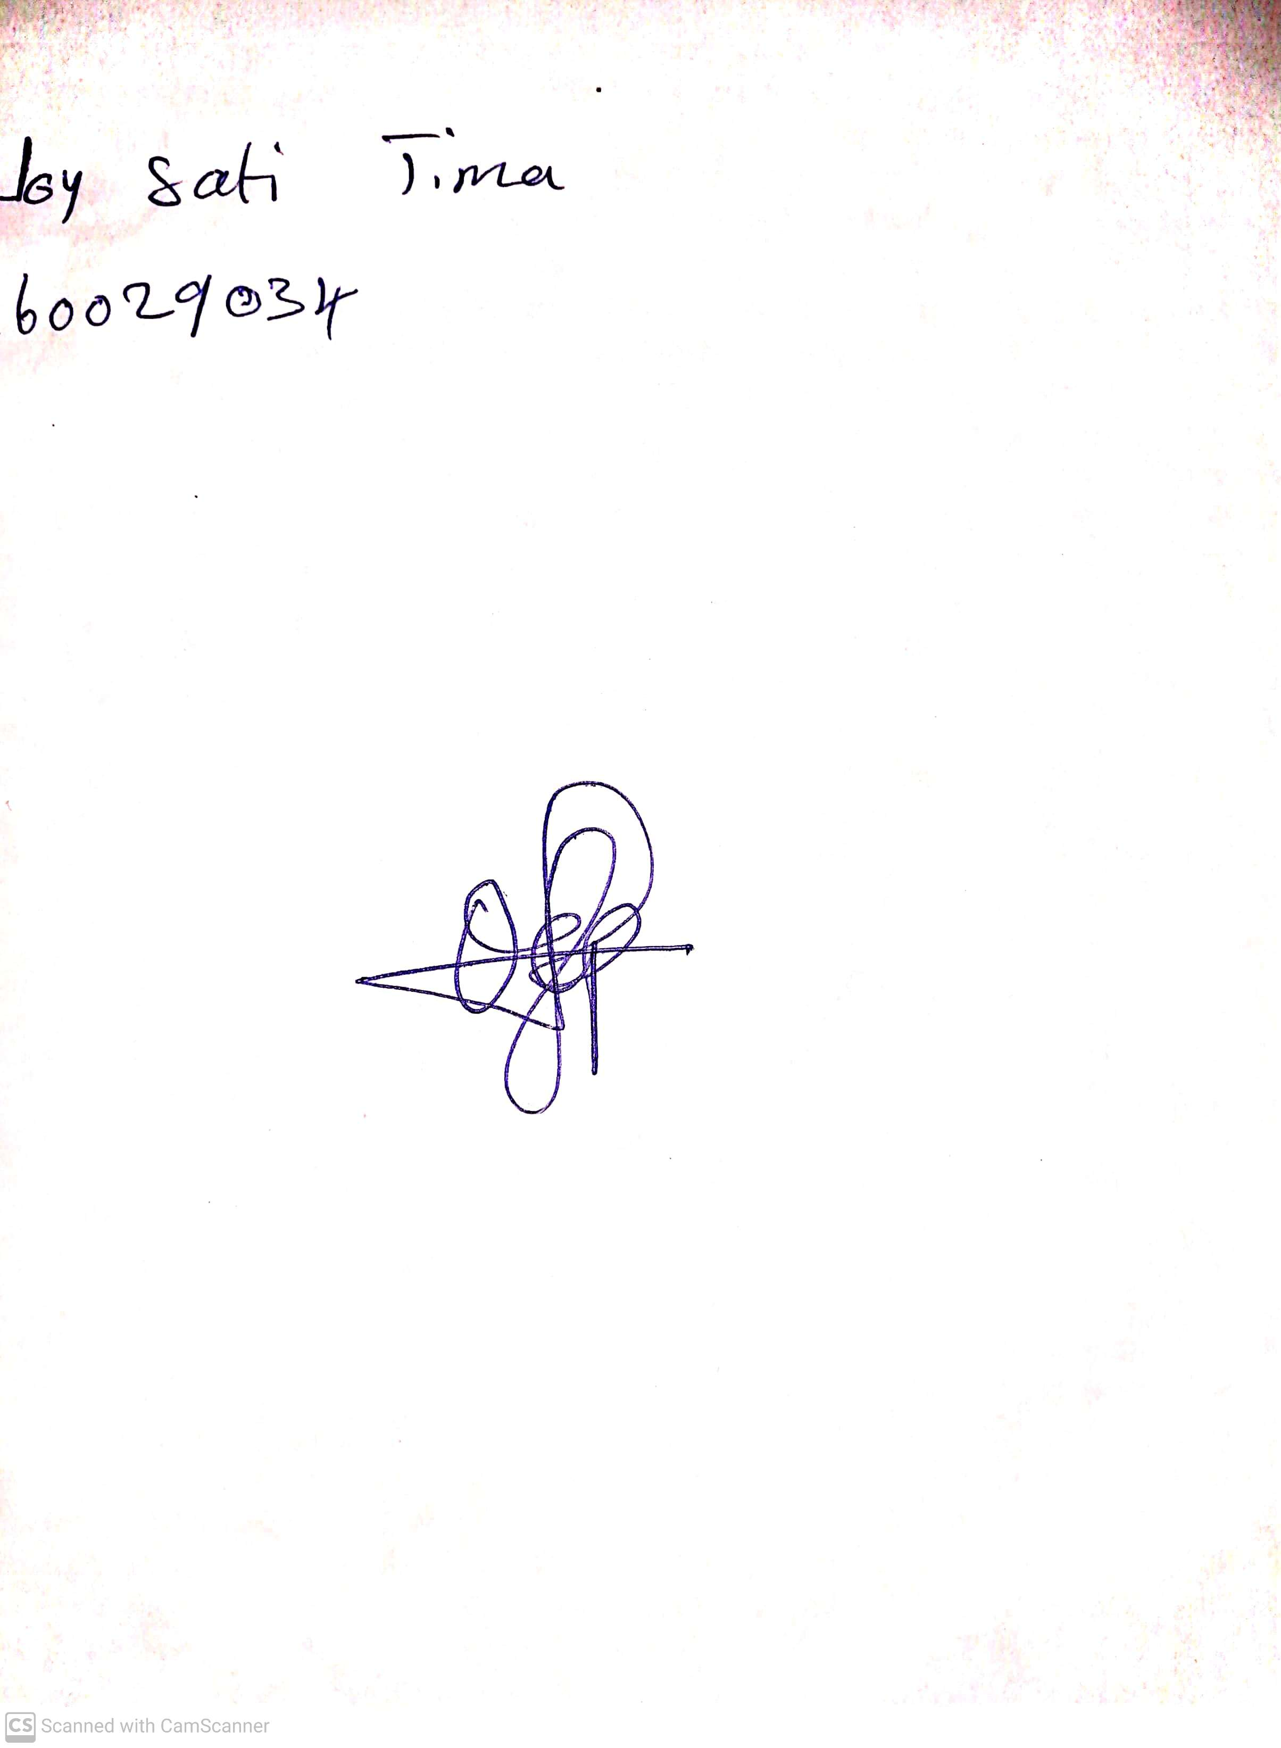

**10th May, 2024**

**Perpetual Ojoma Ocheja**

**Stream Head Nursery**