LESSON PLAN/NOTE FOR WEEK 9 ENDING 10/03/2023

TERM:2nd

WEEK:9th

DATE:10/03/2023

CLASS: Nursery 2

SUBJECT: Letter work

TOPIC: Consonant Digraphs 2

SUB—TOPIC: Words with consonant digraphs 'mb'

PERIOD: 3rd

TIME: 09:30–10:10am

DURATION: 40 minutes

NUMBER IN CLASS: 14

AVERAGE AGE:5 years

SEX: Mixed

LEARNING OBJECTIVES: By the end of the lesson, the Pupils should be able to:

1. Make words with consonant digraphs 'mb'.

2. Spell and pronounce words with consonant digraphs 'mb'

RATIONALE: For Pupils to know how to pronounce words with consonant digraphs 'mb'

PREVIOUS KNOWLEDGE: Pupils have learnt consonant digraphs 'wr' in previous lesson.

INSTRUCTIONAL MATERIALS: A chart of words with consonant digraphs "mb"

REFERENCE MATERIALS: Google. com

LESSON DEVELOPMENT

|  |  |  |  |
| --- | --- | --- | --- |
| Steps | Teacher's activities | Pupils' activities | Learning point |
| Introduction | Teacher introduces the lesson by singing nursery rhymes. | Pupils sing the rhymes along with the teacher. | To prepare pupils minds for the lesson ahead. |
| Presentation step 1 | Teacher makes words with consonant digraphs 'mb' on the board and then ask Pupils to repeat after her. | Pupils pay attention to the teacher and repeat after her. | For proper understanding. |
| Step 2 | Teacher guides pupils to all stand and then spell and pronounce the words on the board . | Pupils all stand and then spell and pronounce the words on the board. | For better understanding. |
| Board summary | Teacher writes the whole note of lesson on the board for pupils to copy. That is;  Consonant digraphs 'mb' are:  ‘mb’ as in comb  ‘mb’ as in thumb  ‘mb’ as in lamb  ‘mb’ as in climb  ‘mb’ as in limb  ‘mb’ as in number etc. | Pupils copy the note into their books. | For onward study. |
| Evaluation | Teacher evaluates the lesson by asking pupils individually to go to the board and read. | Pupils go to the board one after another and read. | To create platform for slow learners. |
| Conclusion | Teacher concludes the lesson by marking pupils books and letting them ready for their examination. | Pupils submit their books on the teacher desk for marking. | For endorsement. |
| Assignment | Read all your notes for examination. | Pupils read their books at home. | To get pupils prepare for their examination. |

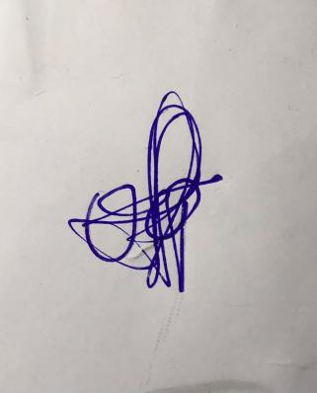

**29th March, 2023**

**Perpetual Ojoma Ocheja**

**Stream Head Nursery**