LESSON PLAN AND NOTE FOR WEEK 3 ENDING 29/09/2023

TERM: 1st

WEEK: 3rd

DATE: 25/09/2023

CLASS: Nursery 2

SUBJECT: Nature studies

TOPIC: My body

SUB—TOPIC: Parts of the body.

PERIOD: 4th

TIME: 10:40—11:20am

DURATION: 40 minutes

NUMBER IN CLASS: 14

AVERAGE AGE: 5 years

SEX: Mixed

LEARNING OBJECTIVES: By the end of the lesson, the pupils should be able to:

1. Mention parts of the body.

2. State the reasons for caring for the body

3. Outline the materials for caring for the body.

RATIONALE: For pupils to know parts of their body and why we should care for our body.

PREVIOUS KNOWLEDGE: Pupils have learnt about the meaning of first aid in previous lesson.

INSTRUCTIONAL MATERIALS: A chart of parts of the body.

REFERENCE MATERIALS: Basic science and technology for Nursery schools book 3 by OPEMIPO DADA.

LESSON DEVELOPMENT

|  |  |  |  |
| --- | --- | --- | --- |
| Steps | Teacher's activities | Pupils' activities | Learning point |
| Introduction | Teacher introduces the lesson by reviewing the previous lesson. | Pupils pay attention to the teacher. | To prepare pupils minds for the lesson ahead. |
| Presentation step 1 | Teacher mentions the parts of the body to pupils and then asks them to repeat after her. | Pupils listen to the teacher and repeat after her. | To improve pupils listening and speaking ability. |
| Step 2 | Teacher states the reasons for caring for the body parts to pupils and also asks them to repeat after her. | Pupils pay attention to the teacher and repeat her. | To enhance pupils participation in the class. |
| Step 3 | Teacher outline the materials for caring for the parts of the body to pupils and also asks pupils to repeat after her. | Pupils listen attentively to the teacher and repeat after her. | To improve pupils speaking ability. |
| Board summary | Teacher writes the whole note of lesson on the board for pupils to copy into their books. That is;  Body parts:    The human body is made up of the following;   1. Head 2. Neck 3. Hair 4. Eyes 5. Nose 6. Mouth–teeth–tongue 7. Ears 8. hand 9. Foot 10. Toe 11. Leg 12. Nail 13. Fingers 14. Elbow etc.   Reasons for caring for our body:   1. To prevent diseases. 2. To look nice and beautiful. 3. To look neat. 4. To have self respect. 5. To prevent body odour. 6. To prevent body rashes and other skin infections. 7. To keep it healthy. 8. To keep it strong.   Materials used for caring for the body:   1. Soap 2. Sponge 3. Water 4. Cotton wool 5. Towel 6. Body cream or lotion 7. Hair brush or comb etc. | Pupils copy the note into their exercise books. | For onward study. |
| Evaluation | Teacher evaluates the lesson by asking pupils the following questions;   1. Mention the parts of the body. 2. Why do we care for our body? 3. State the materials for caring for the body. | Pupils answer the questions asked by the teacher. | To assess pupils level of understanding. |
| Conclusion | Teacher concludes the lesson by marking pupils books. | Pupils submit their books for marking. | For endorsement. |
| Assignment | 1. What is a cut? 2. Why do we care for cut? | Pupils do their assignment at home. | To encourage learning at home. |

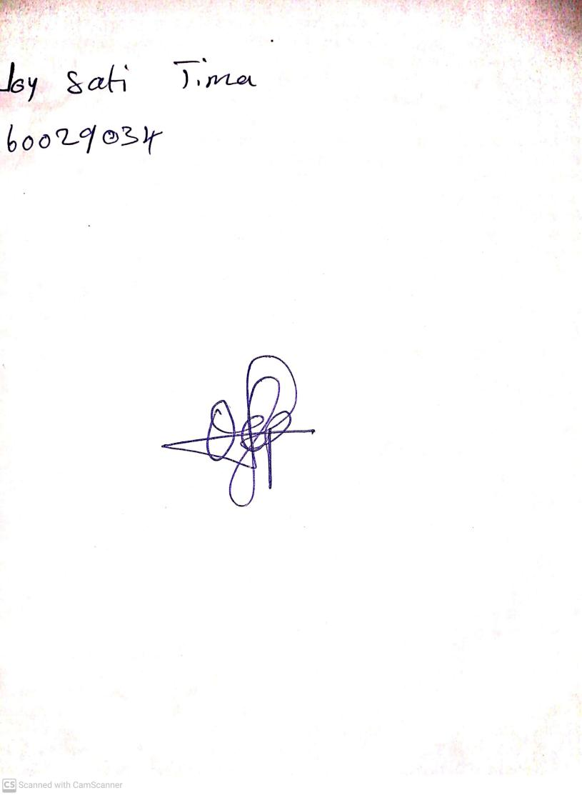

27th August, 2023

Perpetual Ojoma Ocheja

Stream Head Nursery