**LESSON PLAN AND NOTE 1 FOR WEEK 11 ENDING 24/11/2023**

**Term 1st  term**

**Week 11th week**

**Date 20th November,2023**

**Class Nursery one**

**Subject Letter work**

**Topic Tracing letter Vv - Ww.**

**Sub-topic Trace letter Vv, Ww.**

**Period 2nd period**

**Time 8:50 am**

**Duration 35 minutes**

**No in class 15**

**Average Age 3 years**

**Sex Mixed**

**Specific Objectives: By the end of the lesson the pupils should be able to;**

1. **Sound letter Vv, Ww.**
2. **Identify letter Vv, Ww.**
3. **Trace letter Vv, Ww.**

**Rationale: To make sure the pupils sound trace and identify letter Vv, Ww.**

**Previous knowledge: The pupils can match objects to their names.**

**Instructional Resources: Chart, board, marker, exercise books, pencils.**

**Reference Materials: Online Research,chart,board.**

**LESSON PRESENTATION**

|  |  |  |  |
| --- | --- | --- | --- |
| **Steps** | **Teacher’s Activities** | **Pupils’ Activities** | **Learning points** |
| **Introduction** | **The teacher introduces the topic (Tracing of letters Vv - Ww) to the pupils by rhyming it.** | **The pupils listen attentively to the teacher.** | **To arouse the interest of the pupils.** |
| **Step 1** | **The teacher assists the pupils to sound letters Vv, Ww**  **V v**  **W w** | **The pupils individually sound the letters Vv, Ww.** | **For proper understanding.** |
| **Step 2** | **The teacher leads the pupils to identify letter Vv, Ww .**  **Vv Ww** | **The pupils identify the letter Vv, Ww after the teacher.** | **For better understanding.** |
| **Step 3** | **The teacher guides the pupils in tracing letters Vv, Ww inside their notebooks**  **untraced letter Vv**  **untraced letter Ww** | **The pupils trace the letters Vv, Ww as the teacher guides them.** | **For further understanding.** |
| **Summary** | **The teacher summarizes the lesson by sounding capital and small letter Vv, Ww.** | **The pupils can sound capital and small letter Vv, Ww.** | **For onward study.** |
| **Evaluation** | **The teacher asks the pupils to:**   1. **Sound the letters below?**     **Vv Ww**   1. **Identify these letters below?**   **Vv Ww**     1. **Trace the letters Vv, Ww below?**   **untraced letter Vv**  **untraced letter Ww** | **The pupils answer the question correctly.** | **To ascertain the pupils’ understanding.** |
| **Conclusion** | **The teacher summarizes, reacts & corrects the pupils.** | **The pupils answer to the teacher’s questions.** | **To consolidate the lesson.** |
| **Assignment** | **Sound the letters below?**    **Vv Ww**  **Identify these letters below?**  **Vv Ww**  **Trace capital and small letter Vv, Ww?**  **untraced letter Vv**  **untraced letter Ww** | **The pupils copy and do their homework at home.** | **To encourage learning while at home.** |

**LESSON PLAN AND NOTE 2 FOR WEEK 11 ENDING 24/11/2023**

**Term 1st  term**

**Week 11th week**

**Date 22nd November,2023**

**Class Nursery one**

**Subject Letter work**

**Topic Tracing letter Vv - Zz.**

**Sub-topic Trace letter Xx-Yy.**

**Period 4th period**

**Time 10:40 am**

**Duration 35 minutes**

**No in class 15**

**Average Age 3 years**

**Sex Mixed**

**Specific Objectives: By the end of the lesson the pupils should be able to;**

1. **Sound letter Xx-Yy.**
2. **Identify letter Xx-Yy.**
3. **Trace letter Xx-Yy.**

**Rationale: To make sure the pupils trace and identify letter Xx-Yy.**

**Previous knowledge: The pupils can trace and identify letter Vv, Ww.**

**Instructional Resources: Chart, board, marker, exercise books, pencils.**

**Reference Materials: Online Research,chart,board.**

**LESSON PRESENTATION**

|  |  |  |  |
| --- | --- | --- | --- |
| **Steps** | **Teacher’s Activities** | **Pupils’ Activities** | **Learning points** |
| **Introduction** | **The teacher introduces the topic (Tracing letter Vv-Zz) to the pupils by rhyming them.** | **The pupils listen attentively to the teacher.** | **To arouse the interest of the pupils.** |
| **Step 1** | **The teacher assists the pupils to sound letter Xx-Yy.**  **Xx Yy** | **The pupils individually sound the letters Xx-Yy.** | **For proper understanding.** |
| **Step 2** | **The teacher leads the pupils to identify letter Xx-Yy.**    **Xx Yy** | **The pupils identify the letter Xx-Yy after the teacher.** | **For better understanding.** |
| **Step 3** | **The teacher guides the pupils in tracing letters Xx-Yy**  **untraced letter Xx**  **untraced letter Yy** | **The pupils trace the letters Xx-Yy as the teacher guides them.** | **For further understanding.** |
| **Summary** | **The teacher summarizes the lesson by sounding letters Xx-Yy to the pupils.** | **The pupils can sound letters Xx-Yy.** | **For onward study.** |
| **Evaluation** | **The teacher asks the pupils to:**   1. **Sound the letters below?**   **Xx Yy**   1. **Identify these letters below?**   **Xx Yy**   1. **Trace the letters below?**   **untraced letter Xx**  **untraced letter Yy** | **The pupils answer the question correctly.** | **To ascertain the pupils’ understanding.** |
| **Conclusion** | **The teacher summarizes, reacts & corrects the pupils.** | **The pupils answer to the teacher’s questions.** | **To consolidate the lesson.** |
| **Assignment** | **Sound the letters below?**  **Xx Yy**  **Identify these letters below?**  **Xx Yy**  **Trace capital and small letter Xx-Yy ?**  **untraced letter Xx**  **untraced letter Yy** | **The pupils copy and do their homework at home.** | **To encourage learning while at home.** |

**LESSON PLAN AND NOTE 3 FOR WEEK 11 ENDING 24/11/2023**

**Term 1st  term**

**Week 11th week**

**Date 24th  November,2023**

**Class Nursery one**

**Subject Letter work**

**Topic Tracing letter Vv - Zz.**

**Sub-topic Trace letter Zz.**

**Period 2nd period**

**Time 8:50 am**

**Duration 35 minutes**

**No in class 15**

**Average Age 3 years**

**Sex Mixed**

**Specific Objectives: By the end of the lesson the pupils should be able to;**

1. **Sound letter Zz.**
2. **Identify letter Zz.**
3. **Trace letter Zz.**

**Rationale: To make sure the pupils trace and identify letter Zz.**

**Previous knowledge: The pupils can trace and identify letter Xx, Yy.**

**Instructional Resources: Chart, board, marker, exercise books, pencils.**

**Reference Materials: Online Research,chart,board.**

**LESSON PRESENTATION**

|  |  |  |  |
| --- | --- | --- | --- |
| **Steps** | **Teacher’s Activities** | **Pupils’ Activities** | **Learning points** |
| **Introduction** | **The teacher introduces the topic (Tracing letter Vv-Zz) to the pupils by rhyming them.** | **The pupils listen attentively to the teacher.** | **To arouse the interest of the pupils.** |
| **Step 1** | **The teacher assists the pupils to sound letter Zz.**  **Z z** | **The pupils individually sound the letters Zz.** | **For proper understanding.** |
| **Step 2** | **The teacher leads the pupils to identify letter Zz.**    **Z z** | **The pupils identify the letter Zz after the teacher.** | **For better understanding.** |
| **Step 3** | **The teacher guides the pupils in tracing letters Zz.**  **untraced letter Zz** | **The pupils trace the letters Zz as the teacher guides them.** | **For further understanding.** |
| **Summary** | **The teacher summarizes the lesson by sounding letters Zz to the pupils.** | **The pupils can sound letters Zz.** | **For onward study.** |
| **Evaluation** | **The teacher asks the pupils to :**   1. **Sound the letters below?**   **Z z**   1. **Identify these letters below?**   **Z z**   1. **Trace the letters below?**   **untraced letter Zz** | **The pupils answer the question correctly.** | **To ascertain the pupils’ understanding.** |
| **Conclusion** | **The teacher summarizes, reacts & corrects the pupils.** | **The pupils answer to the teacher’s questions.** | **To consolidate the lesson.** |
| **Assignment** | **Sound the letters below?**  **Z z**  **Identify these letters below?**  **Z z**  **Trace capital and small letter Zz?**  **untraced letter Zz** | **The pupils copy and do their homework at home.** | **To encourage learning while at home.** |

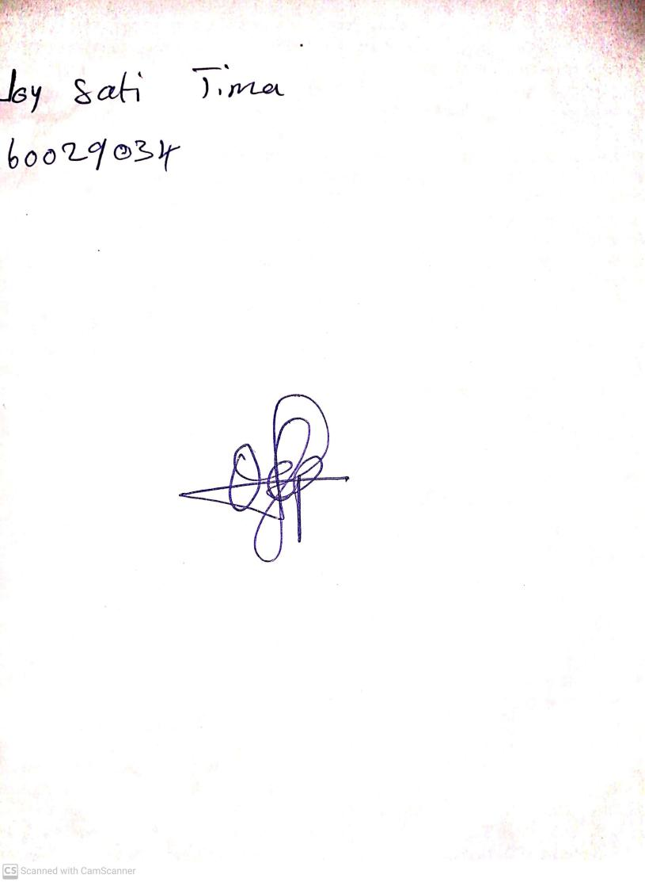

9TH NOVEMBER, 2023

Perpetual Ojoma Ocheja

Stream Head Nursery