**EMERALD ROYAL INTERNATIONAL SCHOOL, MPAPE ABUJA**

**LESSON PLAN AND NOTE FOR WEEK 5 ENDING 2ND JUNE, 2023**

**TERM: THIRD**

**WEEK : 5**

**DATE: 29TH MAY - 2ND JUNE, 2023**

**SUBJECT : CHEMISTRY**

**TOPIC : IONIC THEORY**

**SUB- TOPIC : 1. ionic theory.**

1. **Meaning and examples of electrolytes.**
2. **Meaning and examples of non electrolytes.**

**PERIOD: 1ST**

**TIME : 8: 10 - 8 :50**

**DURATION:**  **40 minutes**

**CLASS: SS2**

**NUMBER IN CLASS:**  **3**

**AVERAGE AGE: 14 years**

**SEX: mixed**

**LEARNING OBJECTIVES: By the end of the lesson, the students should be able to;**

1. Explain ionic theory.
2. Define and give examples of electrolytes.
3. Define and give examples of non electrolytes.

**RATIONALE:** The students should understand the ionic theory, electrolyte and non electrolyte.

**PREVIOUS KNOWLEGDE:** The student have been taught types of reaction.

**INSTRUCTIONAL MATERIALS:** A chart showing ionic theory.

**REFERENCE MATERIALS:** New school Chemistry for Senior Secondary Schools by Osei Yaw Ababio .

|  |  |  |  |
| --- | --- | --- | --- |
| **STEPS** | **TEACHER’S ACTIVITIES** | **STUDENTS’ ACTIVITIES** | **LEARNING POINTS** |
| **INTRODUCTION** | The teacher introduces the lesson by reviewing the previous lesson. | The students were active. | To arouse the students interest. |
| **PRESENTATION**  **STEP 1** | The teacher explains ionic the theory. | The students pay attention. | To keep them focus for better understanding. |
| **STEP 2** | The teacher asks the students to define electrolytes. | The students define electrolyte. | To encourage critical thinking. |
| **STEP 3** | The teacher defines and give examples of non electrolytes. | The students pay attention. | To keep them focus for better understanding. |
| **BOARD SUMMARY** | **IONIC THEORY**  The Ionic theory states that when an electrolyte is melted or dissolved in water, some or all of the molecules of the  substance dissociate into freely moving charged particles called ions. The process of dissociation into ions is called  **IONIZATION.** For example, the ionization of NaCl in aqueous solution is as shown: NaCl Na+ + Cl-  CaCl2 Ca2+ + 2Cl-  **Electrolyte:** An electrolyte is defined as a compound which when in solution or molten state conducts an  electric current and is decomposed by it. They are ionic compounds (electrovalent compounds); that is why  they ionize (dissociate) in solution or molten state to give positive and negative ions which are mobile.  Consequently, electrolytes conduct electricity. Electrolytes vary in the degree to which they conduct  electricity. Strong electrolytes such as salts conduct large amount of current while weak electrolyte such as  ethanoic acid carry small amount of current since the acid only ionize partially in solution. Generally,  examples of electrolytes are all salts, acids, and alkalis. Specifically, they include NaCl solution, Magnesium  Chloride solution, solution of HCl, NaOH, H2SO4, etc  • **Non-electrolytes:** They are substances that do not conduct electricity either in solution or in molten state.  They are covalent and are mainly organic compounds. Examples of non-electrolytes are urea, ethanol,  benzene, trichloromethane, cane sugar, ether, tetrachloromethane, etc. Because they are covalent compounds,  they do not ionize; hence, they do not conduct electricity. | The students ask question for clarification. | To create room for slow learners. |
| **EVALUATION** | The teacher evaluates the students with the following questions;   1. Define ionic theory. 2. Define electrolyte and give 2 examples. 3. Define non electrolyte and give 2 examples. | The students attempt the questions. | To ascertain their level of understanding. |
| **CONCLUSION** | The teacher concludes by copying note on the board. She checks and marks the note. | The students copy the note into their note books. | For future use. |
| **HOME WORK** | With a well labeled diagram explain the behaviour of ion in an electrolyte. | The students did their assignment and submit for marking and correction. | To encourage the students to study at home. |

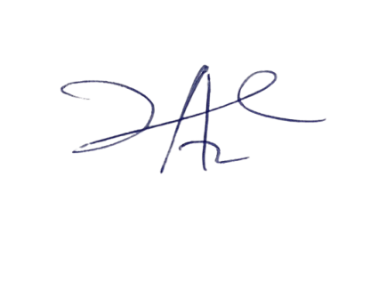

10/5/2023

Principal Head Instuctor