**EMERALD ROYAL INTERNATIONAL SCHOOL, MPAPE ABUJA**

**LESSON PLAN AND NOTE 1 FOR WEEK 1 ENDING FRIDAY, 15TH SEPTEMBER, 2023**

**TERM:** FIRST TERM

**WEEK:** WEEK 1

**SUBJECT:** BASIC SCIENCE

**TOPIC:** EXPLORING THE ENVIRONMENT

**SUB-TOPIC:** THINGS IN THE CLASSROOM

**DATE:** TUESDAY, 12TH AND WEDNESDAY, 13TH SEPTEMBER, 2023

**TIME:** 08:45 – 09:25AM AND 09:25 – 09:55AM

**DURATION:** 40 MINUTES

**PERIOD:** 2ND AND 3RD

**CLASS:** NURSERY 3

**NUMBER IN CLASS:** ELEVEN

**AVERAGE AGE:** FIVE

**SEX:** MIXED

**LEARNING OBJECTIVES:** By the end of the lesson, the pupils should be able to:

1. Define a school.
2. Identify the things in the classroom.

**RATIONALE:** for pupils to learn the meaning of school and things that can be found in the classroom.

**PREVIOUS KNOWLEGDE:** pupils are familiar with things in the classroom.

**INSTRUCTIONAL MATERIALS:**

1. Textbook
2. charts

**REFERENCE MATERIALS:**

1. Smart Basic Science and Technology book 1 by D. I. Bika, Cambridge University Press.

**LESSON DEVELOPMENT**

|  |  |  |  |
| --- | --- | --- | --- |
| **STAGES/STEPS** | **TEACHER’S ACTIVITIES** | **PUPILS’ ACTIVITIES** | **LEARNING POINTS** |
| **INTRODUCTION** | Place a chart of things on the table. | Identify the things on the chart | To arouse the pupils’ interest. |
| **PRESENTATION**  **STEP 1** | Leads pupils to define a school.  **Meaning of a school**  School is a place where we learn how to read and write. | Define a school. | Meaning of a school. |
| **STEP 2** | Leads pupils to identify the things in the classroom.  **Things in the classroom**   1. Table 2. Chair 3. Charts 4. Books 5. Pencils 6. Door 7. Window 8. Shelf 9. Bags 10. Rulers | List the things in the classroom | Examples of things in the classroom. |
| **SUMMARY** | Summarises the lesson by emphasising on the main concept and writes note on the board | Listen and copy their notes | For onward study |
| **EVALUATION** | Asks pupils to:   1. define a school. 2. Mention the things you can find in the classroom. | Respond to the teacher’s question. | To test the pupils understanding on the lesson. |
| **CONCLUSION** | Summarizes, corrects and mark pupils’ notebooks | Submit their notebooks for marking. | Clarifying the concept. |
| **HOME WORK** | 1.Write down five (5) things you can find in the classroom. | Cope and return with task. | Extending lesson home. |

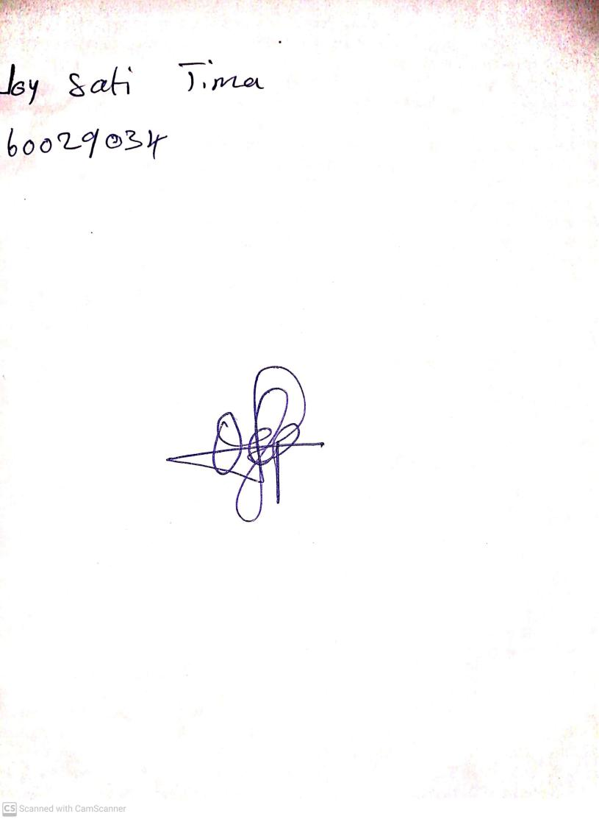

10TH September, 2023

Perpetual Ojoma Ocheja

Stream Head Nursery