**EMERALD ROYAL INTERNATIONAL SCHOOL MPAPE, ABUJA.**

**LESSON PLAN AND NOTE FOR WEEK 5 ENDING 24/05/2024**

**TERM: 3rd**

**WEEK: 5th**

**DATE: 20/05/2024**

**CLASS: Nursery 2**

**SUBJECT: Social norms**

**TOPIC: Care of children with special needs.**

**SUB—TOPIC: Meaning of children with special needs.**

**PERIOD: 2nd period after long break**

**TIME: 11:20—12: 00pm**

**DURATION: 40 minutes**

**NUMBER IN CLASS: 13**

**AVERAGE AGE: 5 years**

**SEX: Mixed**

**LEARNING OBJECTIVES: By the end of the lesson, the Pupils should be able to:**

**1. Explain the meaning of children with special needs.**

**3. Mention the various ways of caring for children with special**

**needs.**

**RATIONALE: For pupils to learn how to care for children with special needs.**

**PREVIOUS KNOWLEDGE: Pupils have learnt mental violence in previous lesson.**

**INSTRUCTIONAL MATERIALS: Vedio clip of children with disabilities**

**REFERENCE MATERIALS: Google. com**

**LESSON DEVELOPMENT**

|  |  |  |  |
| --- | --- | --- | --- |
| **Steps** | **Teacher's activities** | **Pupils' activities** | **Learning point** |
| **Introduction** | **Teacher introduces the lesson by asking pupils if they have seen people with one hand or one leg before?** | **Pupils answer the question ask by the teacher.** | **To prepare pupils minds for the lesson ahead.** |
| **Presentation step 1** | **Teacher explains the meaning of children with special needs to pupils and then asks them to repeat after her.** | **Pupils pay attention to the teacher and repeat after her.** | **For proper understanding.** |
| **Step 2** | **Teacher mentions the ways to care for people with special needs to pupils and also asks them to repeat after her.** | **Pupils listen to the teacher and repeat after her.** | **For better understanding.** |
| **Board summary** | **Teacher summarizes the lesson by writing the whole note of lesson on the board for pupils to copy into their books. That is;**  **CARE OF CHILDREN WITH SPECIAL NEEDS**  **Children with special needs are those children who are disabled in one way or the other.**  **They could be:**   1. **Visually impaired (Blind)** 2. **Hearing impaired (Deaf)** 3. **Speech impaired (Dumb)** 4. **Handicapped (paralysis)**   **CARE FOR CHILDREN WITH SPECIAL NEEDS**  **1. Show them understanding and patience when they struggle.**  **2. Treat their disability as natural.**  **3. Encourage the friendships with both non–disabled and disabled kids.**  **4. Encourage decision making**  **5. Don't try to force them**  **6. Give proper support etc.** | **Pupils copy the note into their books.** | **For onward study.** |
| **Evaluation** | **Teacher evaluates the lesson by asking pupils the following questions:**  **1. What are children with special needs?**  **2. How do we care for children with special needs?** | **Pupils answer the questions asked by the teacher.** | **To assess pupils level of understanding.** |
| **Conclusion** | **Teacher concludes the lesson by marking pupils books.** | **Pupils submit their books for marking..** | **For endorsement.** |
| **Assignment** | **Answer the following questions:**  **1. What is the meaning of orphan's?**  **2. Who are the vulnerable children?**  **3. mention 3 ways we can care for orphaned and vulnerable children.** | **Pupils do their assignment at home.** | **To encourage learning at home.** |

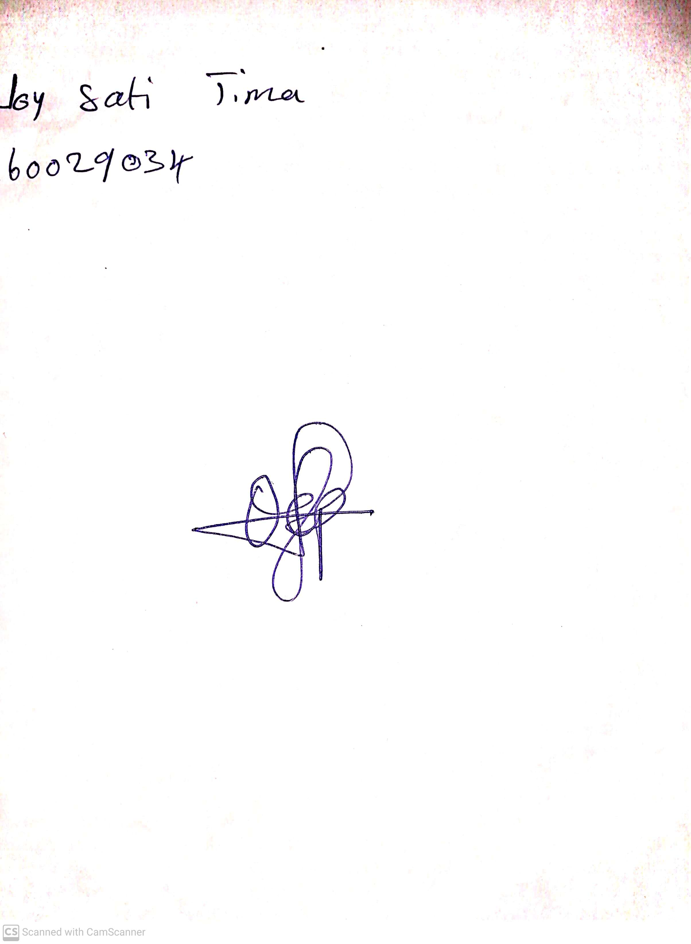

**17th May, 2024**

**Perpetual Ojoma Ocheja**

**Stream Head Nursery**