LESSON PLAN AND NOTE 1 FOR WEEK 4 ENDING 26/05/2023

TERM: 3rd

WEEK: 4thk

DATE: 22/05/2023

CLASS: Nursery 2

SUBJECT: Number work

TOPIC: Place value of numbers

SUB—TOPIC: Meaning of place value

PERIOD: 1st

TIME: 08:50—09:30 am

DURATION: 40 minutes

NUMBER IN CLASS: 17

AVERAGE AGE: 5 years

SEX: Mixed

LEARNING OBJECTIVES: By the end of the lesson, the Pupils should be able to:

1. Explain the meaning of digit.

2. State the meaning of place value.

RATIONALE: For Pupils to know the meaning of the topic, place value of numbers.

PREVIOUS KNOWLEDGE: Pupils have learnt counting of numbers.

INSTRUCTIONAL MATERIALS: chart of place value of numbers.

REFERENCE MATERIALS: Google. com

LESSON DEVELOPMENT

|  |  |  |  |
| --- | --- | --- | --- |
| STAGES/ STEPS | TEACHER'S ACTIVITIES | PUPILS' ACTIVITIES | LEARNING POINT |
| Introduction | Teacher reviews the previous lesson. | Pupils listen attentively to the teacher. | To arouse pupils interest for the lesson. |
| Presentation step 1 | Teacher explains the meaning of digit to pupils and then asks them to repeat after her. | Pupils listen to the teacher and repeat after her. | For proper understanding. |
| Step 2 | Teacher States the meaning of place value to pupils and also asks them to repeat after her. | Pupils pay attention to the teacher and repeat after her. | To enhance Pupils participation in class. |
| Board summary | Teacher writes the whole note of lesson on the board for pupils to copy into their books. That is,  PLACE VALUE OF NUMBERS  Place value: describes the position of each digit in a number.  Digit: means any number from zero to 9.  The 10 digits we used to represent the numbers are:  0 1 2 3 4 5 6 7 8 9 | Pupils copy the note into their exercise books. | For onward study. |
| Evaluation | Teacher evaluates the lesson by asking pupils the following questions;  1. What is the meaning of place value?  2. Digit means ____. | Pupils answer the questions ask by the teacher. | To assess Pupils level of understanding. |
| Conclusion | Teacher concludes the lesson by marking pupils books. | Pupils submit their books for marking. | For endorsement. |
| Assignment | 1. Explain the meaning of place value.  2. 786 which digit is in the tens place?  3. 786 which digit is in the ones place?  4. 786 which digit is in the hundreds place? | Pupils do their assignment at home. | To encourage learning at home. |

LESSON PLAN AND NOTE 2 FOR WEEK 4 ENDING 26/05/2023

TERM: 3rd

WEEK: 4th

DATE: 23/05/2023

CLASS: Nursery 2

SUBJECT: Number work

TOPIC: Place value of numbers

SUB—TOPIC: Meaning of place value.

PERIOD: 2nd

TIME: 08:50—09:30 am

DURATION: 40 minutes

NUMBER IN CLASS: 17

AVERAGE AGE: 5 years

SEX: Mixed

LEARNING OBJECTIVES: By the end of the lesson, the Pupils should be able to:

1. Explain numbers according to their place value.

2. Solve simple problem on place value.

RATIONALE: For Pupils to know the meaning of the topic, place value of numbers.

PREVIOUS KNOWLEDGE: Pupils have learnt the meaning of place value and digit in previous lesson.

INSTRUCTIONAL MATERIALS: chart of place value of numbers.

REFERENCE MATERIALS: Google. com

LESSON DEVELOPMENT

|  |  |  |  |
| --- | --- | --- | --- |
| STAGES/ STEPS | TEACHER'S ACTIVITIES | PUPILS' ACTIVITIES | LEARNING POINT |
| Introduction | Teacher reviews the previous lesson. | Pupils listen attentively to the teacher. | To arouse pupils interest for the lesson. |
| Presentation step 1 | Teacher writes numbers on the board and then explains them according to the position each digit represents and then asks pupils to repeat after her.  As;  Examples: find the place value of each of the digits.  Method 1:  (i) 145  Solution  The use of counting in hundreds tens and ones  145 = 100 + 40 + 5  100 = 10 bundles of ten = 10 tens = 1 hundred.  40 = 4 bundles of ten = 4 tens.  5 = 5 ones  =145= 1 hundreds, 4 tens, 5 ones.  Method 2: place value into hundreds, tens and ones  H T O= Place.  1 4 5= value.  = 145 = 1 hundred, 4 tens, 5 ones | Pupils listen to the teacher and repeat after her. | For proper understanding. |
| Step 2 | Teacher guides pupils to solve some simple questions on the board. As;  Find the place value of each of the digits.  (i) 276  (ii) 158  (iii) 209 etc. | Pupils pay attention to the teacher solve the questions on the board. As;  Solution:  (i) 276= 2 hundreds, 7 tens and 6 ones.  (ii) 158= 1 hundreds, 5 tens and 8 ones.  (iii) 209= 2 hundreds, 0 tens and 9 ones etc. | To enhance Pupils participation in class. |
| Board summary | Teacher writes the whole note of lesson on the board for pupils to copy into their books. That is;  Find the place value of the following digits.  1. 145  2. 273  3. 213  4. 184  5. 159  Solution:   |  |  |  | | --- | --- | --- | | H  (Hundreds) | T  (Tens) | O  (Ones) | | 1 | 4 | 5 | | 2 | 7 | 3 | | 2 | 1 | 3 | | 1 | 8 | 4 | | 1 | 5 | 9 | | Pupils copy the note into their exercise books. | For onward study. |
| Evaluation | Teacher evaluates the lesson by asking pupils the following questions;  Write the place value of each of the digits.  1.248  2. 105  3. 271  4. 300  5. 129 | Pupils answer the questions ask by the teacher. | To assess Pupils level of understanding. |
| Conclusion | Teacher concludes the lesson by marking pupils books. | Pupils submit their books for marking. | For endorsement. |
| Assignment | What is the place value of each underline digit?  (a) 651  (b)128  (c)203  (d)408  (e)643  (f)344  (g)600  (h)733  (i)888  (j)611 | Pupils do their assignment at home. | To encourage learning at home. |

LESSON PLAN AND NOTE 3 FOR WEEK 4 ENDING 26/05/2023

TERM: 3rd

WEEK: 4th

DATE: 26/05/2023

CLASS: Nursery 2

SUBJECT: Number work

TOPIC: Place value of numbers

SUB—TOPIC: solving simple problems on place value of numbers.

PERIOD: 3rd

TIME: 08: 10–80 :50am

DURATION: 40 minutes

NUMBER IN CLASS: 17

AVERAGE AGE: 5 years

SEX: Mixed

LEARNING OBJECTIVES: By the end of the lesson, the Pupils should be able to:

1. Explain numbers according to their place value.

2. Solve simple problem on place value.

RATIONALE: For Pupils to know the meaning of the topic, place value of numbers.

PREVIOUS KNOWLEDGE: Pupils have learnt the meaning of place value and digit in previous lesson.

INSTRUCTIONAL MATERIALS: chart of place value of numbers.

REFERENCE MATERIALS: Google. com

LESSON DEVELOPMENT

|  |  |  |  |
| --- | --- | --- | --- |
| STAGES/ STEPS | TEACHER'S ACTIVITIES | PUPILS' ACTIVITIES | LEARNING POINT |
| Introduction | Teacher reviews the previous lesson. | Pupils listen attentively to the teacher. | To arouse pupils interest for the lesson. |
| Presentation step 1 | Teacher writes numbers on the board and then explains them according to the position each digit represents and then asks pupils to repeat after her.  As;  Examples: In the number 705, study the place value of each number.  Solution:  A. The place value of 7 is Hundreds.  B. The place value of 0 is Tens.  C. The place value of 5 is Ones. | Pupils listen to the teacher and repeat after her. | For proper understanding. |
| Step 2 | Teacher guides pupils to solve some simple questions on the board. As;  Find the place value of each of the digits.  (i) 532  (ii) 649  (iii) 920  (iv) 984 | Pupils pay attention to the teacher solve the questions on the board. As;  Solution:  (i) 532= 5 hundreds, 3 tens and 2 ones.  (ii) 649 = 6 hundreds, 4 tens and 9 ones.  (iii) 920 = 9 hundreds, 2 tens and 0 ones  (iv) 984 = 9 hundreds, 8 Tens and 4 ones. | To enhance Pupils participation in class. |
| Board summary | Teacher writes the whole note of lesson on the board for pupils to copy into their books. That is;  Write the place value of the following digits.  1. 92  2. 84  3. 48  4. 16  5. 125  6. 231  7. 249  8.174  Solution:   |  |  |  | | --- | --- | --- | | H  (Hundreds) | T  (Tens) | O  (Ones) | |  | 9 | 2 | |  | 8 | 4 | |  | 4 | 8 | |  | 1 | 6 | | 1 | 2 | 5 | | 2 | 3 | 1 | | 2 | 4 | 9 | | 1 | 7 | 4 | | Pupils copy the note into their exercise books. | For onward study. |
| Evaluation | Teacher evaluates the lesson by asking pupils the following questions;  What the place value of each of the digits.  1.48  2. 05  3. 27  4. 30  5. 129 | Pupils answer the questions ask by the teacher. | To assess Pupils level of understanding. |
| Conclusion | Teacher concludes the lesson by marking pupils books. | Pupils submit their books for marking. | For endorsement. |
| Assignment | Copy and complete these sentences.  (a) 5 Tens and 8 ones makes 58.  (b) 3 Tens and 5 ones makes_____?  (c) 7 Tens and 4 ones makes_____?  (d) 8 Tens and 3 ones makes_____?  (e) 6 Tens and 1 ones makes______? | Pupils do their assignment at home. | To encourage learning at home. |

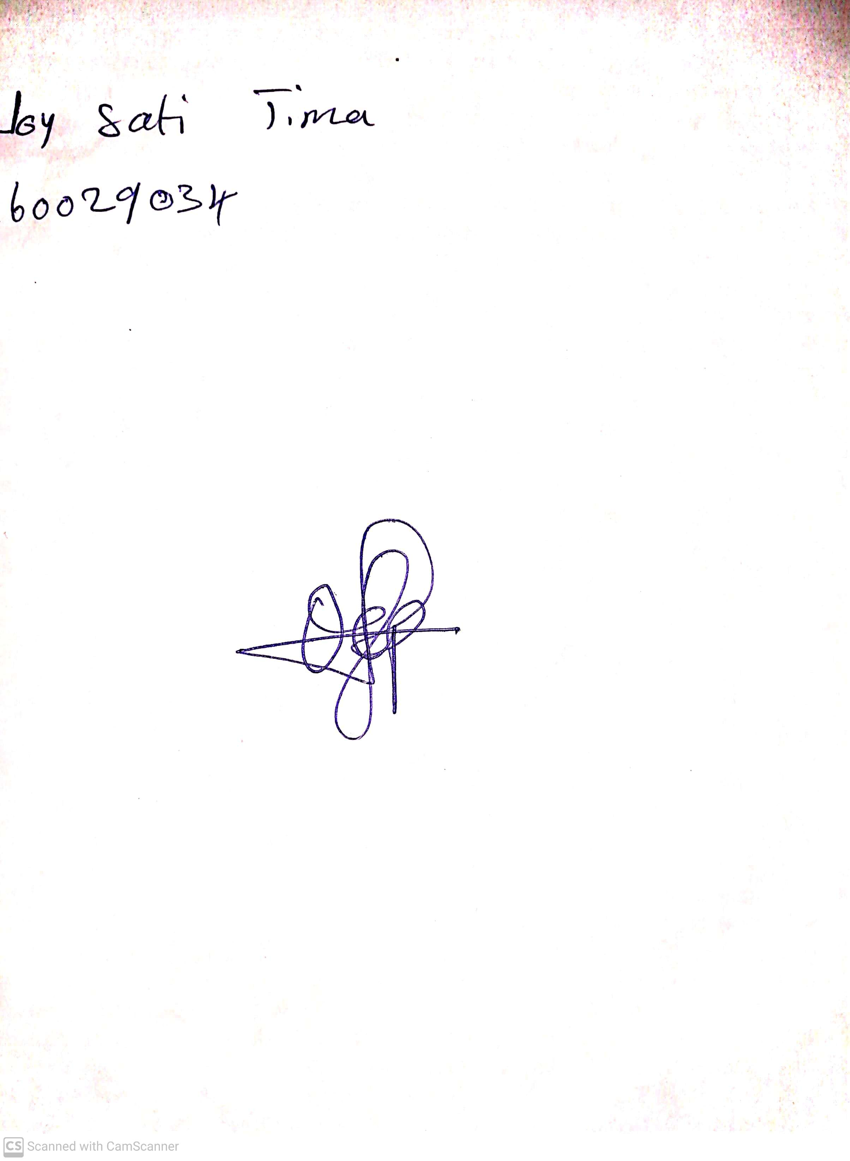

29TH April, 2023

Perpetual Ojoma

Stream Head Nursery