EMERALD ROYAL INTERNATIONAL SCHOOL

MPAPE, ABUJA.

LESSON NOTE FOR WEEK 8 ENDING 1ST MARCH,2024

SUBJECT: Nature studies.

TOPIC: Living things and non- living things.

SUB-TOPIC: Meaning of living things and non-living things.

DATE: 01/3/2024

DURATION: 40 minutes

TIME: 08:50-09:30

PERIOD: 3rd

CLASS: Pre-nursery

NUMBER OF PUPILS: 19

AVERAGE AGE: 2 years

SEX: Mixed

SPECIFIC OBJECTIVES: By the end of the lesson, the pupils should be able to:-

I . Define living things and state the examples of living things.

2. Say the meaning of non-living things and mention the examples of non - living things.

RATIONALE: For Pupils to identify living things and non-living things around their environment.

PREVIOUS KNOWLEDGE: Pupils have been taught the examples of birds which is part of living things.

INSTRUCTIONAL MATERIALS: Table, chair, Pupils in the class and chart.

REFERENCE: Showers kiddies books Elementary science book nursery 1 by Showers kiddies books.

LESSON DEVELOPMENT

|  |  |  |  |
| --- | --- | --- | --- |
| Stages/steps | Teacher's activities | Pupils' activities | Learning points |
| Introduction | Teacher introduces the lesson by reviewing the last lesson on "Birds" which is part of living things. The teacher also introduces the lesson for the day as:-  "Living things and non- living things". | Pupils listen to the teacher as the teacher reviews the lesson for them and into the day's lesson. | To draw the pupils attention to the last lesson and prepare their mind for the new lesson. |
| Presentation  Step 1 | Teacher defines living things as:-  "Living things are those things that have life in them". Teacher also asks the pupils to list those things that have life in them. | Pupils listen and list those things that happened life in them such as:-   1. Plants 2. Human being 3. Animals .eg:- birds, goat,cat,dog etc. | To ensure Pupils can identify living things when they see them. |
| Step 2 | Teacher shows the Pupils a chart that has different objects and the teacher says those things don't have life. The teacher also defines non- living things as those things that have no life in them. Teacher asks the Pupils to mention those things that have no life in them. | Pupils repeat after the teacher to define non-living things. Pupils also mention those things that have no life in them as:-  Chairs  Table  Book  Bag  Television etc. | For better understanding of the lesson. |
| Summary | Teacher summarizes the lesson by going over the lesson again for more understanding. | Pupils listen attentively to the teacher as she is going over the lesson. | To ensure better understanding. |
| Evaluation | Teacher asks the Pupils to :-   1. Define living things. 2. Mention the examples of living things. | Pupils answer the teacher's questions correctly. | To ascertain the level of pupils understanding of the lesson. |
| Conclusion | Teacher concludes the lesson by singing nursery rhymes for the pupils | Pupils sing along with the teacher. | To consolidate the lesson. |
| Assignment | Teacher asks the Pupils to colour non-living things in their text books. Elementary science book 1 page 19. | Pupils do the assignment at home. | To encourage Learning at home.. |

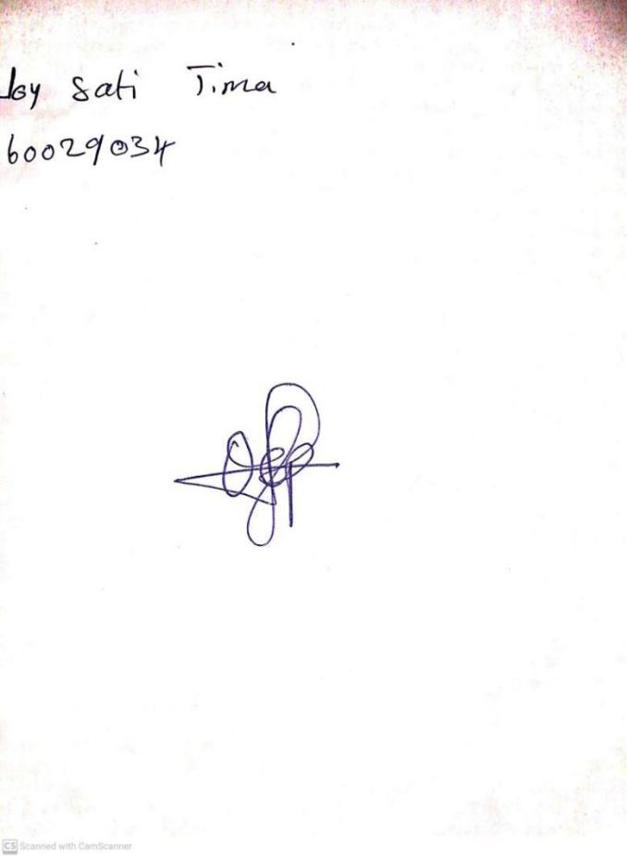

**23RD FEBRUARY, 2024**

**Perpetual Ojoma Ocheja**

**Stream Head Nursery**