**Lesson Plan/Note for Week 2 Ending 20/1/2023.**

**Term:** 2nd.

**Week:** 2

**Date:** 17/1/2023

**Class:** SS 1

**Subject**: Civic Education.

**Topic:** Rule of Law.

**Sub-Topic:** Factors necessary for the operation of rule of law, rule of law and human liberty.

**Period**: 5th

**Time:** 11:10-11:50

**Duration:** 40 Minutes.

**Number in class:** 7 Students.

**Average Age:** 14 Years.

**Sex:** Mixed.

**Specific objectives**: By the end of the lesson, the students should be able to:

(1) Mention the factors necessary for the operation of rule of law.

(11) Explain the factors necessary for the operation of rule of law.

(111) State the rule of law and human liberty.

**Rationale:** To be able to identify the factors necessary for the operation of rule of law.

**Previous knowledge**: The students have been obeying the law of the country and the school Rules and Regulations.

**Instructional Material**: A chart showing the 1999 Constitution of the Federal Republic of Nigeria.

**Reference material**: Gbenga Babalola (2017) Essential Civic Education for senior Secondary schools.

**LESSON DEVELOPMENT**.

|  |  |  |  |
| --- | --- | --- | --- |
| **Stages/Steps** | **Teacher's Activities** | **Students' Activities** | **Learning points.** |
| **Introduction** | Review the previous lesson | Participate actively in the class discussion | To arouse the students interest to learn. |
| **Step 1** | Mentions the factors necessary for the operation of rule of law as: (1) independence of the judiciary (2) freedom of the press. (3) Mass literacy etc. | Listen carefully to the teacher | For better understanding of the lesson. |
| **Step 11** | Guides the students to explain the factors necessary for the operation of rule of law. | Respond to the class activity | To enhance their logical reasoning. |
| **Step 111** | Asks the students to state the rule of law and human liberty. | State the rule of law and human liberty as: (1) individuals should not be made to suffer. (2) offender should be informed before arrested etc. | To encourage critical thinking. |
| **Board Summary** | Summarizes the lesson as:  **Factors necessary for the operation of Rule of Law.**  (1) Independence of the judiciary: for rule of law to be really functional, the judiciary must be independent. The proceedings of courts and subsequent judgement should not be influenced by anyone, not even the state. (2) freedom of the press: A free press is the press that is not controlled by the government censorship regarding politics and ideology. A free press is a guarantee to the rule of law. (3) Mass literacy: There should be high percentage of literate citizens. (4) The law must not be kept secret. (5) There must be room for appeal from tribunal judgement.  **Rule of Law and Human Liberty**  Liberty is the ability or willingness to do something that does not affect others people's freedom. These liberties are:  (1) Offender should not be arrested without being told of the offence he/she committed. (2) An individual should not be made to suffer any penalty or loss of personal liberty in any way unless found uilty. (3) It helps citizens and non- citizens to enjoy their rights in the constitution. (4) The representatives of the people are prevented from enjoying unlimited power which can lead to abuse of power. (5) Absolute supremacy of the law over everyone. (6) It forbits arbitrary rule by the government. | Copy and submit the Note book for marking | For future reference. |
| **Evaluation** | Evaluates the students as:  (1) Mention 5 factors necessary for the operation of rule of law.  (2) state 4 rule of law and human liberty. | Respond to the questions. | Ascertaining the attainment of the stated objectives. |
| **Conclusion** | Rounds up the lesson by marking and correcting students work. | Check and do their correction | Consolidation of the lesson. |
| **Assignment** | Gives home work as:  (1) Explain how rule of law guarantee personal liberty. | Respond by doing the home work at home. | To ensure continuity of learning. |

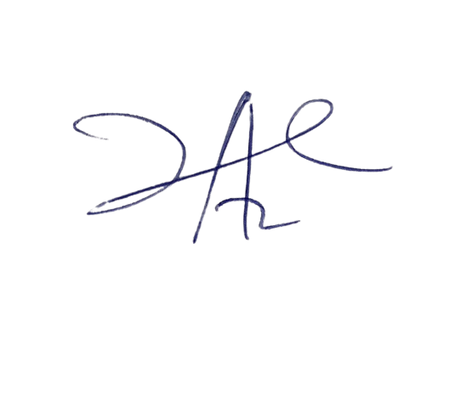

6/3/2023

Principal Head Instructor