**LESSON PLAN AND NOTE FOR WEEK 4 ENDING 6/10/2023**

**Term 1st term**

**Week 4th week.**

**Date 5th October,2023**

**Class Nursery one**

**Subject Social Norms**

**Topic My environment.**

**Sub-topic Meaning of environment**

**Period 7th period**

**Time 1:55 pm**

**Duration 35 minutes**

**No in class 15**

**Average Age 3 years**

**Sex Mixed**

**Specific Objectives: By the end of the lesson the pupils should be able to:**

1. **Define environment.**
2. **Identify things in the environment.**

**Rationale: To ensure the pupils define and identify environment.**

**Previous Knowledge: The pupils can mention the name of their school.**

**Instructional Resources: Board,marker ,online research.**

**Reference Materials: Smart smart Civic Education by A.M Solu, T.Y Alabi, Nursery 2**

**LESSON PRESENTATION**

|  |  |  |  |
| --- | --- | --- | --- |
| **Steps** | **Teacher’s Activities** | **Pupils’ Activities** | **Learning Points** |
| **Introduction** | **The teacher introduces the lesson by taking the pupils round the school’s premises to observe the environment.** | **The pupils participates actively with the teacher in learning.** | **To arouse the pupils’ interest towards the lesson.** |
| **Step 1** | **The teacher defines environment as “the things around us”** | **The pupils actively repeats after their teacher the meaning of environment.** | **For proper understanding.** |
| **Step 2** | **The teacher takes the pupils around the school premises and shows them things around which includes:**  **CARS**  **SCHOOL BUS**  **BULDING**  **PLAYGROUND**  **NIGERIA FLAG**  **AGRICULTURAL FARM etc.** | **The pupils pays attention to the teacher and repeats after the teacher.** | **For better understanding.** |
| **Summary** | **The teacher summarizes the lesson by defining environment for the pupils..** | **The pupils actively participates with their teacher.** | **For onward study.** |
| **Evaluation** | **What is environment?**  **Mention 3 things you can fnd in your environment?** | **The pupils answer the questions accordingly.** | **To ascertain the pupils’ understanding.** |
| **Conclusion** | **The teacher summarizes,reacts,and corrects the pupils.** | **The teacher gives answers to the teacher’s question.** | **To consolidate the lesson.** |
| **Assignment** | **Mention the things you can find in your school environment?**  **What is envinoment?** | **The pupils copy and do their home-work at home.** | **To encourage learning while at home.** |

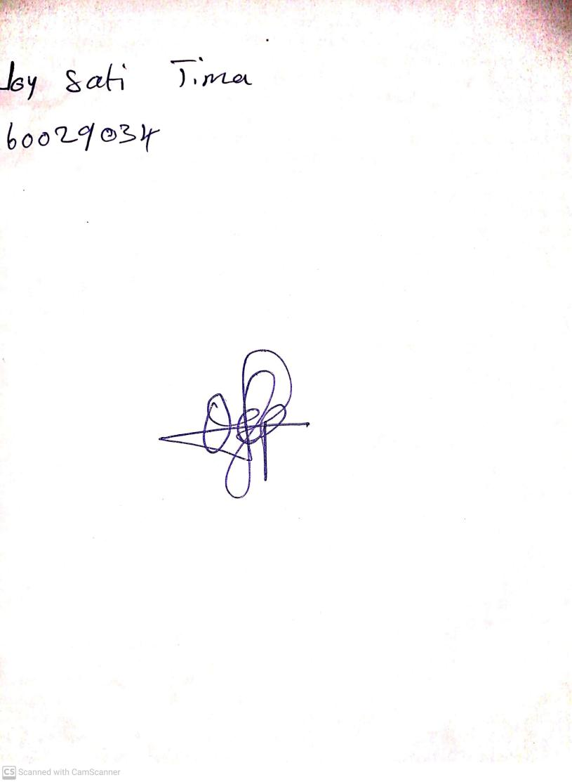

15th August, 2023

Perpetual Ojoma Ocheja

Stream Head Nursery