**LESSON PLAN AND NOTE FOR WEEK 7 ENDING 25/10/2024**

**Term 1st term**

**Week 7th week**

**Date 23rd October, 2024**

**Class Nursery One**

**Subject Social Norms**

**Topic Objects at home.**

**Sub-topic Meaning of objects at home**

**Period 4th period**

**Time 10:40 am**

**Duration 35 minutes**

**No in class 15**

**Average Age 3 years**

**Sex Mixed**

**Specific Objectives: By the end of the lesson, the pupils should be able to:**

1. **Define objects at home.**
2. **Mention objects at home.**
3. **Identify objects at home.**

**Rationale: For the pupils to know objects at home and identify them.**

**Previous Knowledge: The pupils can define good habits and how to exhibit good habits.**

**Instructional Resources: Online research.**

**Reference Material: Smart Smart Civic Education by A.M Solu & T.Y Alabi, nursery 2**

**LESSON PRESENTATION**

|  |  |  |  |
| --- | --- | --- | --- |
| **Steps** | **Teacher’s Activities** | **Pupils’ Activities** | **Learning Points** |
| **Introduction** | **The teacher introduces the lesson [Objects at home] by asking the pupils what and what objects they can find in their homes.** | **The pupils listens to the teacher.** | **To arouse the pupils’ interest.** |
| **Step 1** | **The teacher gives the pupils the meaning of objects at home as “ objects that are at home and we see them”.** | **The pupils pay attention and repeats the meaning of objects at home continuously.** | **For proper understanding.** |
| **Step 2** | **The teacher mention objects we can find in the home which includes:**  **CHAIR**  **TELEVISION**  **POT**  **SPOON**  **GAS COOKER**  **BLENDER**  **TABLE**  **DINING TABLE**  **BOOKS**  **BED**  **FAN**  **CLOTHES**  **WARDROBE**  **BALL**  **BICYCLE.** | **The pupils participates and mentions with the teacher objects found in the home.** | **For better understanding.** |
| **Step 3** | **The teacher leads the pupils to identify the objects found at home.**  **image of a dinning table A dining table**  **image of a blenderA blender** | **The pupils identify the objects at home together with the teacher.** | **For further understanding.** |
| **Summary** | **The teacher summarizes the lesson by defining objects at home for the pupils.** | **The pupils listen and understands the lesson.** | **For onward study.** |
| **Evaluation** | **The teacher asks the pupils to:**   1. **What are objects at home?** 2. **Mention 3 objects you can find in your home?** 3. **Identify the object found at home below?**   **image of a wardrobe________?**  **image of television________?** | **The pupils answer the question correctly.** | **To ascertain the pupils’ understanding.** |
| **Conclusion** | **The teacher reacts and summarizes the lesson to the pupils.** | **The pupils gives answers to the teacher.** | **To consolidate the lesson.** |
| **Assignment** | 1. **Mention 5 objects found in the home?** 2. **What are objects at home?** 3. **Identify the object we can find at home below?**   **image of a dinning table ___________**  **image of a blender____________**  **image of a wardrobe _________**  **image of television _________**   1. **Colour the object we can see at home below?**   **plain blender**  **plain dinning table** | **The pupils copy and do their homework .** | **To encourage learning while at home.** |

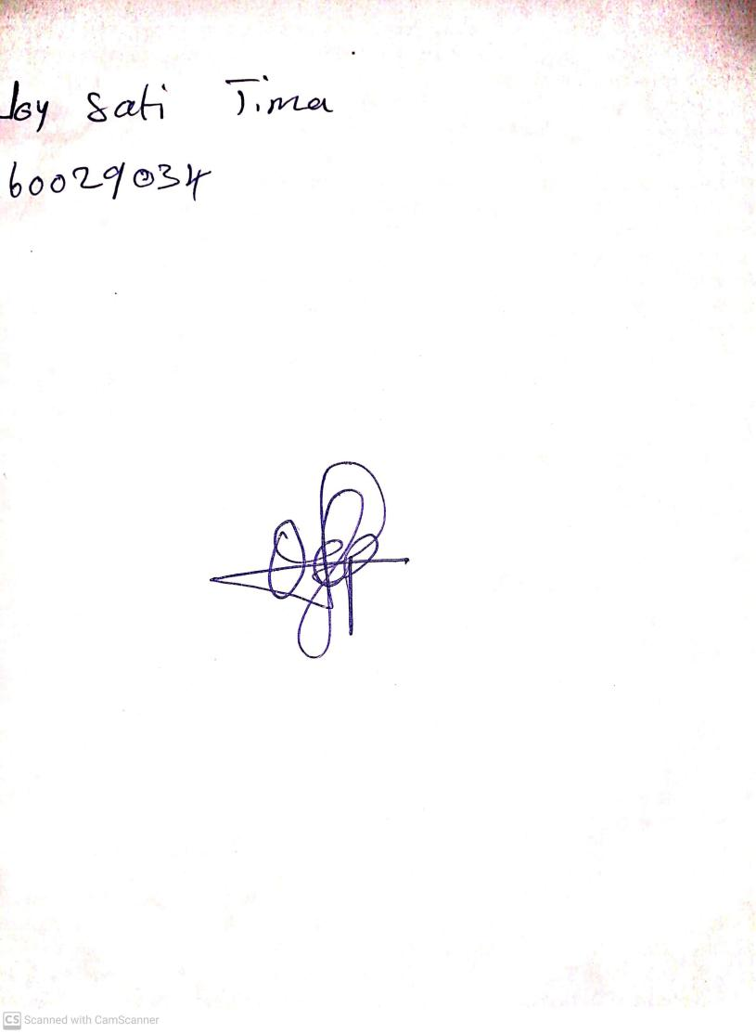

25th October, 2024

Perpetual Ojoma Ocheja

Stream Head Nursery