**EMERALD ROYAL INTERNATIONAL SCHOOL, MPAPE ABUJA**

**LESSON PLAN AND NOTE FOR WEEK 8 ENDING FRIDAY, 1ST MARCH, 204**

**TERM:** FIRST TERM

**WEEK:** WEEK 8

**SUBJECT:** BASIC SCIENCE

**TOPIC:** ROAD MARKINGS

**SUB-TOPIC:** EXAMPLES OF ROAD MARKINGS

**DATE:** TUESDAY, 27TH AND WEDNESDAY, 28TH FEBRUARY, 2024

**TIME:** 08:45 – 09:25AM AND 09:25 – 09:55AM

**DURATION:** 40 MINUTES

**PERIOD:** 2ND AND 3RD

**CLASS:** NURSERY 3

**NUMBER IN CLASS:** TWELVE

**AVERAGE AGE:** FIVE

**SEX:** MIXED

**LEARNING OBJECTIVES:** By the end of the lesson, the pupils should be able to:

1. Identify road markings.
2. Explain the different road markings.

**RATIONALE:** for pupils to learn to identify the road markings.

**PREVIOUS KNOWLEGDE:** pupils have learnt the meaning of road markings.

**INSTRUCTIONAL MATERIALS:**

1. Flash cards.
2. Road chart.

**REFERENCE MATERIALS:**

Smart Basic Science and Technology book 1 by D. I. Bika, Cambridge University Press

**LESSON DEVELOPMENT**

|  |  |  |  |
| --- | --- | --- | --- |
| **STAGES/STEPS** | **TEACHER’S ACTIVITIES** | **PUPILS’ ACTIVITIES** | **LEARNING POINTS** |
| **INTRODUCTION** | Review previous knowledge | Respond to the teacher | To arouse the pupils’ interest. |
| **PRESENTATION**  **STEP 1** | Teaches and guides the pupils to identify the road markings.   1. Crosswalk lines   Screenshot_20240319-143151   1. Pavement   Screenshot_20240319-142948   1. Zebra marking   Screenshot_20240319-143101 | Identify the road markings. | For better understanding. |
| **STEP 2** | Teaches the uses of air  **Explanation of the different road markings**   1. Crosswalk lines   Screenshot_20240319-143151  The lines at the crosswalk are usually at intersections and show where motorist must stop.   1. Pavement   Screenshot_20240319-142948  Pavements are road marking that tells motorist about something or giving motorist warning of conditions ahead.  3. Zebra marking  Screenshot_20240319-143101  Zebra markings are road marks that shows where pedestrians may cross while using the road. Motorist must stop their cars when pedestrians use a zebra crossing. | Listen attentively and learn. | For proper understanding. |
| **SUMMARY** | Summarises the lesson by emphasising on the main concept and writes note on the board | Listen and copy their notes | For onward study |
| **EVALUATION** | Asks pupils to:   1. Identify road markings. 2. State the uses of the different road markings. | Respond to the teacher’s question. | To test the pupils understanding on the lesson. |
| **CONCLUSION** | Summarizes, corrects and mark pupils’ notebooks | Submit their notebooks for marking. | Clarifying the concept. |
| **HOME WORK** | 1. Identify road markings. 2. State the uses of the different road markings. | Cope and return with task. | Extending lesson home. |

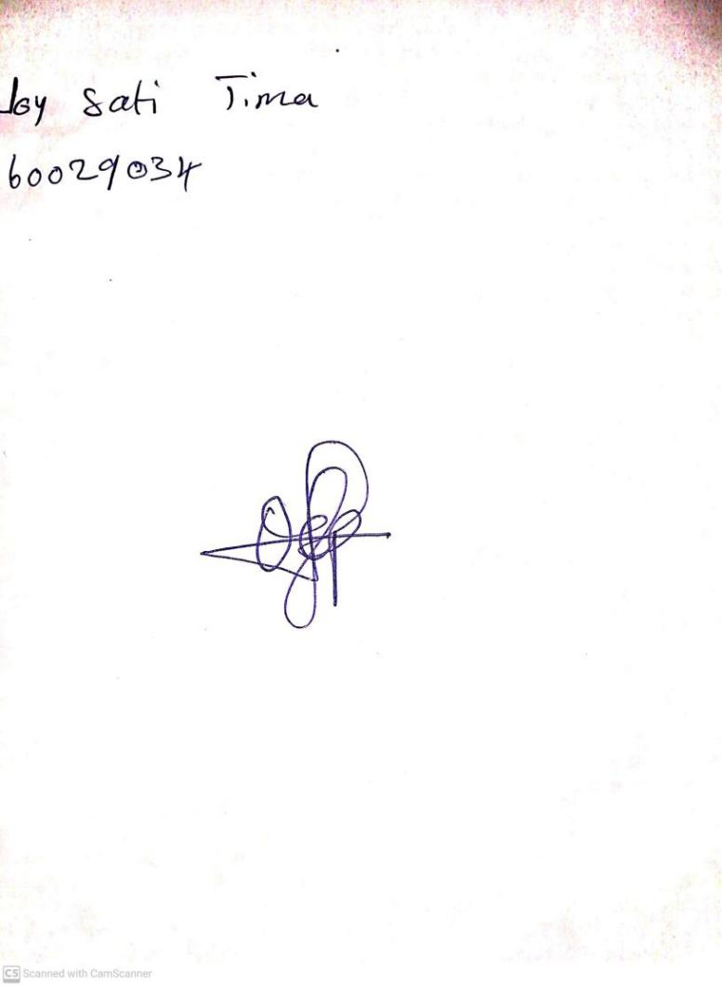

23RD FEBRUARY, 2024

Perpetual Ojoma Ocheja

Stream Head Nursery