EMERALD ROYAL INTERNATIONAL SCHOOL

MPAPE, ABUJA.

LESSON PLAN/NOTE FOR WEEK 5 ENDING 9th FEBRUARY,2024.

SUBJECT: Nature studies

TOPIC: Insects.

SUB-TOPIC: Flying insects and crawling insects.

DATE : 8th February,2024.

DURATION: 40 minutes

TIME: 09:30---- 10: 10

PERIOD: 3rd

CLASS: Pre-nursery

NUMBER OF PUPILS: 19

AVERAGE AGE: 2years

SEX: mixed

SPECIFIC OBJECTIVES: By the end of the lesson, the pupils should be able to:-

1. Define flying insects and their examples.

2. State the meaning of crawling insects and their examples.

RATIONALE: For pupils to identify different kinds of insects.

PREVIOUS KNOWLEDGE: Pupils have learnt the meaning of insects in the previous lesson.

INSTRUCTIONAL MA.TERIALS: Chart.

REFERENCE: Showers Kiddies Books Elementary Science Nursery 1 by Showers Kiddies Books.

LESSON DEVELOPMENT

|  |  |  |  |
| --- | --- | --- | --- |
| Stages/Steps | Teacher's activities | Pupils' activities | Learning points. |
| Introduction | Teacher introduces the lesson by singing nursery rhymes for the pupils. | Pupils sing the rhymes along with the teacher. | To arouse the interest of the pupils. |
| Presentation  Step 1 | Teacher flying insects to the pupils as:- "Flying insects are those insects that have wings and they can fly". Examples of flying insects are:-  Butterfly  Mosquito  Housefly  Bee  The teacher asks the pupils to repeat after him/her. | Pupils pay attention to the teacher and repeat after the teacher. | To ensure pupils can define flying insects and list the flying insects. |
| Step 2 | Teacher shows the pupils the pictures of crawling insects on the chart. The teacher also defines crawling insects and list their examples as:- "Crawling insects ate those insects that do not have wings .  Examples of crawling insects:-   1. Ant 2. Spider 3. Centipede 4. Millipede | Pupils look and point at the Crawling insects on a chart. Pupils also listen as the teacher is explaining the Crawling insects and their examples. | To ensure pupils are familiar with the Crawling insects. |
| Summary | Teacher summarizes the lesson by going over the lesson again for better understanding of the lesson. | Pupils listen attentively to the teacher as he/she is explaining the lesson again. | For better understanding of the lesson. |
| Evaluation | Teacher evaluates the pupils by asking them to:-   1. List the flying insects. 2. Define crawling insects. | Pupils answer the teacher's questions correctly. | To ascertain the level of pupils ability. |
| Conclusion | Teacher ends the lesson by singing a nursery rhyme for the pupils. | Pupils sing along with the teacher. | To improve pupils speaking ability. |
| Assignment | Teacher encourages the pupils to practice the meaning of flying insects at home. | Pupils do the assignment at home. | To encourage learning at home. |

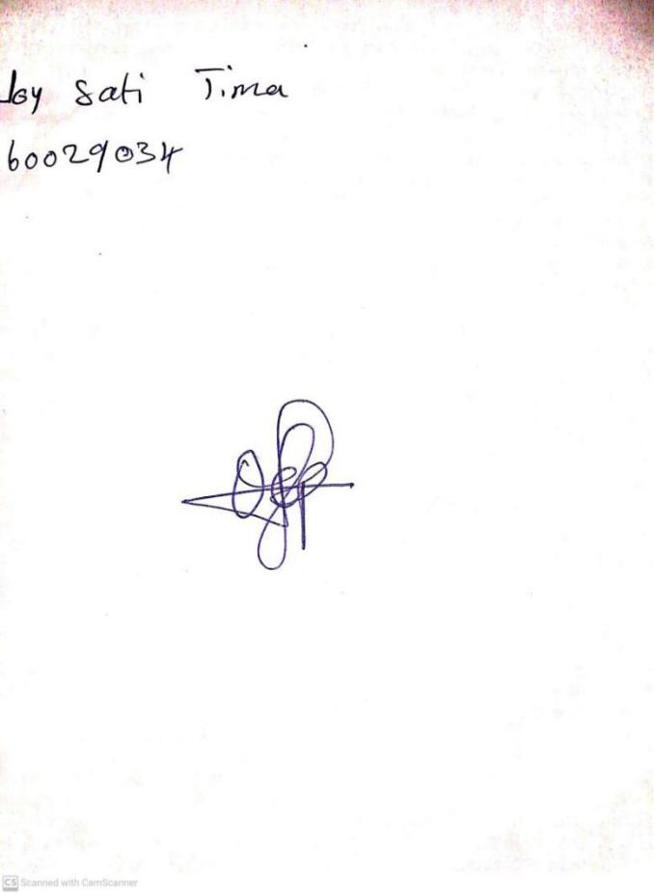

**2ND FEBRUARY, 2024**

**Perpetual Ojoma Ocheja**

**Stream Head Nursery**