**EMERALD ROYAL INTERNATIONAL SCHOOL, MPAPE ABUJA**

**LESSON PLAN AND NOTE FOR WEEK 3 ENDING FRIDAY, 29TH SEPTEMBER, 2023**

**TERM:** FIRST TERM

**WEEK:** WEEK 3

**SUBJECT:** SOCIAL STUDIES

**TOPIC:** FAMILY

**SUB-TOPIC:** TYPES OF FAMILY

**DATE:** TUESDAY, 26TH ANDWEDNESDAY, 27TH SEPTEMBER, 2023

**TIME:** 11:50 – 12:30PM AND 01:20 – 02:00PM

**DURATION:** 40 MINUTES

**PERIOD:** 6TH AND 8TH

**CLASS:** NURSERY 3

**NUMBER IN CLASS:** ELEVEN

**AVERAGE AGE:** FIVE

**SEX:** MIXED

**LEARNING OBJECTIVES:** By the end of the lesson, the pupils should be able to:

1. Identify the types of family we have.
2. States the qualities of a family.

**RATIONALE:** for pupils to learn the types of family and the qualities of a family.

**PREVIOUS KNOWLEGDE:** pupils learnt the meaning of family and members of the family.

**INSTRUCTIONAL MATERIALS:**

1. Charts.
2. Textbook

**REFERENCE MATERIALS:**

1. Social Studies for primary schools book 1 by Olufemi J. Olugasa, Olusola H. Bamidele, Felix K. Alonge, Julius O. Onwuka

**LESSON DEVELOPMENT**

|  |  |  |  |
| --- | --- | --- | --- |
| **STAGES/STEPS** | **TEACHER’S ACTIVITIES** | **PUPILS’ ACTIVITIES** | **LEARNING POINTS** |
| **INTRODUCTION** | Review previous knowledge | Respond to the teacher | To arouse the pupils’ interest. |
| **PRESENTATION**  **STEP 1** | Teaches and states the types of family.  **Types of family**  There are two main type of family.   1. Nuclear family 2. Extended family   **Nuclear family**  Nuclear family is the type of family that consist of father, mother and their children.  **Extended family**  Extended family consist of two or more families which is made up of father, mother, children, grandfather, grandmother, uncles aunts etc. | Listen attentively and learn. | Types of family. |
| **STEP 2** | Teaches and list the qualities of a family.  **Qualities of a family**  Qualities of a family are those good ways of behaving.   1. Honesty 2. Contentment 3. Selflessness 4. Obedient 5. discipline | Listen attentively and learn. | Qualities of a family |
| **SUMMARY** | Summarises the lesson by emphasising on the main concept and writes note on the board | Listen and copy their notes | For onward study |
| **EVALUATION** | Asks pupils to:   1. List the types of family 2. State the qualities of a family. | Respond to the teacher’s question. | To test the pupils understanding on the lesson. |
| **CONCLUSION** | Summarizes, corrects and mark pupils’ notebooks | Submit their notebooks for marking. | Clarifying the concept. |
| **HOME WORK** | 1. List the types of family. 2. State the qualities of a family. | Cope and return with task. | Extending lesson home. |

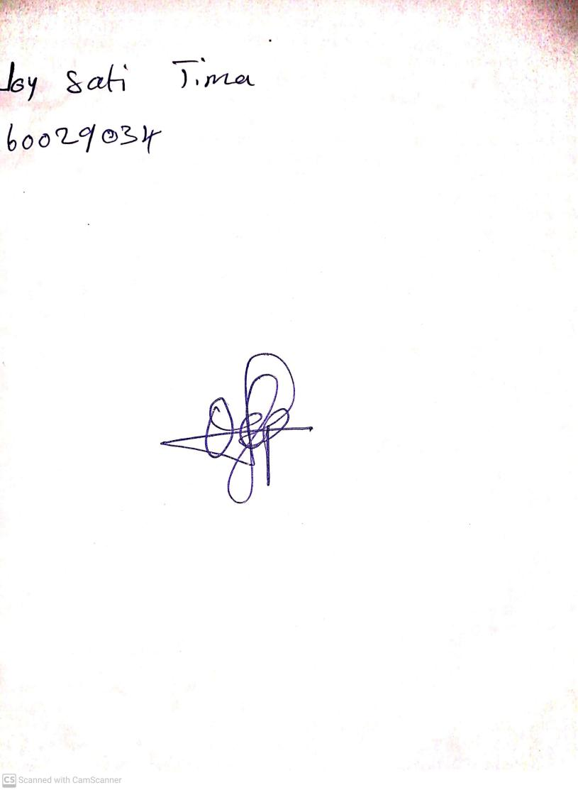

22ND September, 2023

Perpetual Ojoma Ocheja

Stream Head Nursery