**Lesson Plan/Note For Week 5 Ending 10/ 02/2023.**

**Term:** 2nd

**Week:** 5

**Date**: 8/02/2023.

**Class:** SS 1

**Subject:** Civic Education.

**Topic:** pillars of Democracy.

**Sub-Topic:** State and local Government.

**Period:** 5th

**Time**: 11:10-11:50.

**Duration:** 40 Minutes.

**Number in class:** 7 Students.

**Average Age**: 14 Years.

**Sex:** Mixed

**Specific objectives:** By the end of the lesson, the students should be able to:

(1) Explain State Governments.

(11) Describe the Local Government.

(111) state the functions of Local Government.

**Rationale:** for the students to be able to differentiate between the state and local government.

**Previous knowledge:** The students have heard about Local Government and their functions.

**Instructional Material:** A chart showing members of the house of assembly in a meeting.

**Reference material:** Gbenga Babalola (2017) Essential Civic Education for senior Secondary schools.

**LESSON DEVELOPMENT**

|  |  |  |  |
| --- | --- | --- | --- |
| **Stages/steps** | **Teacher's Activities** | **Students' Activities** | **Learning points** |
| **Introduction** | Review the previous lesson | Participate actively in the class discussion. | To arouse the students interest to learn. |
| **Step 1** | Explains the state government as: The state government is the second ties of government in a federal system. | Listen carefully to the class teacher | For better understanding of the lesson. |
| **Step 11** | Guides the students to describe the local government. | Respond to the class activity | To encourage critical thinking. |
| **Step 111** | Asks the students to state the functions of the local government. | State the functions of the local government as: (1) provision of health care (2) collection of rates. (3) maintenance of law and order etc. | To enhance their logical reasoning. |
| **Board Summary** | Summarises the lesson as:  **State Government**  State government is the second tier of government in a federal system. The head of the state government is the Governor. There are thirty six states currently in Nigeria. The legislative arm of the state government is called the state house of assembly.  **The Local Government**  The local government is the third tier of government structure in Nigeria. It is the government of the grassroots level where majority of the people live. It is the closest government to the people. The essence of local government creation is to involve local participation in the affairs of the country.  **Functions of the Local Government**  (1) provision of health care centre. (2) collection of rates, radio and television licenses. (3) maintenance of roads within their jurisdiction. (4) maintenance of law and order. (5) naming of streets. (6) registration of birth, death and marriages. (7) control and regulations of outdoor advertising and hoarding. (8) establishment and maintenance of cemeteries, burial ground and home for the destitute.  However, the head of the local government is the chairman. The chairman supervises the activities of the local government and presides over all meetings in the council. | Copy and submit the note book for marking | For future reference |
| **Evaluation** | Evaluates the students as:  (1) Explain state government.  (2) Describe the Local Government.  (3) state 5 functions of local government. | Respond to the questions | Ascertaining the attainment of the stated objectives. |
| **Conclusion** | Rounds up the lesson by marking and correcting students work | Check and do their correction | Consolidation of the lesson. |
| **Assignment** | Gives home work as:  (1) State 8 problems of local government. | Respond to the questions by doing the home work at home | To ensure continuity of learning. |

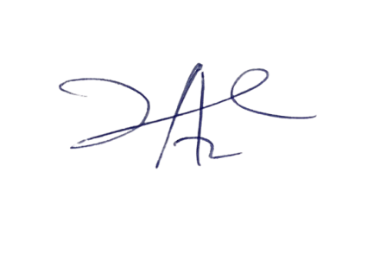

14/3/2023

Principal Head Instructor