**EMERALD ROYAL INTERNATIONAL SCHOOL**

**MPAPE, ABUJA.**

**LESSON PLAN AND NOTE FOR WEEK 5 ENDING 09/02/2024**

**TERM: 2nd**

**WEEK: 5th**

**DATE: 05/02/2024**

**CLASS: Nursery 2**

**SUBJECT: Nature studies**

**TOPIC: Insects**

**SUB—TOPIC: Meaning and examples of insects.**

**PERIOD: 4th**

**TIME: 10:40—11:20am**

**DURATION: 40 minutes**

**NUMBER IN CLASS: 13**

**AVERAGE AGE: 5 years**

**SEX: Mixed**

**LEARNING OBJECTIVES: By the end of the lesson, the pupils should be able to:**

**1. Explain the meaning of insects .**

**2. Mention the examples of insects.**

**3. Outline first aid treatment for insects bites and where insects live.**

**RATIONALE: For pupils to know about insects.**

**PREVIOUS KNOWLEDGE: Pupils have been seeing insects.**

**INSTRUCTIONAL MATERIALS: Ant, cockroach, and a ladybug**

**REFERENCE MATERIALS: Basic science and technology Nursery schools book 3 by OPEMIPO DADA.**

**LESSON DEVELOPMENT**

|  |  |  |  |
| --- | --- | --- | --- |
| **Steps** | **Teacher's activities** | **Pupils' activities** | **Learning point** |
| **Introduction** | **Teacher introduces the lesson by singing nursery rhymes.** | **Pupils sing the rhymes along with the teacher.** | **To prepare pupils minds for the lesson proper.** |
| **Presentation step 1** | **Teacher Explains the meaning of insects to pupils and then ask them to repeat after her.** | **Pupils listen to the teacher and repeat after her.** | **For proper understanding.** |
| **Step 2** | **Teacher mention the examples of insects to pupils and also ask them to repeat after her.** | **Pupils pay attention to the teacher and repeat after him or her.** | **For better understanding.** |
| **Step 3** | **Teacher outline the first aid treatment for insects bites and places that insects lives.** | **Pupils listen attentively to the teacher .** | **For further understanding.** |
| **Board summary** | **Teacher writes the whole note of lesson on the board for pupils to copy into their books. That is;**  **INSECTS**  **Insects are are living things. Some can bite us and some cannot. Some have wings and can fly.**  **Some have no wings and move by crawling on the ground.**  **EXAMPLES OF INSECTS**  **1. House fly**  **2. Bee**  **3. Butterfly**  **4. Tsetse fly**  **5. Wasp**  **6. Cockroach.**  **7. Mosquito**  **8. Dragon fly**  **9. Grasshopper**  **10. Ladybug**  **11. Caterpillar**  **12. Ant**  **13. Slug etc.**  **WHERE INSECTS LIVE**  **1. We can find some insects in the home.**  **2. We can find some insects in the bush.**  **3. We can find some insects in the soil.**  **FIRST AID TREATMENT FOR INSECTS BITES**  **1. Wash the area with soap and water.**  **2. Put some ice in a towel on the area.**  **3. Apply an insects bite cream on the area.**  **4. Go to the hospital if you get sick after the bite.** | **Pupils copy the note into their books.** | **For onward study.** |
| **Evaluation** | **Teacher asks pupils questions base on the topic treated so far.**   1. **What are insects?** 2. **Where do insects lives?** 3. **Mention the types of insects.** 4. **What are the first aid treatment for insect bites?** | **Pupils answer the questions asked by the teacher.** | **To assess pupils level of understanding.** |
| **Conclusion** | **Teacher marks pupils books.** | **Pupils submit their books for marking.** | **For endorsement.** |
| **Assignment(home work)** | **Circle the insects in the box. Activity 12 page 45 basic science text book.** | **Pupils do their assignment at home.** | **To encourage learning at home.** |

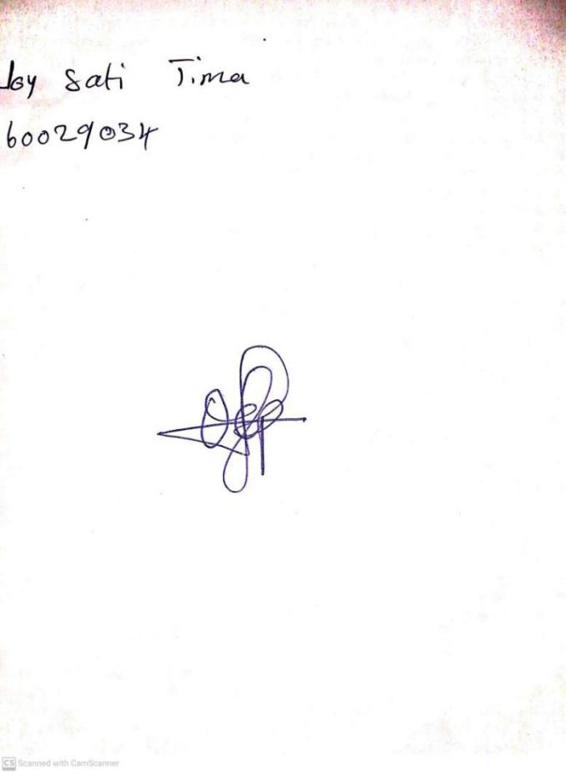

**2nd February, 2024**

**Stream Head Nursery**

**Perpetual Ojoma Ocheja**