**EMERALD ROYAL INTERNATIONAL SCHOOL MPAPE, ABUJA**

**NURSERY 2 (TWO) SCHEME OF WORK**

**1ST TERM**

**CULTURAL AND CREATIVE ARTS**

|  |  |
| --- | --- |
| **WEEKS** | **TOPICS** |
| **1** | **Colouring the bird and the happy rat.** |
| **2** | **Four butterflies near a lighted candle and the boy dreaming.** |
| **3** | **Mr rat the painter and mother cat and the kittens** |
| **4** | **Tracing the dotted tortoise and colour.** |
| **5** | **Colouring balloon and daddy** |
| **6** | **Xmas tree and a dog with a bone** |
| **7** | **Colour by code and antelope** |
| **8** | **A girl playing a flute and mother rat.** |
| **9** | **Connect the dots 1-21, help the rat to get the cake and colour.** |
| **10** | **Colour the boy going to school and cycle.** |
| **11** | **Connect and colour the animal 1-25 and the train.** |
| **12** | **Colour the cock, pig and piglets** |
| **13** | **Revision** |
| **14** | **Examination** |

**EMERALD ROYAL INTERNATIONAL SCHOOL MPAPE, ABUJA**

**NURSERY 2 (TWO) SCHEME OF WORK**

**2ND TERM**

**CULTURAL AND CREATIVE ARTS**

|  |  |
| --- | --- |
| **WEEKS** | **TOPICS** |
| **1** | **A chick on an Easter egg** |
| **2** | **Connect and name the flower and a boy with his toy train** |
| **3** | **Colour the toys and gorilla** |
| **4** | **Colour the flower vase and a boy in a shoe-car.** |
| **5** | **Connect the dotted lion and colour the bird.** |
| **6** | **The donkey and the basket of flower.** |
| **7** | **Colour the ice cream and a puppet drumming** |
| **8** | **Means of transportation.** |
| **9** | **A canoe man on the sea and Mr cock** |
| **10** | **Draw and colour three oranges and the candles.** |
| **11** | **Three legged race and a gift to the baby.** |
| **12** | **Colour the flower and the mouse and a duck crossing the road.** |
| **13-14** | **Revision/ Examination** |

**EMERALD ROYAL INTERNATIONAL SCHOOL MPAPE, ABUJA**

**NURSERY 2 (TWO) SCHEME OF WORK**

**3RD TERM**

**CULTURAL AND CREATIVE ARTS**

|  |  |
| --- | --- |
| **WEEKS** | **TOPICS** |
| **1** | **The shepherd and his sheep, the latest arrival on the farm.** |
| **2** | **Demonstration on the cycle and the bear.** |
| **3** | **Two toys standing by a horse and the man on the horse.** |
| **4** | **Colouring a frog on the leaf and mummy** |
| **5** | **Colouring a cobbler and the flower** |
| **6** | **Connect and colour the elephant and the man’s head.** |
| **7** | **The baby’s hair and the nipost bird** |
| **8** | **Colour the boy planting flower and the cat.** |
| **9** | **Colour the sea animals parade and the bucket.** |
| **10** | **Puppet and the ambulance.** |
| **11** | **A rat running out of the bush and a bear riding on a bicycle.** |
| **12** | **Colour the rat carrying cake and the surprise monkey.** |
| **13-14** | **Revision / Examination.** |

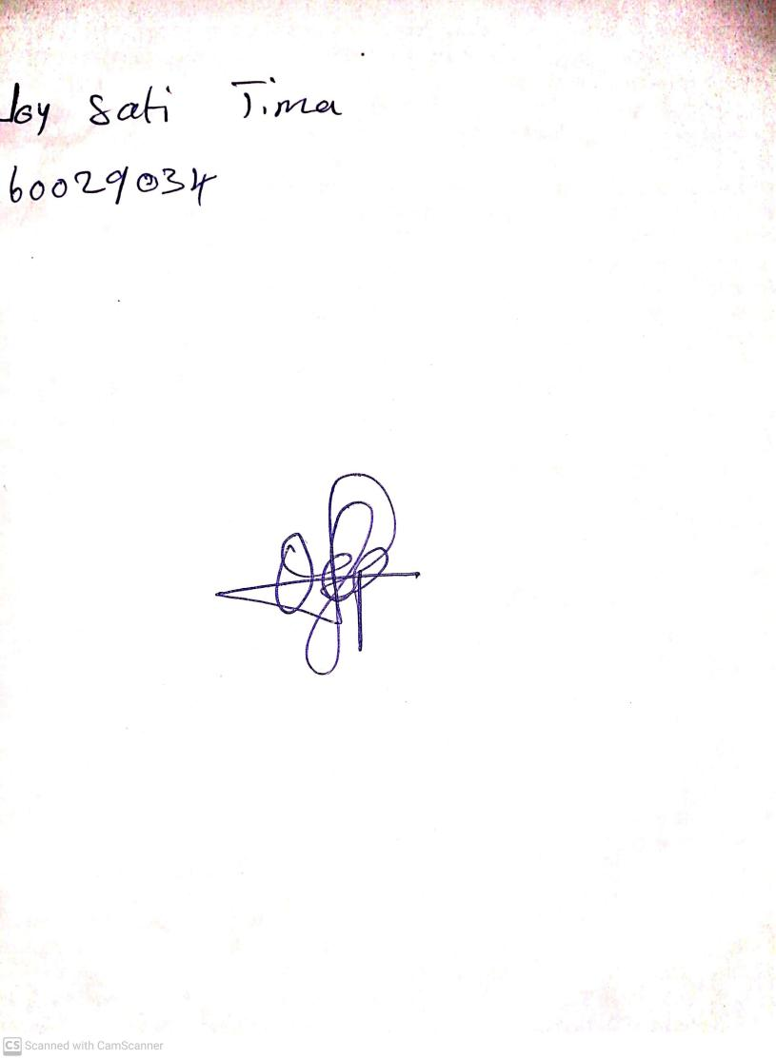

11TH OCTOBER, 2023

Perpetual Ojoma Ocheja

Stream Head Nursery