LESSON PLAN FOR WEEK 7 ENDING 24TH FEBRUARY, 2023

|  |  |
| --- | --- |
| TERM | 2ND |
| WEEK | 7 |
| DATE | 20TH -24TH February, 2023 |
| CLASS | SS 1 |
| SUBJECT | Government |
| TOPIC | Representative Government |
| SUB-TOPIC | Features of Representative Government |
| PERIOD | 6th |
| TIME | 11:50-12:30 |
| DURATION | 40 Minutes |
| NO IN CLASS | 2 |
| AVERAGE AGE | 15years |
| SEX | Mixed |
| SPECIFIC OBJECTIVES | By the end of the lesson, scholars should be able to:  i.Define Representative Government.  ii.State the features of Representative |
| RATIONALE | To acquaint the scholars with the meaning and features of representative government. |
| PREVIOUS KNOWLEDGE | The scholars can explain separation of powers in a cabinet system of government. |
| INSTRUCTIONAL RESOURCES | Charts from textbook explaining the topic. |
| REFERENCE MATERIAL | Essential Government for Senior Secondary Schools.  Debbie C. Chris(2017) |

LESSON DEVELOPMENT

|  |  |  |  |
| --- | --- | --- | --- |
| STEPS | TEACHER’S ACTIVITIES | SCHOLARS’ ACTIVITIES | LEARNING POINTS |
| Introduction | The teacher introduces the lesson by asking the scholars the system of government that is practiced in Nigeria. | The scholars name the system of government practiced in Nigeria Representative system of Government (Indirect Democracy). | To arouse scholar’s interest towards the topic. |
| Step 1 | The teacher defines Representative Government. | The scholars listen carefully. | To ensure proper understanding of the topic. |
| Step 2 | The teacher outlines the features of Representative Government. | The scholars ask questions on the topic. | To make room for logical reasoning on the topic. |
| Board summary | The teacher summarizes the lesson thus:  **Representative Government**  Representative government, also known as indirect democracy is defined as a government of elected representatives of the people. Those elected, through organized elections, rule on behalf of the people and with every assurance that their interests will be enhanced and protected. The system is based on accountability and responsibility of the political leaders. Elections into different positions in government are conducted periodically.  **Features of Representative Government**  1.Free and Fair elections: In every representative government, elections are conducted free and fair, devoid of any electoral malpractices.  2.Periodic Elections: Elections are conducted periodically. In some political systems, it could be every four or five years.  3.Independent electoral commission: This body is incharge of elections and should be independent and impartial in the discharge of its functions.  4.Free Press: The press should be free so as to be able to disseminate information to the people on choice of candidates and political parties.  5.Existence of law courts: People should have free access to the courts whenever they are aggrieved.  6.Rule of law: The provisions of the constitution as well as laws of the land must be observed and obeyed by both the rulers and the ruled.  7.Freedom of choice: The people should have free choices to make when deciding for political parties and candidates. | The scholars copy notes into their notebooks. | For reference purposes. |
| Evaluation | The teacher evaluates the scholars thus:  i.Define Representative government.  ii.Mention two features of representative government. | The scholars attempt the questions. | To ascertain their level of understanding of the lesson. |
| Conclusion | The teacher check scholars notes and make corrections. | The scholars take corrections made by the teacher. | For consolidation of the lesson. |
| Assignment | The teacher gives the scholars assignment:  State five importance of representative government. | The scholars copy their assignments to do at home. | To encourage continuity of learning. |

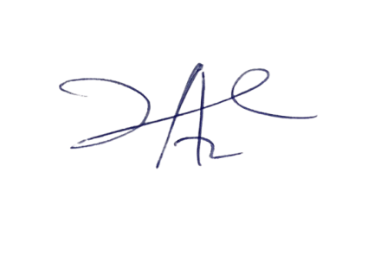

28/3/2023

Principal Head Instructor