**EMERALD ROYAL INTERNATIONAL SCHOOL**

**MPAPE, ABUJA.**

**LESSON PLAN AND NOTE FOR WEEK 3 ENDING 29/09/2023**

TERM: FIRST

WEEK: 3ND

DATE: 25/09/2023

CLASS: NURSERY 2

SUBJECT: SOCIAL NORMS

TOPIC: FORMS OF CHILD ABUSE .

SUB-TOPIC: EXAMPLES OF FORMS OF CHILD ABUSE

PERIOD: 2ND PERIOD AFTER LONG BREAK

TIME: 11: 20- 12: 00PM

DURATION: 40 MINUTES.

NUMBER IN CLASS: 14

AVERAGE AGE: 5 YEARS.

SEX: MIXED.

SPECIFIC OBJECTIVES: BY THE END OF THE LESSON,THE PUPILS SHOULD BE ABLE TO:

1. MENTION AT LEAST 3 FORMS OF CHILD ABUSE
2. EXPLAIN THE 3 FORMS OF CHILD ABUSE

RATIONALE: FOR PUPILS TO KNOW MORE ABOUT CHILD ABUSE.

PREVIOU KNOWLEDGE: PUPILS HAVE LEARNT THE MEANING AND EXAMPLES OF CHILD ABUSE IN PREVIOUS LESSON.

INSTRUCTIONAL MATERIALS: A VIDEO CLIP OF PEOPLE WHO ARE ABUSE PHYSICALLY,SEXUALLY AND EMOTIONALLY IN TEACHERS PHONE.

REFERENCE MATERIALS: GOOGLE.COM

**LESSON DEVELOPMENT**

|  |  |  |  |
| --- | --- | --- | --- |
| STAGES/STEPS | TEACHER’S ACTIVITIES | PUPILS’ ACTIVITIES | LEARNING POINTS |
| INTRODUCTION | Teacher introduces the lesson by reviewing the previous lesson. | Pupils pay attention to the teacher. | To arouse pupils interest for the lesson ahead. |
| PRESENTATION  STEP 1 | Teacher mentions the forms of child abuse to pupils and then asks them to repeat after her. | Pupils listen attentively to the teacher and repeat after her. | For proper understanding . |
| STEP 2 | Teacher explains the different forms of child abuse to pupils and also asks them to repeat after her. | Pupils pay attention to the teacher and repeat after her. | For better understanding of the lesson. |
| BOARD SUMMARY | Teacher summarizes the lesson by writing the whole note of lesson on the board for pupils to copy into their books. Ie,  FORMS OF CHILD ABUSE   1. Physical form of child abuse. 2. Sexual form of child abuse. 3. Emotional form of child abuse.   Physical form of child abuse:  It is any non accidental physical injury to the child and can include striking,kicking,burning or biting the child, or any action that results in a physical impairment of the child.  Sexual abuse (molestation)  It is a form of child abuse in which an adult or older adolescent uses a child for sexual stimulation.  Emotional abuse:  is a form of abuse characterized by a person subjecting or behaviour that may result in psychological trauma including anxiety,chronic depression,or post-traumatic stress disorder. | Pupils copy the note into their exercise books. | For onward study. |
| EVALUATION | Teacher evaluates the lesson by asking the following questions;   1. Mention the 3 forms of child abuse. 2. Explain the 3 forms of child abuse. | Pupils answer the questions asked by the teacher. | To assess pupils level of understanding. |
| CONCLUSION | Teacher concludes the lesson by marking pupils books. | Pupils submit their books for marking. | For endorsement. |
| ASSIGNMENT | 1. What is stigmatization? 2. Mention at least 3 effects of stigmatization. | Pupils do their assignment at home. | To encourage learning at home. |

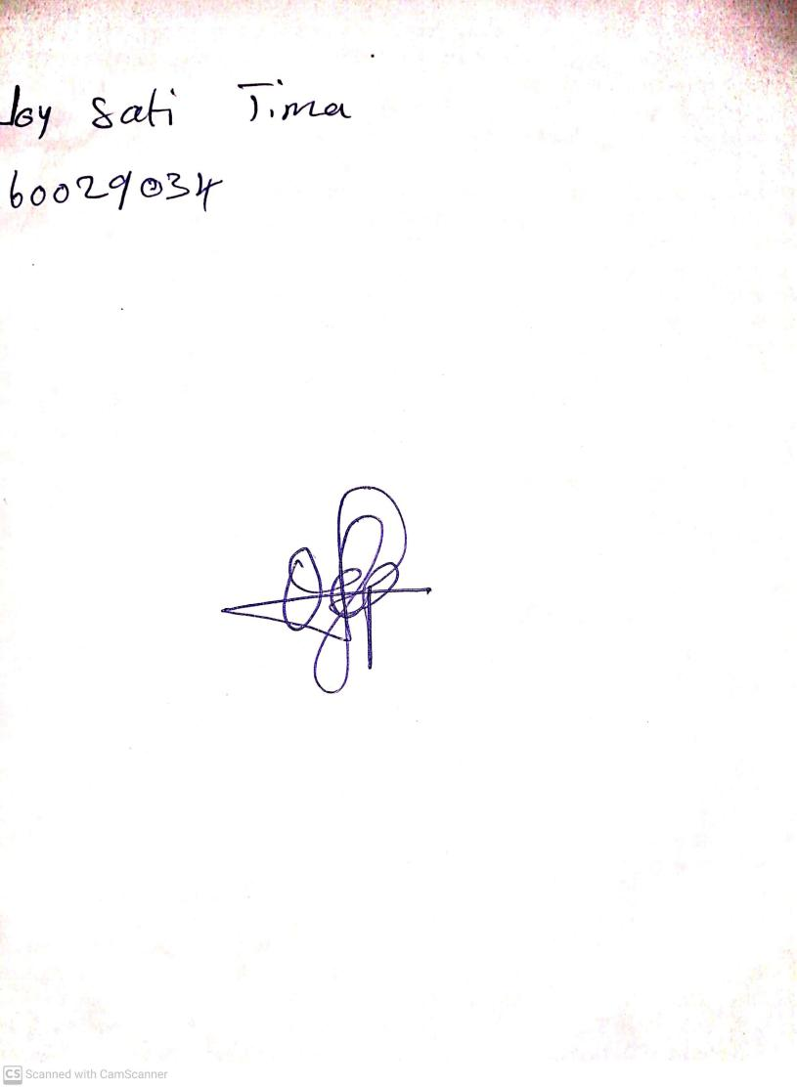

18th September, 2023

Perpetual Ojoma Ocheja

Stream Head Nursery