**EMERALD ROYAL INTERNATIONAL SCHOOL, MPAPE ABUJA**

**LESSON PLAN AND NOTE FOR WEEK 6 ENDING FRIDAY, 16TH FEBRUARY, 2024**

**TERM:** FIRST TERM

**WEEK:** WEEK 6

**SUBJECT:** ENGLISH LANGUAGE (SPEECH)

**TOPIC:** SIMPLE GREETINGS

**SUB-TOPIC:** SIMPLE GREETINGS AT HOME

**DATE:** WEDNESDAY, 14TH FEBRUARY, 2024

**TIME:** 02:00 – 02:30PM

**DURATION:** 30 MINUTES

**PERIOD:** 9TH

**CLASS:** NURSERY 3

**NUMBER IN CLASS:** TWELVE

**AVERAGE AGE:** FIVE

**SEX:** MIXED

**LEARNING OBJECTIVES:** By the end of the lesson, the pupils should be able to

1. Define greeting.
2. Practices simple greeting at home.

**RATIONALE:** for pupils to learn how to greet.

**PREVIOUS KNOWLEGDE:** pupils have learnt about rhymes.

**INSTRUCTIONAL MATERIALS:**

1. Textbook. Nigeria Primary English book 1

**REFERENCE MATERIALS:**

1. Nigeria Primary English book 1 by B. Someye, D Dallas etal 2000

**LESSON DEVELOPMENT**

|  |  |  |  |
| --- | --- | --- | --- |
| **STAGES/STEPS** | **TEACHER’S ACTIVITIES** | **PUPILS’ ACTIVITIES** | **LEARNING POINTS** |
| **INTRODUCTION** | Review previous knowledge. | Respond to the question. | Arouse the pupils interest. |
| **PRESENTATION**  **STEP 1** | Teaches pupils the meaning of simple greeting.  **Meaning of simple greeting**  Simple greeting is an act, gesture or expression of acknowledgement and salutation to people. It is a sign of showing respect. | Define simple greeting. | For proper understanding. |
| **STEP 2** | Leads pupils to practice simple greetings at home.  **Greeting in the morning**  **Sarah:** good morning, daddy.  **Daddy:** good morning, Sarah. How was your night?  **Sarah:** it was fine sir.  **Daddy:** I hope you slept well?  **Sarah:** yes, Dad. I slept well. | Identify the rhyming words. | For better understanding. |
| **SUMMARY** | Summarizes the lesson by emphasizing on the main concept and writes note on the board. | Listen and copy their notes | For onward study |
| **EVALUATION** | Ask pupils to:   1. Define simple greeting. 2. Get a partner and practice simple greeting. | Respond to the teacher’s questions. | To test the understanding of the pupils of the lesson |
| **CONCLUSION** | Summarizes, correct and mark pupils’ notebooks. | Write the note on the board and submit their notebooks for marking | Clarifying the concept. |
| **HOME-WORK** | Nigeria Primary English, book 1 page 126. | Copy and return home with task | Extending lesson home. |

**LESSON PLAN AND NOTE FOR WEEK 6 ENDING FRIDAY, 16TH FEBRUARY, 2024**

**TERM:** FIRST TERM

**WEEK:** WEEK 6

**SUBJECT:** ENGLISH LANGUAGE (GRAMMAR)

**TOPIC:** PUNCTUATION MARK

**SUB-TOPIC:** PUNCTUATION MARK (FULL STOP)

**DATE:** MONDAY, 12TH FEBRUARY, 2024

**TIME:** 01:20 – 02:00PM

**DURATION:** 30 MINUTES

**PERIOD:** 8TH

**CLASS:** NURSERY 3

**NUMBER IN CLASS:** TWELVE

**AVERAGE AGE:** FIVE

**SEX:** MIXED

**LEARNING OBJECTIVES:** By the end of the lesson, the pupils should be able to

1. State the meaning of full stop.
2. Use the full stop correctly.

**RATIONALE:** for pupils to know how to use the full stop correctly.

**PREVIOUS KNOWLEGDE:** pupils have learnt how to use capital letters correctly while writing a sentence.

**INSTRUCTIONAL MATERIALS:**

1. Nigeria Primary English book 1

**REFERENCE MATERIALS:**

1. Nigeria Primary English book 1 by B. Someye, D Dallas etal 2000

**LESSON DEVELOPMENT**

|  |  |  |  |
| --- | --- | --- | --- |
| **STAGES/STEPS** | **TEACHER’S ACTIVITIES** | **PUPILS’ ACTIVITIES** | **LEARNING POINTS** |
| **INTRODUCTION** | Review previous knowledge. | Respond to the teacher. | Arouse the pupils interest. |
| **PRESENTATION**  **STEP 1** | Teaches pupils the meaning of full stop  **Meaning of full stop**  A full stop is a punctuation mark that is used at the end of a sentence or an abbreviation. | Listen attentively and learn. | For proper understanding. |
| **STEP 2** | Guides pupils to use a full stop correctly while writing a sentence.  A full stop is used at the end of a sentence  For examples,   1. I don’t like sleeping late. 2. I gave Emmanuel a pencil on Tuesday. 3. Shola is afraid of monkeys. 4. The television is working fine. 5. Mother is cooking dinner in thee kitchen. | Listen attentively and learn. | For better understanding. |
| **SUMMARY** | Summarizes the lesson by emphasizing on the main concept and writes note on the board. | Listen and copy their notes | For onward study |
| **EVALUATION** | Ask pupils to:   1. Give the meaning of full stop. 2. Write a short sentences and add a full stop appropriately. | Respond to the teacher’s questions. | To test the understanding of the pupils of the lesson |
| **CONCLUSION** | Summarizes, correct and mark pupils’ notebooks. | Write the note on the board and submit their notebooks for marking | To consolidate the lesson. |
| **HOME-WORK** | Nigeria Primary English, book 1, page 128, 129 exercise 1 & 2. | Return home with task | Extending lesson home. |

**LESSON PLAN AND NOTE FOR WEEK 6 ENDING FRIDAY, 16TH FEBRUARY, 2024**

**TERM:** FIRST TERM

**WEEK:** WEEK 6

**SUBJECT:** ENGLISH LANGUAGE (COMPREHENSION)

**TOPIC:** READING

**SUB-TOPIC:** THE THREE BILLY GOAT

**DATE:** THURSDAY, 15TH AND FRIDAY, 16TH FEBRUARY, 2024

**TIME:** 09:25 – 10:55AM AND 11: 25 – 12PM

**DURATION:** 30 MINUTES

**PERIOD:** 3RD AND 6TH

**CLASS:** NURSERY 3

**NUMBER IN CLASS:** TWELVE

**AVERAGE AGE:** FIVE

**SEX:** MIXED

**LEARNING OBJECTIVES:** By the end of the lesson, the pupils should be able to:

1. Read the passage carefully.
2. Pronounce difficult words.
3. Answer the questions bellow the passage.

**RATIONALE:** to improve the pupils reading skill and also learn about ‘my family’.

**PREVIOUS KNOWLEGDE:** pupils have learnt about reading passage ‘Mr. Kusa the banker’.

**INSTRUCTIONAL MATERIALS:**

1. Nigeria Primary English book 1, fourth edition

**REFERENCE MATERIALS:**

1. Nigeria Primary English book 1 by B. Someye, D Dallas etal 2000

**LESSON DEVELOPMENT**

|  |  |  |  |
| --- | --- | --- | --- |
| **STAGES/STEPS** | **TEACHER’S ACTIVITIES** | **PUPILS’ ACTIVITIES** | **LEARNING POINTS** |
| **INTRODUCTION** | Review previous knowledge, and asked pupils to open their textbook to page 127. | Respond to the teacher instructions. | Arouse the pupils interest. |
| **PRESENTATION**  **STEP 1** | Lead pupils to read the passage ‘the three Billy goat’.  A very long time ago, there were three billy goats who were going up the hillside to make themselves fat.  On their way up, there was a bridge. Under the bridge lived a great ugly troll…………. | Read the passage after the teacher. | For proper understanding. |
| **STEP 2** | Guides pupils to pronounce difficult words in the passage.  **Words from the passage**   1. Hillside 2. Bridge 3. Troll 4. Ugly 5. Youngest 6. Tripping 7. Roared 8. Gobbled 9. Spears 10. poked | Spell and pronounce difficult words in the passage. | For better understanding. |
| **STEP 3** | Ask pupils questions based on the passage.   1. I am from _____ family. 2. We are ________ in my family. 3. My mother is a ____ woman. | Answer the questions. | For further understanding. |
| **SUMMARY** | Summarizes the lesson by emphasizing on the main concept and writes note on the board. | Listen and copy their notes | For onward study |
| **EVALUATION** | Ask pupils to:   1. Read the passage carefully. 2. Pronounce difficult words. 3. Answer the question from the passage. | Respond to the teacher’s questions. | To test the understanding of the pupils of the lesson |
| **CONCLUSION** | Summarizes, correct and mark pupils’ notebooks. | Write the note on the board and submit their notebooks for marking | Clarifying the concept. |
| **HOME-WORK** | Nigeria Primary English. Book 1, page 38, exercise 1 and 2. | Return home with task | Extending lesson home. |

**LESSON PLAN AND NOTE FOR WEEK 6 ENDING FRIDAY, 16TH FEBRUARY, 2024**

**TERM:** FIRST TERM

**WEEK:** WEEK 6

**SUBJECT:** ENGLISH LANGUAGE (COMPOSITION)

**TOPIC:** LETTERS OF THE ALPHABET

**SUB-TOPIC:** IDENTIFICATION OF CAPITAL AND SMALL LETTER Qq to Tt

**DATE:** THURSDAY, 15TH FEBRUARY, 2024

**TIME:** 11:10 – 11:50PM

**DURATION:** 40 MINUTES

**PERIOD:** 5TH

**CLASS:** NURSERY 3

**NUMBER IN CLASS:** TWELVE

**AVERAGE AGE:** FIVE

**SEX:** MIXED

**LEARNING OBJECTIVES:** By the end of the lesson, the pupils should be able to

1. Identify capital and small letters Qq - Tt.
2. Write capital and small letters Qq - Tt.

**RATIONALE:** for pupils to know how to identify and write letters Qq - Tr.

**PREVIOUS KNOWLEGDE:** pupils have learnt about my family.

**INSTRUCTIONAL MATERIALS:**

1. Textbook- Nigeria Primary English book 1
2. Letter chart
3. Flash cards

**REFERENCE MATERIALS:**

1. Nigeria Primary English book 1 by B. Someye, D Dallas etal 2000

**LESSON DEVELOPMENT**

|  |  |  |  |
| --- | --- | --- | --- |
| **STAGES/STEPS** | **TEACHER’S ACTIVITIES** | **PUPILS’ ACTIVITIES** | **LEARNING POINTS** |
| **INTRODUCTION** | Review previous knowledge. | Respond to the teacher. | Arouse the pupils interest. |
| **PRESENTATION**  **STEP 1** | Leads pupils to identify capital and small letters Qq - Tt.  Qq Rr Ss Tt | Identify capital and small letters Qq - Tt. | For proper understanding. |
| **STEP 2** | Leads pupils to write capital and small letters Qq - Tt.  Qq Rr Ss Tt | Write capital and small letters Qq - Tt. | For better understanding. |
| **SUMMARY** | Summarizes the lesson by emphasizing on the main concept and writes note on the board. | Listen and copy their notes | For onward study |
| **EVALUATION** | Ask pupils to:   1. Identify capital and small letters Qq - Tt Form the flash cards. 2. Write capital and small letters Qq-Tt | Respond to the teacher’s questions. | To test the understanding of the pupils of the lesson |
| **CONCLUSION** | Summarizes, correct and mark pupils’ notebooks. | Write the note on the board and submit their notebooks for marking | Clarifying the concept. |
| **HOME-WORK** | 1. Nigeria Primary English. Page 129 | Return home with task | Extending lesson home. |

**LESSON PLAN AND NOTE FOR WEEK 6 ENDING FRIDAY, 16TH FEBRUARY, 2024**

**TERM:** FIRST TERM

**WEEK:** WEEK 6

**SUBJECT:** ENGLISH LANGUAGE (PHONICS)

**TOPIC:** SOUND BANK

**SUB-TOPIC:** WORDS WITH THE SOUNDS /ʤ/

**DATE:** TUESDAY, 13TH FEBRUARY, 2023

**TIME:** 10:30 – 11:10AM

**DURATION:** 40 MINUTES

**PERIOD:** 4TH

**CLASS:** NURSERY 3

**NUMBER IN CLASS:** TWELVE

**AVERAGE AGE:** FIVE

**SEX:** MIXED

**LEARNING OBJECTIVES:** By the end of the lesson, the pupils should be able to

1. Identify the sound /ʤ/.
2. Pronounce the sound /ʤ/.
3. Mention words with the sound /ʤ/.

**RATIONALE:** for pupils to identify and pronounce the sound /ʤ/.

1. **PREVIOUS KNOWLEGDE:** pupils have learnt about the sound /ʧ/

**INSTRUCTIONAL MATERIALS:**

1. Flash cards.
2. Pictorial charts.

**REFERENCE MATERIALS:**

1. Nigeria Primary English book 1 by B. Someye, D Dallas etal 2000

**LESSON DEVELOPMENT**

|  |  |  |  |
| --- | --- | --- | --- |
| **STAGES/STEPS** | **TEACHER’S ACTIVITIES** | **PUPILS’ ACTIVITIES** | **LEARNING POINTS** |
| **INTRODUCTION** | Display flash cards on a flat surface with words with the sound /ʤ/. | Focus on the flash cards to identify words with the sounds /ʤ/. | Arouse the pupils interest. |
| **PRESENTATION**  **STEP 1** | Leads pupils to identify the sound /ʤ/ on the flash cards and in the textbook.  **/ʤ/** | Learn attentively. | For proper understanding. |
| **STEP 2** | Teaches pupils how to pronounce the sound /ʤ/.  The sound /ʤ/ is a voiced sound. When pronouncing the sound, the vocal cords vibrate. | Learn carefully. | For better understanding. |
| **STEP 3** | Teaches pupils word with the sound /ʤ/.   1. Jam 2. John 3. Jump 4. Jane 5. Badge 6. Fridge 7. Jeep 8. Juice 9. Bridge 10. Edge 11. Manager 12. Giant | Learn attentively. | For further understanding. |
| **SUMMARY** | Summarizes the lesson by emphasizing on the main concept and writes note on the board. | Listen and copy their notes | For onward study |
| **EVALUATION** | Ask pupils to:   1. Identify the sound /ʤ/. 2. Pronounce the sound /ʤ/. 3. Mention words with the sound /ʤ/. | Respond to the teacher’s questions. | To test the understanding of the pupils of the lesson |
| **CONCLUSION** | Summarizes, correct and mark pupils’ notebooks. | Write the note on the board and submit their notebooks for marking | Clarifying the concept. |
| **HOME-WORK** | Nigeria Primary English work book 1, page 32. | Return home with task | Extending lesson home. |

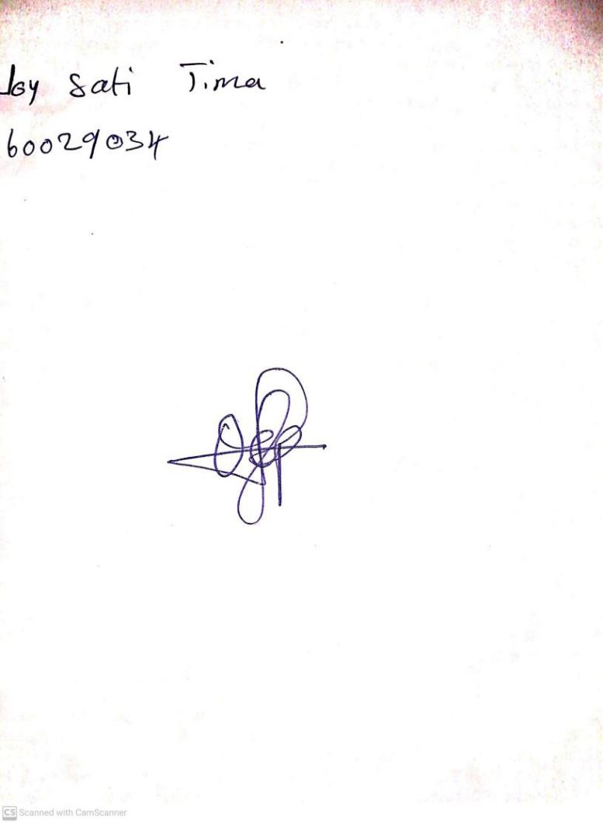

9TH FEBRUARY, 2024

Perpetual Ojoma Ocheja

Stream Head Nursery