**LESSON PLAN AND NOTE FOR WEEK 6 ENDING 20/10/2023**

**Term 1st term**

**Week 6th week.**

**Date 19th September,2023**

**Class Nursery one**

**Subject Social Norms**

**Topic Good habits.**

**Sub-topic Meaning of good habit**

**Period 7th period**

**Time 1:55 pm**

**Duration 35 minutes**

**No in class 15**

**Average Age 3 years**

**Sex Mixed**

**Specific Objectives: By the end of the lesson the pupils should be able to:**

1. **Define good habit.**
2. **Identify the things we do to exhibit good habits.**

**Rationale: To ensure the pupils define and identify good habits.**

**Previous Knowledge: The pupils can identify things around them.**

**Instructional Resources: Board,marker ,online research.**

**Reference Materials: Smart smart Civic Education by A.M Solu, T.Y Alabi, Nursery 2**

**LESSON PRESENTATION**

|  |  |  |  |
| --- | --- | --- | --- |
| **Steps** | **Teacher’s Activities** | **Pupils’ Activities** | **Learning Points** |
| **Introduction** | **The teacher introduces the topic (good habit) by teaching the pupils meaning of good habits as “what we do to live well”.** | **The pupils listens attentively to the teacher and repeats after the teacher the meaning of good habits.** | **To arouse the pupils’ interest towards the lesson.** |
| **Step 1** | **The teacher assists the pupils to continuously say the meaning of good habits.** | **The pupils continuously repeats the meaning of good habits.** | **For proper understanding.** |
| **Step 2** | **The teacher teaches the pupils how to live well that is,**  **EATING GOOD FOOD.**  **EATING GOOD FRUITS.**  **DRINKING CLEAN WATER.** | **The pupils pays attention to the teacher and lists other good food and fruits.** | **For better understanding.** |
| **Summary** | **The teacher summarizes the lesson by listing a lot of healthy good food and friuts for the pupils that makes everyone healthy.** | **The pupils actively participates with their teacher.** | **For onward study.** |
| **Evaluation** | **What is good habits?**  **Mention 3 ways we can do to live well?** | **The pupils answer the questions accordingly.** | **To ascertain the pupils’ understanding.** |
| **Conclusion** | **The teacher summarizes,reacts,and corrects the pupils.** | **The teacher gives answers to the teacher’s question.** | **To consolidate the lesson.** |
| **Assignment** | **What is Good Habit?**  **Colour the fruits for healthy living below?**  **uncoloured apple**  **uncolored pineapple**  **Mention three things we do to live well?** | **The pupils copy and do their home-work at home.** | **To encourage learning while at home.** |

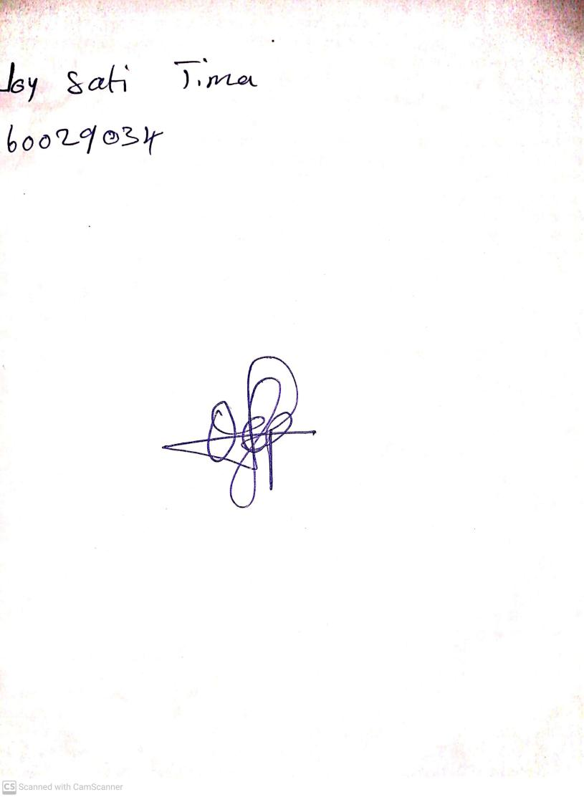

15th August, 2023

Perpetual Ojoma Ocheja

Stream Head Nursery