**LESSON PLAN AND NOTE FOR WEEK 5 ENDING 24/5/2024**

**Term 3rd term**

**Week 5th week**

**Date 21st May,2024**

**Class Nursery one**

**Subject Nature studies**

**Topic Animals.**

**Sub-topic Meaning of Animals.**

**Period 2nd period**

**Time 9:05 am**

**Duration 35 minutes**

**No in class 14**

**Average Age 3 years**

**Sex Mixed.**

**Specific Objectives: By the end of the lesson, the pupils should know how to:**

1. **Define Animals.**
2. **Mention the types of animals**
3. **Identify the types of animals.**

**Rationale: To help the pupils have vital knowledge of animals**

**Previous Knowledge: The pupils have knowledge of table manners**

**Instructional Resources: Online Research,Animals chart.**

**Reference Materials: Online Research, Elementary Science by Showers Kiddies.**

**LESSON PRESENTATION**

|  |  |  |  |
| --- | --- | --- | --- |
| **Steps** | **Teacher’s Activities** | **Pupils’ Activities** | **Learning Points** |
| **Introduction** | **The teacher introduces the topic (Animals ) by showing the pupils pictures of different kinds of animals.** | **The pupils could identify the examples of animals.** | **To arouse the interest of the pupils.** |
| **Step 1** | **The teacher starts the lesson by teaching the pupils the meaning of animals as “living things that make their own food by eating plants”.** | **The pupils listen attentively to the teacher and repeats after the teacher the meaning of animals.** | **For proper understanding.** |
| **Step 2** | **The teacher mention the types of animals which include**  **Domestic Wild**  **Dogs Snake**  **Rat Lion**  **Rabbit Tiger etc** | **The pupils listens to the teacher and repeats after the teacher the types of animals.** | **For better understanding.** |
| **Step 3** | **The teacher leads the pupils to identify the types of animals from the domestic and wild animals chart.** | **The pupils participates in identifying types of animals from the chart.** | **For further understanding.** |
| **Summary** | **The teacher summarizes the lesson by defining animals.** | **The pupils knows the definition of a animals.** | **For onward study.** |
| **Evaluation** | **Question:**  **Define table animals?**  **Mention the types of animals?**  **Identify the types of animals from the domestic animals?** | **The pupils answer the question correctly.** | **To ascertain the pupils’ understanding.** |
| **Conclusion** | **The teacher summarizes, reacts, and corrects the pupils.** | **The pupils gives answers to the teacher’s question.** | **To consolidate the lesson.** |
| **Assignment** | **Question:**  **Define table animals?**  **Mention the types of animals?**  **Identify the types of animals from the domestic animals?**    **Dog __________**  **Tiger**  **____________** | **The pupils copy and do their homework at home.** | **To encourage learning while at home.** |

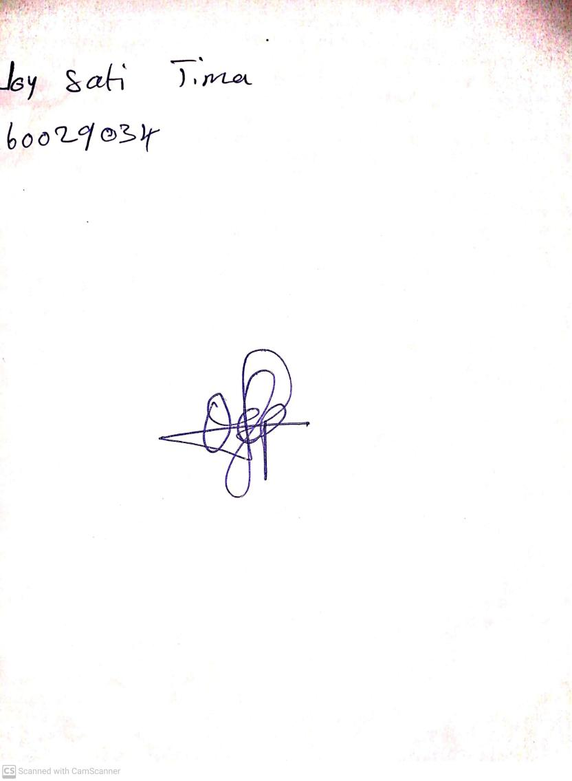

17th May, 2024

Perpetual Ojoma Ocheja

Stream Head Nursery