**EMERALD ROYAL INTERNATIONAL SCHOOL**

**MPAPE, ABUJA.**

**LESSON PLAN AND NOTE FOR WEEK 6 ENDING 20/10/2023**

TERM: FIRST

WEEK: 6TH

DATE: 16/10/2023

CLASS: NURSERY 2

SUBJECT: SOCIAL NORMS

TOPIC: RESPONSIBILITIES .

SUB-TOPIC: MY RESPONSIBILITIES IN SCHOOL AND SOCIETY.

PERIOD: 2ND PERIOD AFTER LONG BREAK

TIME: 11: 20- 12: 00PM

DURATION: 40 MINUTES.

NUMBER IN CLASS: 14

AVERAGE AGE: 5 YEARS.

SEX: MIXED.

SPECIFIC OBJECTIVES: BY THE END OF THE LESSON,THE PUPILS SHOULD BE ABLE TO:

1. STATE THEIR RESPONSIBILITIES IN SCHOOL.
2. MENTION THEIR RESPONSIBILITIES IN THE SOCIETY.

RATIONALE: FOR PUPILS TO KNOW THEIR RESPONSIBILITIES INSCOOL AND SOCIETY

PREVIOU KNOWLEDGE: PUPILS HAVE LEARNT THEIR RSPONSIBILITIES AT HOME.

INSTRUCTIONAL MATERIALS: ORGANISING SCHOOLARS TO ARRANGE THE CLASSROOM.

REFERENCE MATERIALS: GOOGLE.COM

**LESSON DEVELOPMENT**

|  |  |  |  |
| --- | --- | --- | --- |
| STAGES/STEPS | TEACHER’S ACTIVITIES | PUPILS’ ACTIVITIES | LEARNING POINTS |
| INTRODUCTION | Teacher introduces the lesson by reviewing the previous lesson. | Pupils pay attention to the teacher. | To arouse pupils interest for the lesson ahead. |
| PRESENTATION  STEP 1 | Teacher states the responsibilities in school to pupils and then asks them to repeat after her. | Pupils listen attentively to the teacher and repeat after her. | For proper understanding . |
| STEP 2 | Teacher mentions the responsibilities of children in the society to pupils and also asks them to repeat after her. | Pupils pay attention to the teacher and repeat after her. | For better understanding of the lesson. |
| BOARD SUMMARY | Teacher summarizes the lesson by writing the whole note of lesson on the board for pupils to copy into their books. That is;  MY RESPONSIBILITIES IN SCHOOL.  My responsibilities in school are:   1. Being punctual and respectful. 2. Keep the school neat and tidy. 3. Completing all home work assignments. 4. Reading on a regular basis. 5. Obey all the teachers 6. Attending classes on time and regularly. 7. Taking good care of school properties. 8. Doing your best. 9. Being prepared for classes with all necessary supplies etc.   MY RESPONSIBILITIES IN THE SOCIETY  My responsibilities in the society are:   1. Fulfilling civic duty. 2. Your actions must benefit the whole of society. 3. Must be honest. 4. Must be loyal. 5. Must be helpful etc. | Pupils copy the note into their exercise books. | For onward study. |
| EVALUATION | Teacher evaluates the lesson by asking the following questions;   1. State the responsibility in school. 2. Mention your duties or responsibiliyies in the society. | Pupils answer the questions asked by the teacher. | To assess pupils level of understanding. |
| CONCLUSION | Teacher concludes the lesson by marking pupils books. | Pupils submit their books for marking. | For endorsement. |
| ASSIGNMENT | 1. What is saving? 2. List 5 things we can save. 3. Mention 5 places we can save things. | Pupils do their assignment at home. | To encourage learning at home. |

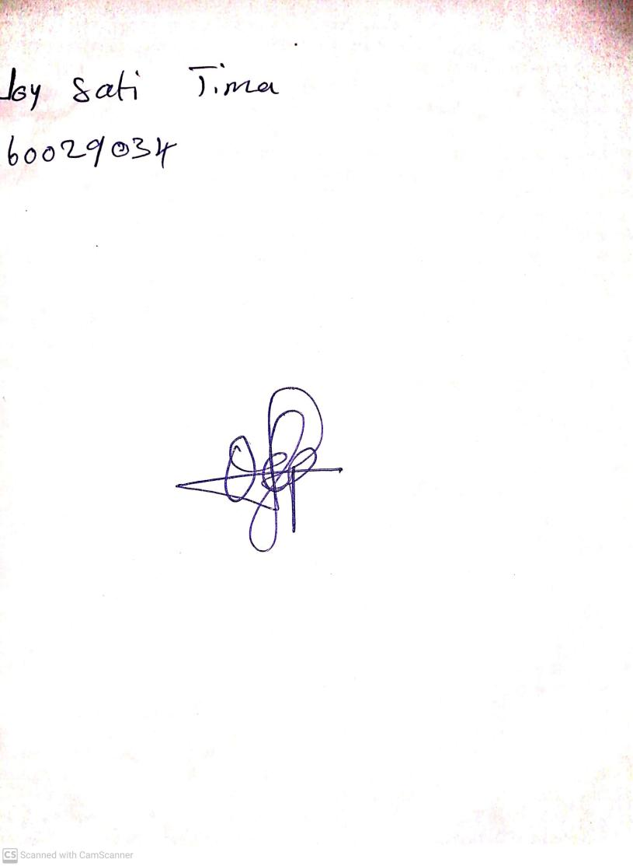

18th September, 2023

Perpetual Ojoma Ocheja

Stream Head Nursery