**EMERALD ROYAL INTERNATIONAL SCHOOL**

**MPAPE, ABUJA.**

**LESSON PLAN AND NOTE FOR WEEK 5 PERIOD 1 ENDING 11/10/2024**

**TERM: FIRST**

**WEEK: 5TH**

**DATE: 07/10/2024**

**CLASS: NURSERY 2**

**SUBJECT: NUMBER WORK**

**TOPIC: COUNTING NUMBER 25 -30 .**

**SUB-TOPIC: COUNTING AND IDENTIFICATION OF NUMBERS 1-30**

**PERIOD: 1ST.**

**TIME: O8:50-09:30.**

**DURATION: 40 MINUTES.**

**NUMBER IN CLASS: 14**

**AVERAGE AGE: 5 YEARS.**

**SEX: MIXED.**

**SPECIFIC OBJECTIVES: BY THE END OF THE LESSON,THE PUPILS SHOULD BE ABLE TO:**

1. **COUNT NUMBER 1-30 ORALLY.**
2. **IDENTIFY NUMBER 1-30 ON A CHART.**

**RATIONALE: FOR PUPILS TO BE ABLE TO COUNT SEQUENTIALLY AND IDENTIFY NUMBER 1-30.**

**PREVIOU KNOWLEDGE: PUPILS HAVE LEARNT COUNTING OF NUMBERS 1-25 IN PREVIOUS LESSON.**

**INSTRUCTIONAL MATERIALS: NUMBER CHART FROM 1-30.**

**REFERENCE MATERIALS: THE NEW MASTERING MATHEMATICS FOR NURSERY SCHOOLS BOOK 3 BY HENRY.Z.IDOGUN.**

**LESSON DEVELOPMENT**

|  |  |  |  |
| --- | --- | --- | --- |
| **STAGES/STEPS** | **TEACHER’S ACTIVITIES** | **PUPILS’ ACTIVITIES** | **LEARNING POINTS** |
| **INTRODUCTION** | **Teacher introduces the lesson by singing a number rhyme for the pupils.** | **Pupils sing the rhyme along with the teacher.** | **To arouse pupils interest in the lesson.** |
| **PRESENTATION**  **STEP 1** | **Teacher claps and count number 1-30 and then asks pupils to repeat after her.** | **Pupils repeat after the teacher by counting number 1-30 while clapping their hands. That is; 1 2 3 4 5 6 7 8 9 10 11 12 13 14 15 16 17 18 19 20 21 22 23 24 25 26 27 28 29 30** | **To enhance play way method of learning .** |
| **STEP 2** | **Teacher displaces number chart from 1-30 and then identify and asks pupils to repeat after her** | **Pupils identify the numbers after the teacher repeatedly.** | **For better understanding of the lesson.** |
| **BOARD SUMMARY** | **Teacher summarizes the lesson by counting the numbers 1-30 on the chart over and over again.** | **Pupils pay attention to the teacher.** | **For more understanding of the lesson.** |
| **EVALUATION** | **Teacher asks Pupils to:**   1. **Count numbers 1–30 on the board all together.** 2. **Identify numbers 1 - 30 on the chart one after the other.** | **Pupils count and identify the numbers 1 - 30 on the board one after another.** | **To ascertain if pupils can count and identify numbers 1-30 on their own.** |
| **CONCLUSION** | **Teacher ends the lesson by singing a nursery rhyme.** | **Pupils sing the rhyme along with the teacher.** | **To improve pupils speaking ability.** |
| **ASSIGNMENT (HOME WORK)** | **Identify, count and write numbers 1 -30** | **Pupils do their assignment at home.** | **To encourage learning at home.** |

**LESSON PLAN AND NOTE FOR WEEK 5 PERIOD 2 ENDING 11/10/2024**

**TERM: FIRST**

**WEEK: 5TH**

**DATE: 08/15/2024**

**CLASS: NURSERY 2**

**SUBJECT: NUMBER WORK**

**TOPIC: COUNTING NUMBER 21-30 .**

**SUB-TOPIC: BACKWARD COUNTING OF NUMBERS 30- 1**

**PERIOD: 2ND.**

**TIME: O8:50-09:30.**

**DURATION: 40 MINUTES.**

**NUMBER IN CLASS: 14**

**AVERAGE AGE: 5 YEARS.**

**SEX: MIXED.**

**SPECIFIC OBJECTIVES: BY THE END OF THE LESSON,THE PUPILS SHOULD BE ABLE TO:**

1. **COUNT NUMBER 30-1 BACKWARDLY**
2. **WRITE NUMBER 30-1**

**RATIONALE: FOR PUPILS TO KNOW BACKWARD COUNTING OF NUMBERS 30-1**

**PREVIOU KNOWLEDGE: PUPILS HAVE LEARNT COUNTING OF NUMBERS 1-30 IN PREVIOUS LESSON.**

**INSTRUCTIONAL MATERIALS: NUMBER FLASH CARDS.**

**REFERENCE MATERIALS: THE NEW MASTERING MATHEMATICS FOR NURSERY SCHOOLS BOOK 3 BY HENRY.Z.IDOGUN.**

**LESSON DEVELOPMENT**

|  |  |  |  |
| --- | --- | --- | --- |
| **STAGES/STEPS** | **TEACHER’S ACTIVITIES** | **PUPILS’ ACTIVITIES** | **LEARNING POINTS** |
| **INTRODUCTION** | **Teacher introduces the lesson by reviewing the previous lesson.** | **Pupil listen to the teacher.** | **To arouse pupils interest for the lesson ahead.** |
| **PRESENTATION**  **STEP 1** | **Teacher displaces numbers flash cards on the pupils table from 30-1 counts and then asks pupils to repeat after her. I.e,30 29 28 27 26 25 24 23 22 21 20 19 18 17 16 15 14 13 12 11 10 9 8 7 6 5 4 3 2 1.** | **Pupils identify and count numbers 30-1 after the teacher.** | **For proper understanding of the lesson .** |
| **STEP 2** | **Teacher then writes numbers 30-1 on the board for pupils to copy into their exercise books.** | **Pupils count and copy the numbers into their exercise books. I.e,**  **30 29 28 27 26 25 24 23 22 21 20 19 18 17 16 15 14 13 12 11 10 9 8 7 6 5 4 3 2 1.** | **For better understanding of the lesson.** |
| **BOARD SUMMARY** | **Teacher summarizes the lesson by going through the lesson on the board over and over again.** | **Pupils pay attention to the teacher.** | **For more understanding of the lesson.** |
| **EVALUATION** | **Teacher asks Pupils to:**   1. **count numbers 30 - 1 on the board one after the other.** 2. **Identify number on flash cards individually.** | **Pupils count numbers 30 - 1 on the board one after another.** | **To assess pupils understanding of the lesson.** |
| **CONCLUSION** | **Teacher marks pupils books.** | **Pupils submit their books for marking.** | **For endorsement.** |
| **ASSIGNMENT** | **Identify, count and write numbers 30- 1.** | **Pupils do their assignment at home.** | **To encourage learning at home.** |

**LESSON PLAN AND NOTE FOR WEEK 5 PERIOD 3 ENDING 11/10/2024**

**TERM: FIRST**

**WEEK: 5TH**

**DATE: 11/10/2024**

**CLASS: NURSERY 2**

**SUBJECT: NUMBER WORK**

**TOPIC: COUNTING NUMBER 25-30 .**

**SUB-TOPIC: COUNTING OF NUMBERS 25- 30**

**PERIOD: 3RD.**

**TIME: O8:1O- 08:50.**

**DURATION: 40 MINUTES.**

**NUMBER IN CLASS: 14**

**AVERAGE AGE: 5 YEARS.**

**SEX: MIXED.**

**SPECIFIC OBJECTIVES: BY THE END OF THE LESSON,THE PUPILS SHOULD BE ABLE TO:**

**1.COUNT NUMBER 25 - 30**

**2.WRITE NUMBER 25-30**

**RATIONALE: FOR PUPILS TO BE ABLE TO COUNT AND WRITE NUMBER 25-30.**

**PREVIOU KNOWLEDGE: PUPILS HAVE LEARNT BACKWARD COUNTING OF NUMBERS 30-1 IN PREVIOUS LESSON.**

**INSTRUCTIONAL MATERIALS: NUMBER CHART FROM 25 - 30.**

**REFERENCE MATERIALS: THE NEW MASTERING MATHEMATICS FOR NURSERY SCHOOLS BOOK 3 BY HENRY.Z.IDOGUN.**

**LESSON DEVELOPMENT**

|  |  |  |  |
| --- | --- | --- | --- |
| **STAGES/STEPS** | **TEACHER’S ACTIVITIES** | **PUPILS’ ACTIVITIES** | **LEARNING POINTS** |
| **INTRODUCTION** | **Teacher introduces the lesson by reviewing the previous lesson.** | **Pupil listen to the teacher.** | **To arouse pupils interest for the lesson ahead.** |
| **PRESENTATION**  **STEP 1** | **Teacher writes numbers 25-30 on the board, counts and then asks pupils to repeat after her. I.e, 25 26 27 28 29 30** | **Pupils count numbers 25-30 after the teacher.** | **For proper understanding of the lesson .** |
| **STEP 2** | **Teacher prepares pupils books for them to count and copy the numbers on the board into their exercise books.** | **Pupils count and copy the numbers into their exercise books. I.e,**  **25 26 27 28 29 30** | **For better understanding of the lesson.** |
| **BOARD SUMMARY** | **Teacher summarizes the lesson by going through the lesson on the board over and over again.** | **Pupils pay attention to the teacher.** | **For more understanding of the lesson.** |
| **EVALUATION** | **Teacher asks Pupils to:**   1. **count numbers 25-30 on the board one after the other.** 2. **Write number 25–30 on the board one after another.** | **Pupils count numbers 25-30 on the board one after another.** | **To assess pupils understanding of the lesson.** |
| **CONCLUSION** | **Teacher marks pupils books.** | **Pupils submit their books for marking.** | **For endorsement.** |
| **ASSIGNMENT** | **Identify, and circle number 25-30 amongst others. 4 6 25 21 7 2 26 14 24 8 28 6 9 32 17 15 12 18 19 27 22 29 33 30 03** | **Pupils do their assignment at home.** | **To encourage learning at home.** |

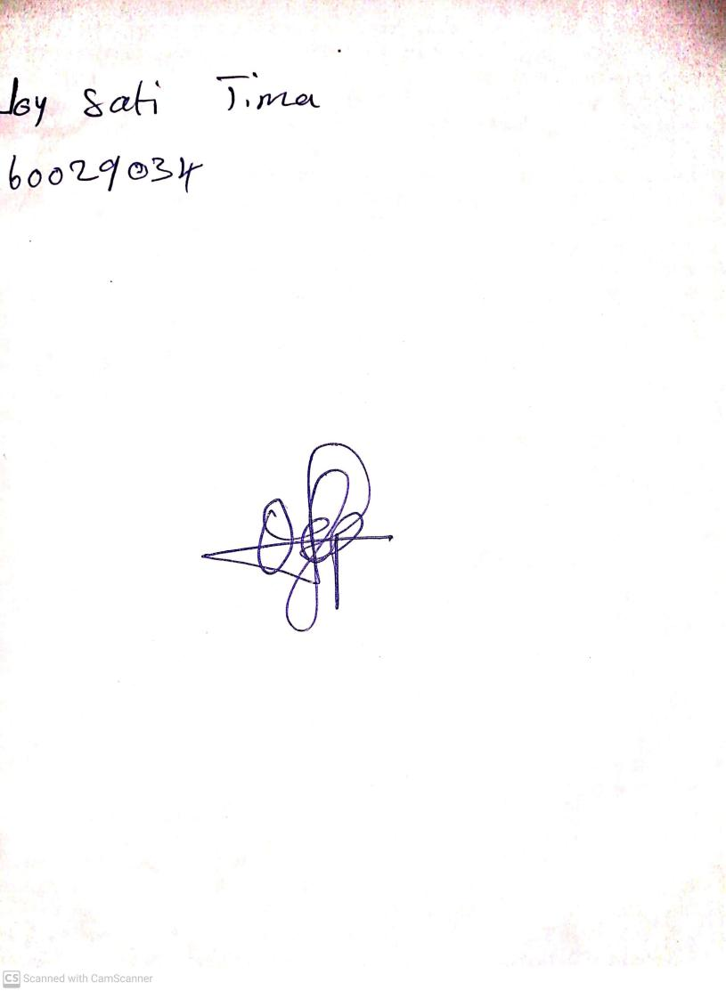

**27th September, 2024**

**Perpetual Ojoma Ocheja**

**Stream Head Nursery**