**EMERALD ROYAL INTERNATIONAL SCHOOL**

**MPAPE, ABUJA.**

**LESSON PLAN AND NOTE FOR WEEK 1 ENDING 15TH SEPTEMBER,2023**

TERM : First term.

WEEK : 1

SUBJECT: Social Norms

TOPIC: Myself

SUB-TOPIC: My name.

DATE: 13/8/2023

DURATION: 40 minutes

TIME: 10:40-11:20

PERIOD: 5th

CLASS: pre-nursery

NUMBER OF PUPILS:

AVERAGE AGE: 2

SEX: Mixed

SPECIFIC OBJECTIVES: By the end of the lesson, the pupils should be able to:-

1. Say their names.

2. Say their surnames.

RATIONALE: For pupils to know about themselves.

PREVIOUS KNOWLEDGE: Pupils can answer their names when they are called upon.

INSTRUCTIONAL MATERIALS: Pupils in the classroom.

REFERENCE: Smart start Civic education for nursery Schools book 1 by T.Y. Alabi and A. M. Solu.

LESSON DEVELOPMENT

|  |  |  |  |
| --- | --- | --- | --- |
| Stages/steps | Teacher's activities | Pupils' activities | Learning points |
| Introduction | Teacher introduces the lesson by singing nursery rhymes for the pupils | Pupils attempt to sing the rhymes along with the teacher. | To get pupils attention for the lesson. |
| Presentation  Step 1 | Teacher models the pupils on how one can say his/her name.  That is :- The teacher touches her chest and say " my name is Mrs Gloria." | Pupils pay attention to the teacher as she says her name. | To improve pupils speaking abilities. |
| Step 2 | Teacher calls out the pupils one after another and asks them to say their names after the teacher.  That's:- " My name is ( the child's name)". | Pupils repeat after the teacher to say their names repeatedly. | To improve pupils speaking abilities and to enable the pupils say their names. |
| Summary | Teacher summarizes the lesson by asking the pupils to say their names again. | Pupils pay attention and say their names. | To ensure better understanding of the lesson. |
| Evaluation | Teacher calls the pupils one after another and asks:-  "What is your name? | Pupils answer the teacher's question correctly. | To assess pupils level of understanding of the lesson. |
| Conclusion | Teacher ends the lesson by playing a video clips for the pupils. | Pupils pay attention and watch the video. | To consolidate the lesson. |

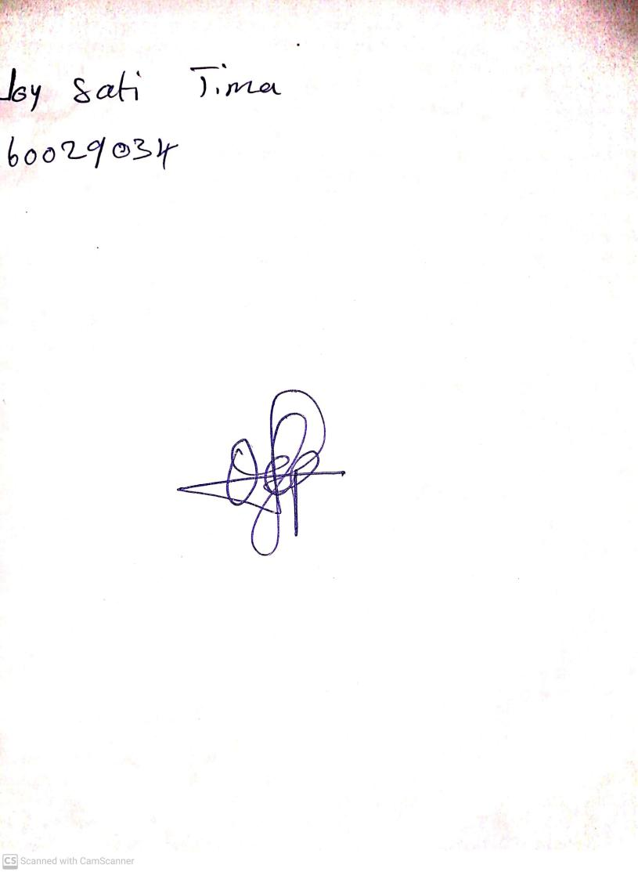

25th August, 2023

Perpetual Ojoma Ocheja

Stream Head Nursery