EMERALD ROYAL INTERNATIONAL SCHOOL

MPAPE, ABUJA.

LESSON PLAN AND NOTE 1 FOR WEEK 3 ENDING 29TH SEPTEMBER, 2023.

SUBJECT: Literacy

TOPIC: Alphabets.

SUB-TOPIC: Sounding and identification of letters K and L.

DATE: 26/9/2023.

DURATION: 40 minutes.

TIME: 08:50--09:30.

PERIOD: 2nd

CLASS: Pre-nursery

NUMBER OF PUPILS: 11

AVERAGE AGE: 2 YEARS

SEX: Mixed.

SPECIFIC OBJECTIVES: By the end of the lesson, the pupils should be able to:-

1. Say the sound for letters K and L.
2. Identify the letters that sound/k/ and /l/.

RATIONALE: For pupils to be able to identify letters.

PREVIOUS KNOWLEDGE: Pupils may have been taught letters A-J in the previous lesson.

INSTRUCTIONAL MATERIALS: Flash cards, chart.

REFERENCE:Mastering English for nursery schools book 1 by J.M.Omogbai.

LESSON DEVELOPMENT

|  |  |  |  |
| --- | --- | --- | --- |
| STAGES/STEPS | TEACHER’S ACTIVITIES | PUPILS’ ACTIVITIES | LEARNING POINTS |
| INTRODUCTION | Teacher introduces the lesson by singing ABC'S song for the pupils. | Pupils listen attentively to the teacher and try to emulate the teacher to sing. | To arouse the interest of the pupils for the lesson. |
| PRESENTATION  STEP 1 | Teacher says the sound for letter K and L for the pupils to repeat after her. | Pupils repeat the sounds as:-  Letter K sounds/k/.  Letter L sounds/l/. | For better understanding of the lesson . |
| STEP2 | Teacher shows the pupils letter K and L on the flash cards and identifies the letters for the pupils randomly. | Pupils pay attention to the teacher and say the sounds of the letters after the teacher. | For proper understanding of the lesson. |
| SUMMARY | Teacher summarizes the lesson by pointing at letter K and L on the chart for pupils to see and identify. | Pupils point at the two letters, letter K and L on the chart and identify them. | For more understanding of the lesson. |
| EVALUATION | Teacher asks the pupils to   1. Identify letter K and L on a flash cards. 2. Say the sounds for letter K and L on a chart | Pupils answer the teacher’s question. | To assess the level of pupils understanding of the lesson. |
| CONCLUSION | Teacher marks the pupils books and make corrections where necessary. | Pupils submit their books for marking and corrections . | For onwards study. |
| ASSIGNMENT | Teacher asks the pupils to continue saying the sounds for letter K and L at home.  Letter K sounds /k/ /k/ /k/.  Letter L sounds /l/ /l/ /l/. | Pupils do their Home work at home. | To ensure learning takes place at home. |

LESSON PLAN AND NOTE 2 FOR WEEK 2 ENDING 22ND SEPTEMBER, 2023.

SUBJECT: Literacy

TOPIC: Alphabets.

SUB-TOPIC: Identification and tracing of letters M and N.

DATE: 20/9/2023.

DURATION: 40 minutes.

TIME: 08:50--09:30.

PERIOD: 2nd

CLASS: Pre-nursery

NUMBER OF PUPILS: 11

AVERAGE AGE: 2 YEARS

SEX: Mixed.

SPECIFIC OBJECTIVES: By the end of the lesson, the pupils should be able to:-

1.Identify letters M and N and their sounds.

2.Trace letter M and N.

RATIONALE: For pupils to be able to identify letters and their sounds.

PREVIOUS KNOWLEDGE: Pupils have been practising the letters and their sounds in the previous lesson. and G in the previous period.

INSTRUCTIONAL MATERIALS: Flash cards, and chart.

REFERENCE:Mastering English for nursery schools book 1 by J.M.Omogbai.

LESSON DEVELOPMENT

|  |  |  |  |
| --- | --- | --- | --- |
| STAGES/STEPS | TEACHER’S ACTIVITIES | PUPILS’ ACTIVITIES | LEARNING POINTS |
| INTRODUCTION | Teacher introduces the lesson by reviewing the previous lesson on letter K and L. | Pupils listen to their teacher as she sounds the letters. | To arouse the interest of the pupils for the lesson. |
| PRESENTATION  STEP 1 | Teacher shows the pupils letters M and N on the flash cards to identify. Teacher also says the sounds of letter M and N. | Pupils take turns to point at the letter M and N on the flash cards and identify them . Pupils also say the sounds.  Letter M sounds /m/  Letter N sounds /n/. | For better understanding of the lesson. |
| STEP2 | Teacher prepares the pupils books and guides them to trace letter M and N. | Pupils identify and trace letter M - N in their books. | To improve pupils psychomotive skills. |
| SUMMARY | Teacher summarizes the lesson by singing the phonics song for the pupils. | Pupils sing the phonics song along with the teacher. | For more understanding of the lesson. |
| EVALUATION | Teacher randomly places flash cards of letters and asks the pupils to :-   1. Identify letters M and N. 2. Sound letter M and N. | Pupils identify the letters correctly. | To assess the level of pupils understanding of the lesson. |
| CONCLUSION | Teacher marks the pupils books and make corrections where necessary. | Pupils submit their books for marking and corrections . | For onwards study. |
| ASSIGNMENT | Teacher asks the pupils to identify and match letters correctly.  M n  N m | Pupils do their Home work at home. | To ensure learning takes place at home. |

LESSON PLAN AND NOTE 3 FOR WEEK 3 ENDING 29TH SEPTEMBER, 2023.

SUBJECT: Literacy

TOPIC: Alphabets

SUB-TOPIC: Identification and colouring of letters O.

DATE: 29/9/2023.

DURATION: 40 minutes.

TIME: 08:50--09:30.

PERIOD: 2nd

CLASS: Pre-nursery

NUMBER OF PUPILS: 11

AVERAGE AGE: 2 YEARS

SEX: Mixed.

SPECIFIC OBJECTIVES: By the end of the lesson, the pupils should be able to:-

1. Identify letter O and it's sound.

2. Colour letter O .

RATIONALE: For pupils to be able to identify letters.

PREVIOUS KNOWLEDGE: Pupils have been practicing letters and their sounds in the previous lesson..

INSTRUCTIONAL MATERIALS: Flash cards and charts.

REFERENCE:Mastering English for nursery schools book 1 by J.M.Omogbai.

LESSON DEVELOPMENT

|  |  |  |  |
| --- | --- | --- | --- |
| STAGES/STEPS | TEACHER’S ACTIVITIES | PUPILS’ ACTIVITIES | LEARNING POINTS |
| INTRODUCTION | Teacher introduces the lesson by reviewing the last lesson on letter M and N. | Pupils listen as the teacher reviews the last lesson. | To arouse the interest of the pupils for the lesson proper. |
| PRESENTATION  STEP 1 | Teacher writes letters O on the board for pupils to identify and sound it. | Pupils pay attention to the teacher as she is writing the letter "O" on the board. Pupils identify and sound the letter.  Letter O sounds /o/  Letter O sounds /o/  Every letter makes a sound  The O sounds /o/. | For proper recognition of letter.. |
| STEP2 | Teacher prepares the pupils books for them to colour letter O. | Pupils colour the letter O and practice it's sound.  O  Letter O sounds /o/  Every letter makes a sound  The O sounds /o/. | To improve pupils psychomotive skills. |
| SUMMARY | Teacher summarizes the lesson by going over the lesson from the start A - O for more clarification. | Pupils pay attention to the teacher and repeat after teacher. | For more understanding of the lesson. |
| EVALUATION | Teacher calls out the pupils one after another to:-  1. identify letter O on a chart amongst other letters.  2. Sound letter O. | Pupils answer the teacher’s questions. | To assess the level of pupils understanding of the lesson. |
| CONCLUSION | Teacher marks the pupils books and make corrections where necessary. | Pupils submit their books for marking and corrections . | For onwards study. |
| ASSIGNMENT | Teacher asks the pupils to identify and trace letter O correctly at home. | Pupils do their Home work at home. | To ensure learning takes place at home. |

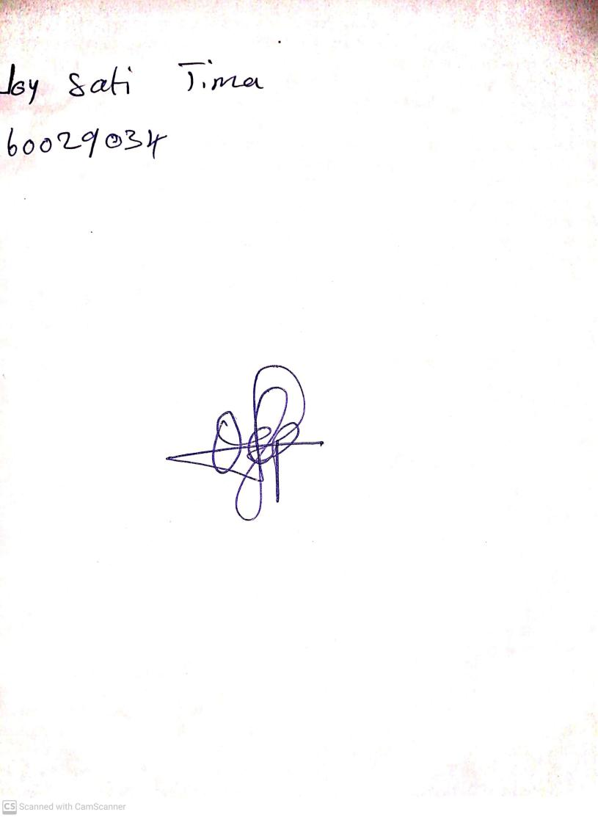

2ND OCTOBER, 2023

Perpetual Ojoma Ocheja

Stream Head Nursery