EMERALD ROYAL INTERNATIONAL SCHOOL

MPAPE, ABUJA.

LESSON PLAN FOR WEEK 5 ENDING 9th FEBRUARY,2024.

SUBJECT: Social norms.

TOPIC: Table manners

SUB-TOPIC: Meaning of table manners and types of table manners.

DATE: 6/02/2024.

DURATION: 40minutes

TIME: 10:40 -11:20.

PERIOD: 4th

CLASS: Pre- nursery

NUMBER OF PUPILS: 17

AVERAGE AGE: 2years

SEX: Mixed.

SPECIFIC OBJECTIVES: By the end of the lesson, the pupils should be able to:-

1. State the meaning of table manners.

2Mention the types of table manners.

RATIONALE: For pupils to have good etiquette.

PREVIOUS KNOWLEDGE: Pupils have been taught the objects around their school .

INSTRUCTIONAL MATERIALS: Eating time in school.

REFERENCE: Smart start Civic education for nursery Schools book 1 by T.Y Alabi and A.M . Solu.

LESSON DEVELOPMENT

|  |  |  |  |
| --- | --- | --- | --- |
| Stages/steps | Teacher's activities | Pupils activities | Learning points |
| Introduction | Teacher introduces the lesson by singing a nursery rhyme for the pupils. | Pupils listen attentively and sing along with the teacher. | To arouse the interest of the pupils for the lesson. |
| Presentation  Step 1 | Teacher explains to the pupils the meaning of table manners as:- "Table manners is concerns with things we must do or things we must not do when eating." | Pupils listen to the teacher as he/she is explaining the meaning of table manners and repeat after the teacher. | For proper understanding. |
| Step 2 | Teacher leads the pupils to mention the types of table manners. | Pupils list the types of table manners as:-1.Good table manners.  2.Bad table manners | Fo better understanding. |
| Summary | Teacher summarizes the lesson by asking the pupils to:-  1. Define table manners.   1. How many types of table manners do we have? | Pupils listen and answer the teacher's questions correctly. | To ascertain if the pupils understand the lesson. |
| Evaluation | Teacher evaluates the lesson by asking the pupils to:- 1. Mention the types of table manners. | Pupils answer the teacher's question. | To assess the level of pupils understanding. |
| Conclusion | Teacher ends he lesson by singing nursery rhymes. | Pupils sing along with the teacher. | To make the learning fun. |
| Assignment | Teacher encourages the pupils to practice the meaning of table manners at home. | Pupils do the assignment at home. | To encourage learning at home. |

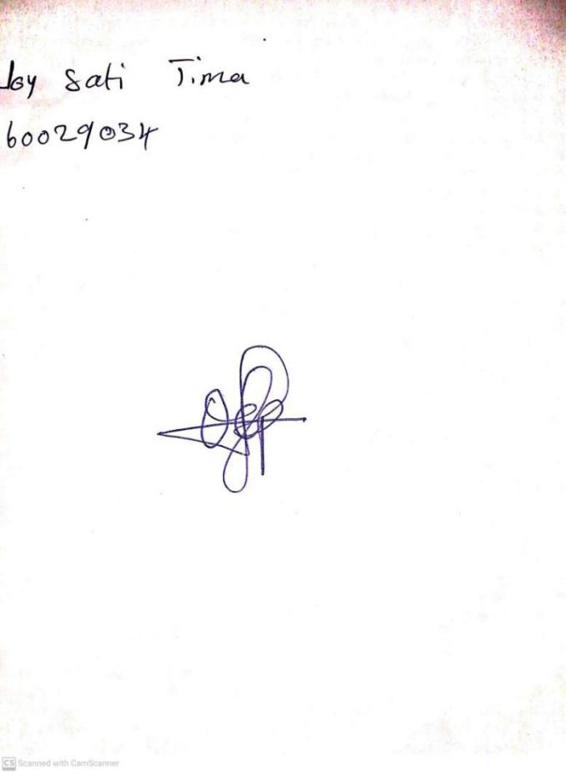

**2ND FEBRUARY, 2024**

**Perpetual Ojoma Ocheja**

**Stream Head Nursery**